APPENDIX -IX

MANDATORYPUBLICDISCLOSURE
A:GENERALINFORMATION:

SLNO. | INFORMATION | DETAILS
1 | NAMEOFTHESCHOOL | GREENVALLEYHIGHSCHOOL
2 | AFFILIATION NO.(IF APPLICABLE) | 430112
3 | SCHOOLCODE(IFAPPLICABLE) | 10098
4 | COMPLETEADDRESSWITHPINCODE | ViaSevasiGotri,OffEffluentChannelroad,  Ampad,Vadodara,Gujarat,VADODARA(BARODA),GUJARAT-391101
5 | PRINCIPAL NAME | IRFANKASAMMULTANI
6 | PRINCIPALQUALIFICATION | M.A,B.ED.
7 | SCHOOLEMAILID | greenvalleyhigh@gmail.com
8 | CONTACTDETAILS(LANDLINE/MOBILE) | 09409289929

B:DOCUMENTSANDINFORMATION:

SLNO. | DOCUMENTS/INFORMATION | LINKSOFUPLOADEDDOCUMENTSONYOURSCHOOL'SWEBSITE
1 | COPIESOFAFFILIATION/UPGRADATIONLETTERANDRECENTEXTENSIONOFAFFILIATION,IF ANY | PDF Attached
2 | COPIESOFSOCIETIES/TRUST/COMPANY  REGISTRATION/RENEWALCERTIFICATE,ASAPPLICABLE | PDF Attached
3 | COPY OFNOOBJECTIONCERTIFICATE(NOC)ISSUED,IFAPPLICABLE,BYTHESTATE GOVT./UT | PDF Attached
4 | COPIES OFRECOGNITION CERTIFICATEUNDERRTEACT,2009,ANDIT’SRENEWALIFAPPLICABLE | PDF Attached
5 | COPYOFVALIDBUILDINGSAFETY  CERTIFICATE AS PER THE NATIONALBUILDINGCODE | PDF Attached
6 | COPYOFVALIDFIRESAFETYCERTIFICATEISSUEDBYTHECOMPETENTAUTHORITY | PDF Attached
7 | COPYOFTHESELFCERTIFICATIONSUBMITTEDBYTHESCHOOLFOR  AFFILIATION/UPGRADATION/EXTENSIONOFAFFILIATION | PDF Attached
8 | COPIESOFVALIDWATER,HEALTHANDSANITATIONCERTIFICATES | PDF Attached --
NOTE:

THE SCHOOLS NEEDS TO UPLOAD THE SELF ATTESTED COPIES OF ABOVE LISTED DOCUMETNS BYCHAIRMAN/MANAGER/SECRETARYANDPRINCIPAL.INCASE, ITISNOTICEDATLATER STAGETHATUPLOADEDDOCUMENTSARENOTGENUINETHENSCHOOLSHALLBELIABLEFORACTIONASPERNORMS.

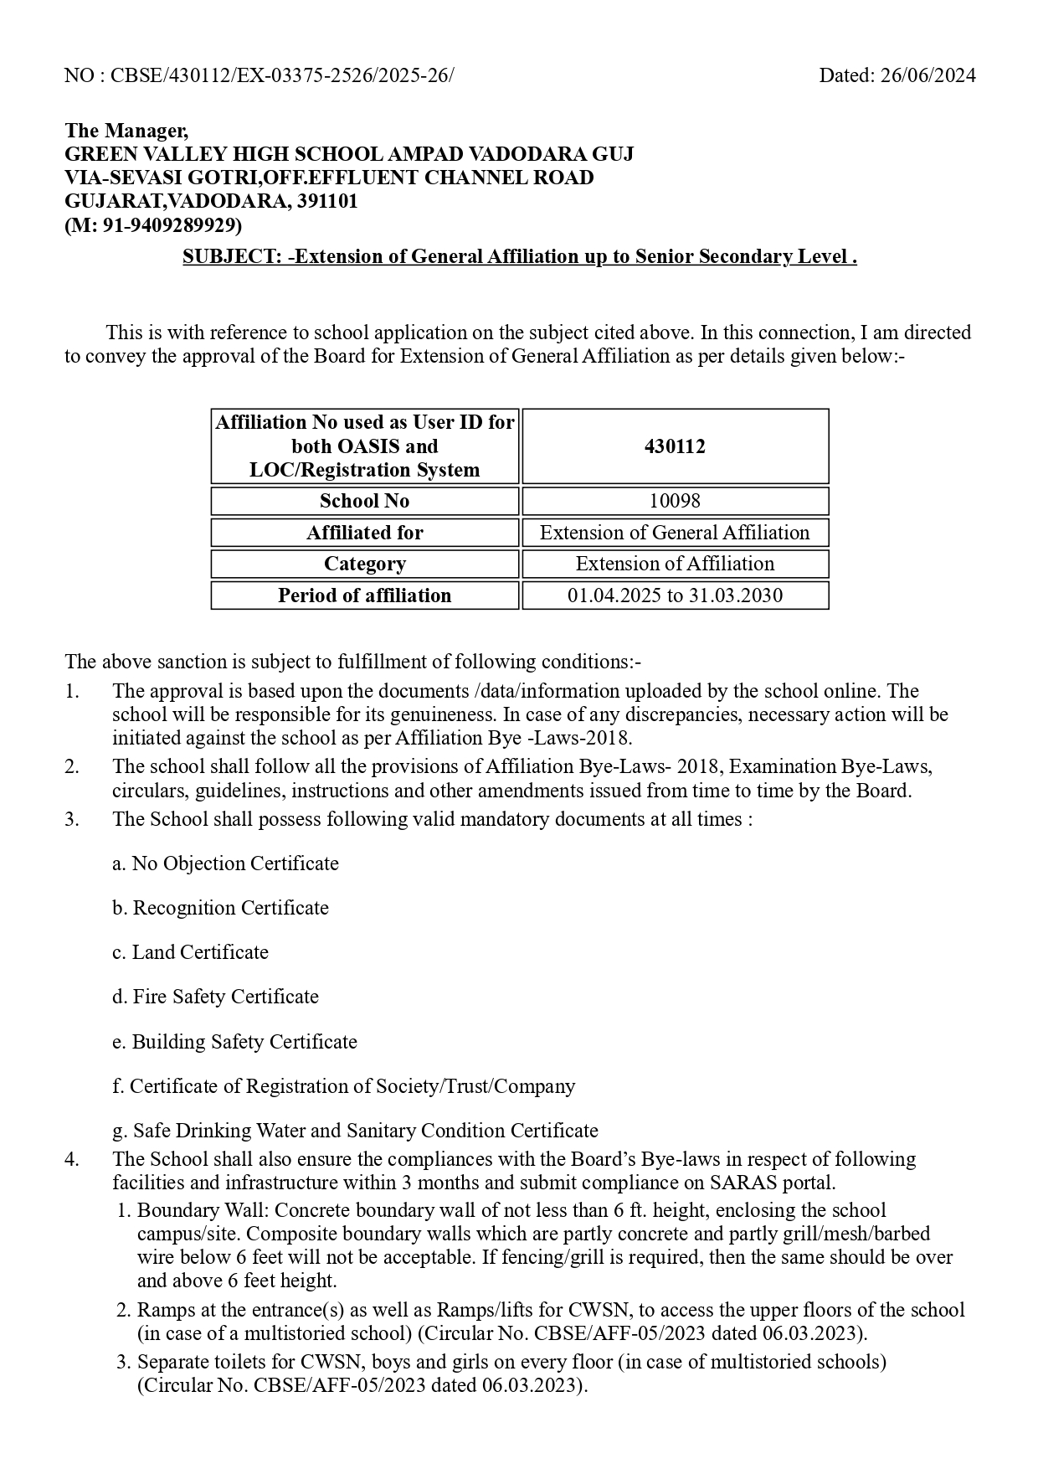
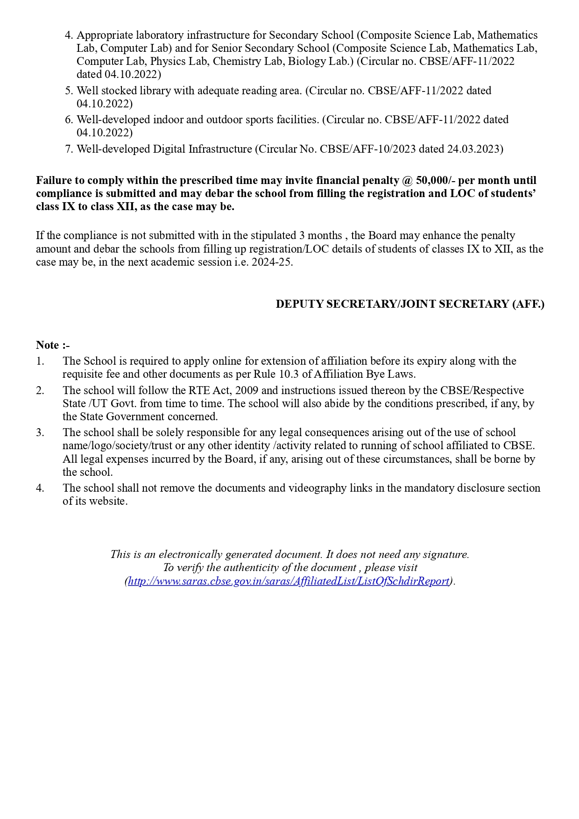
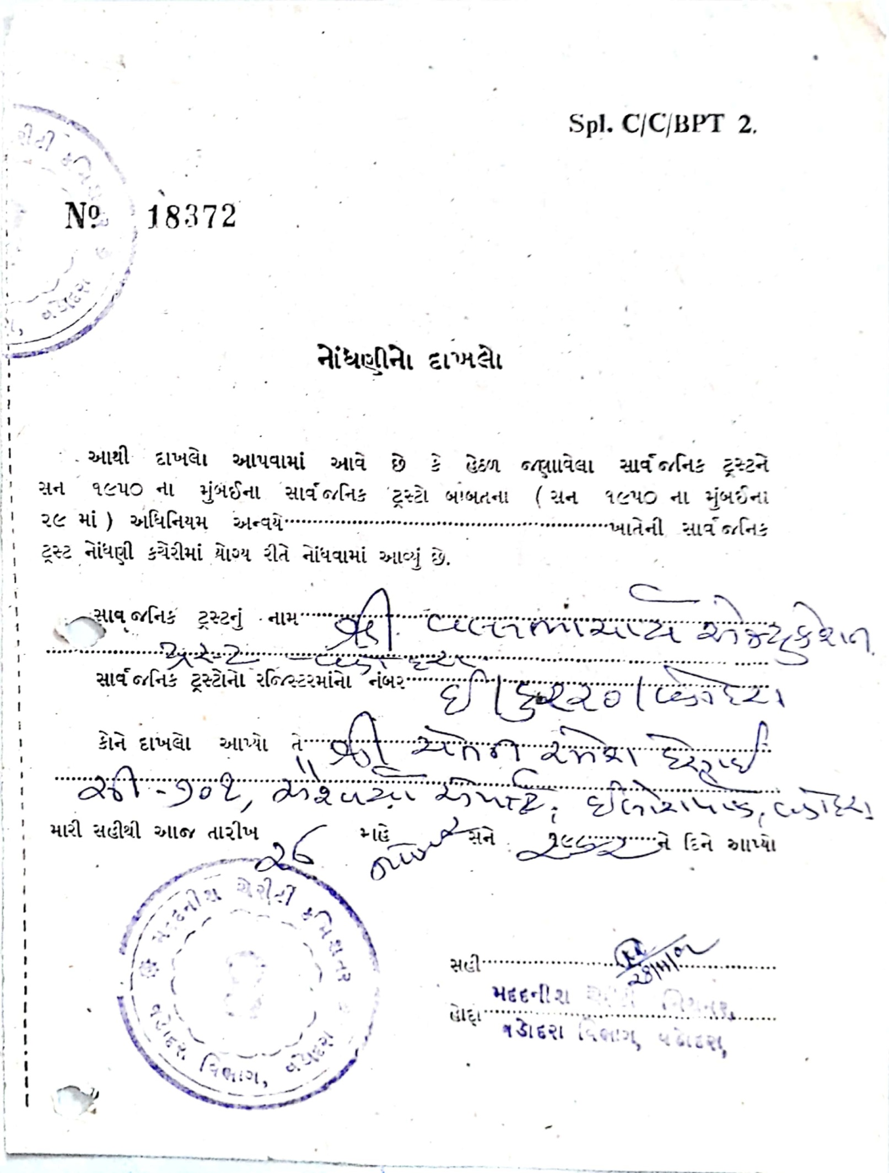

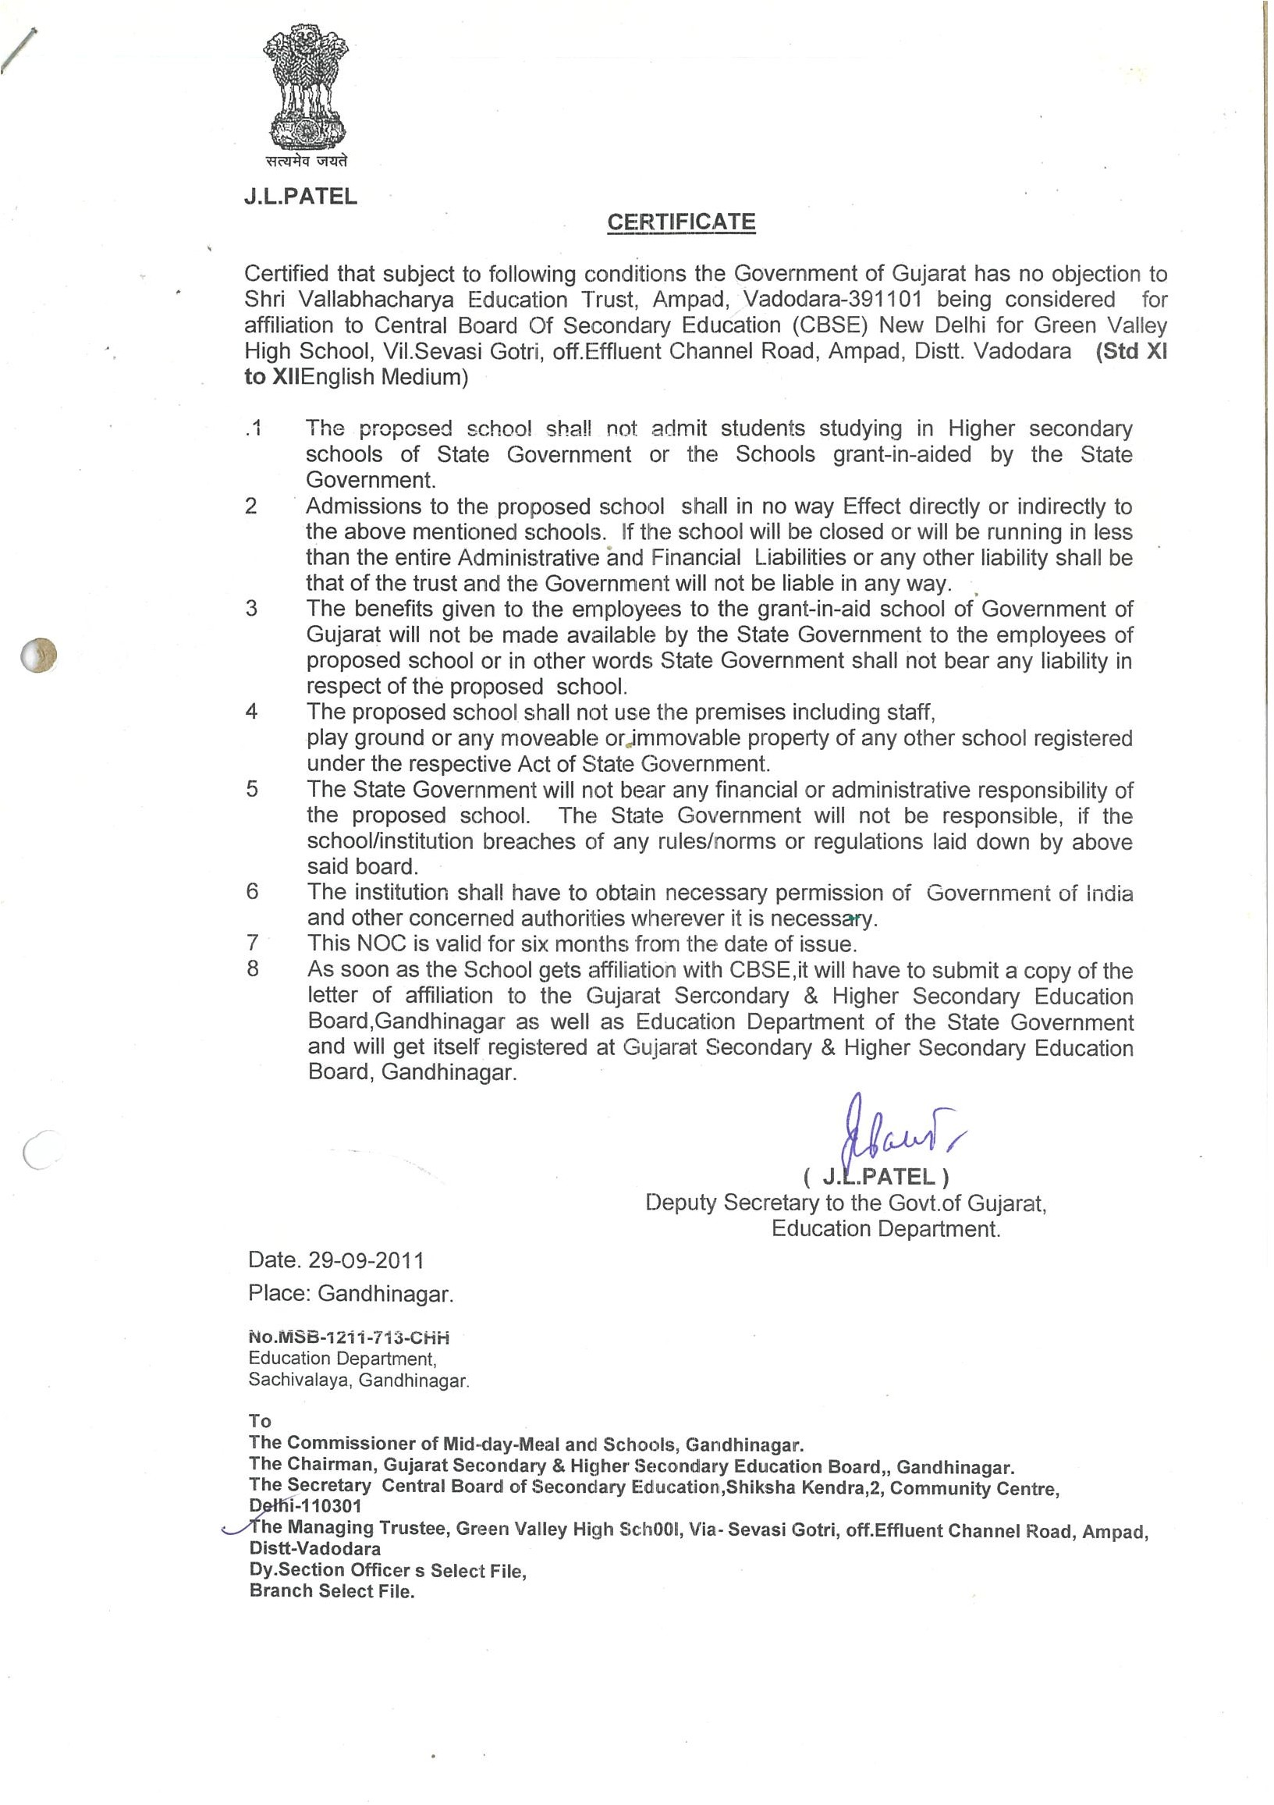

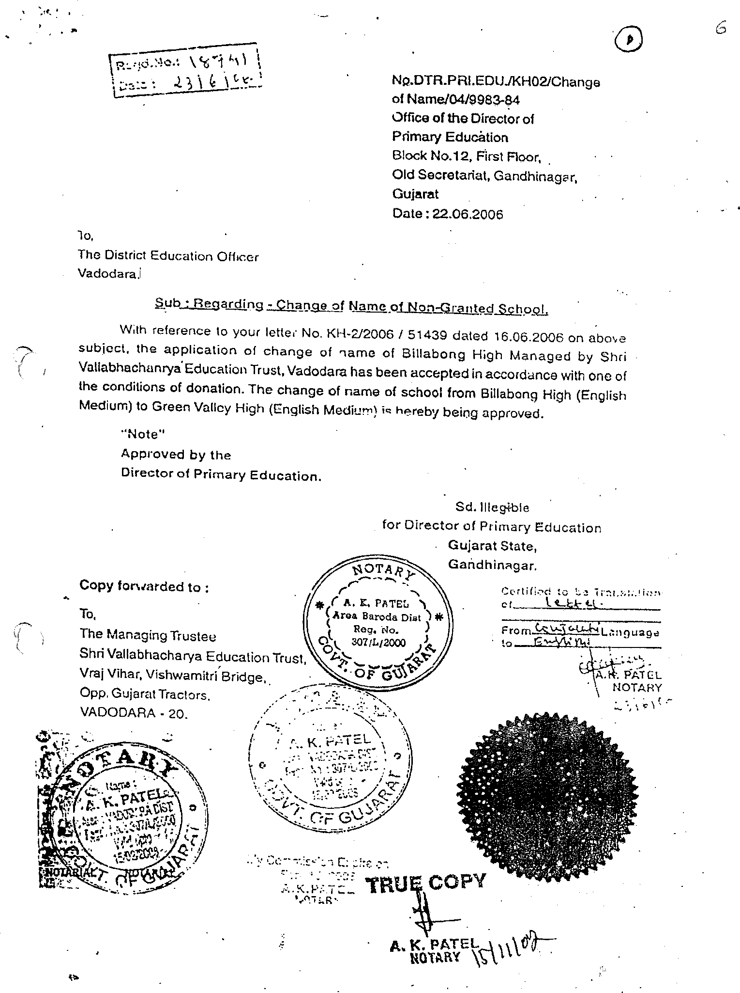

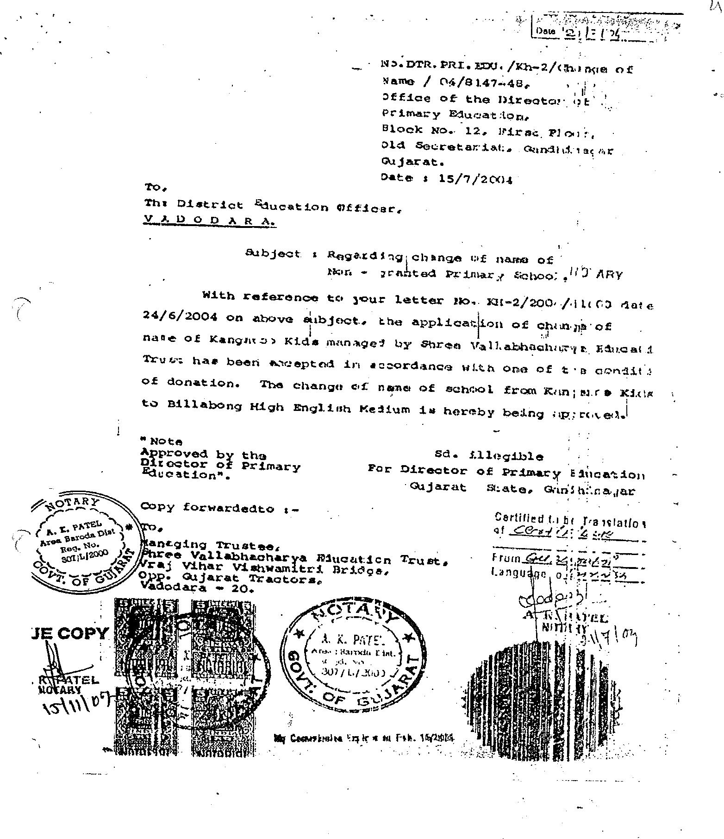

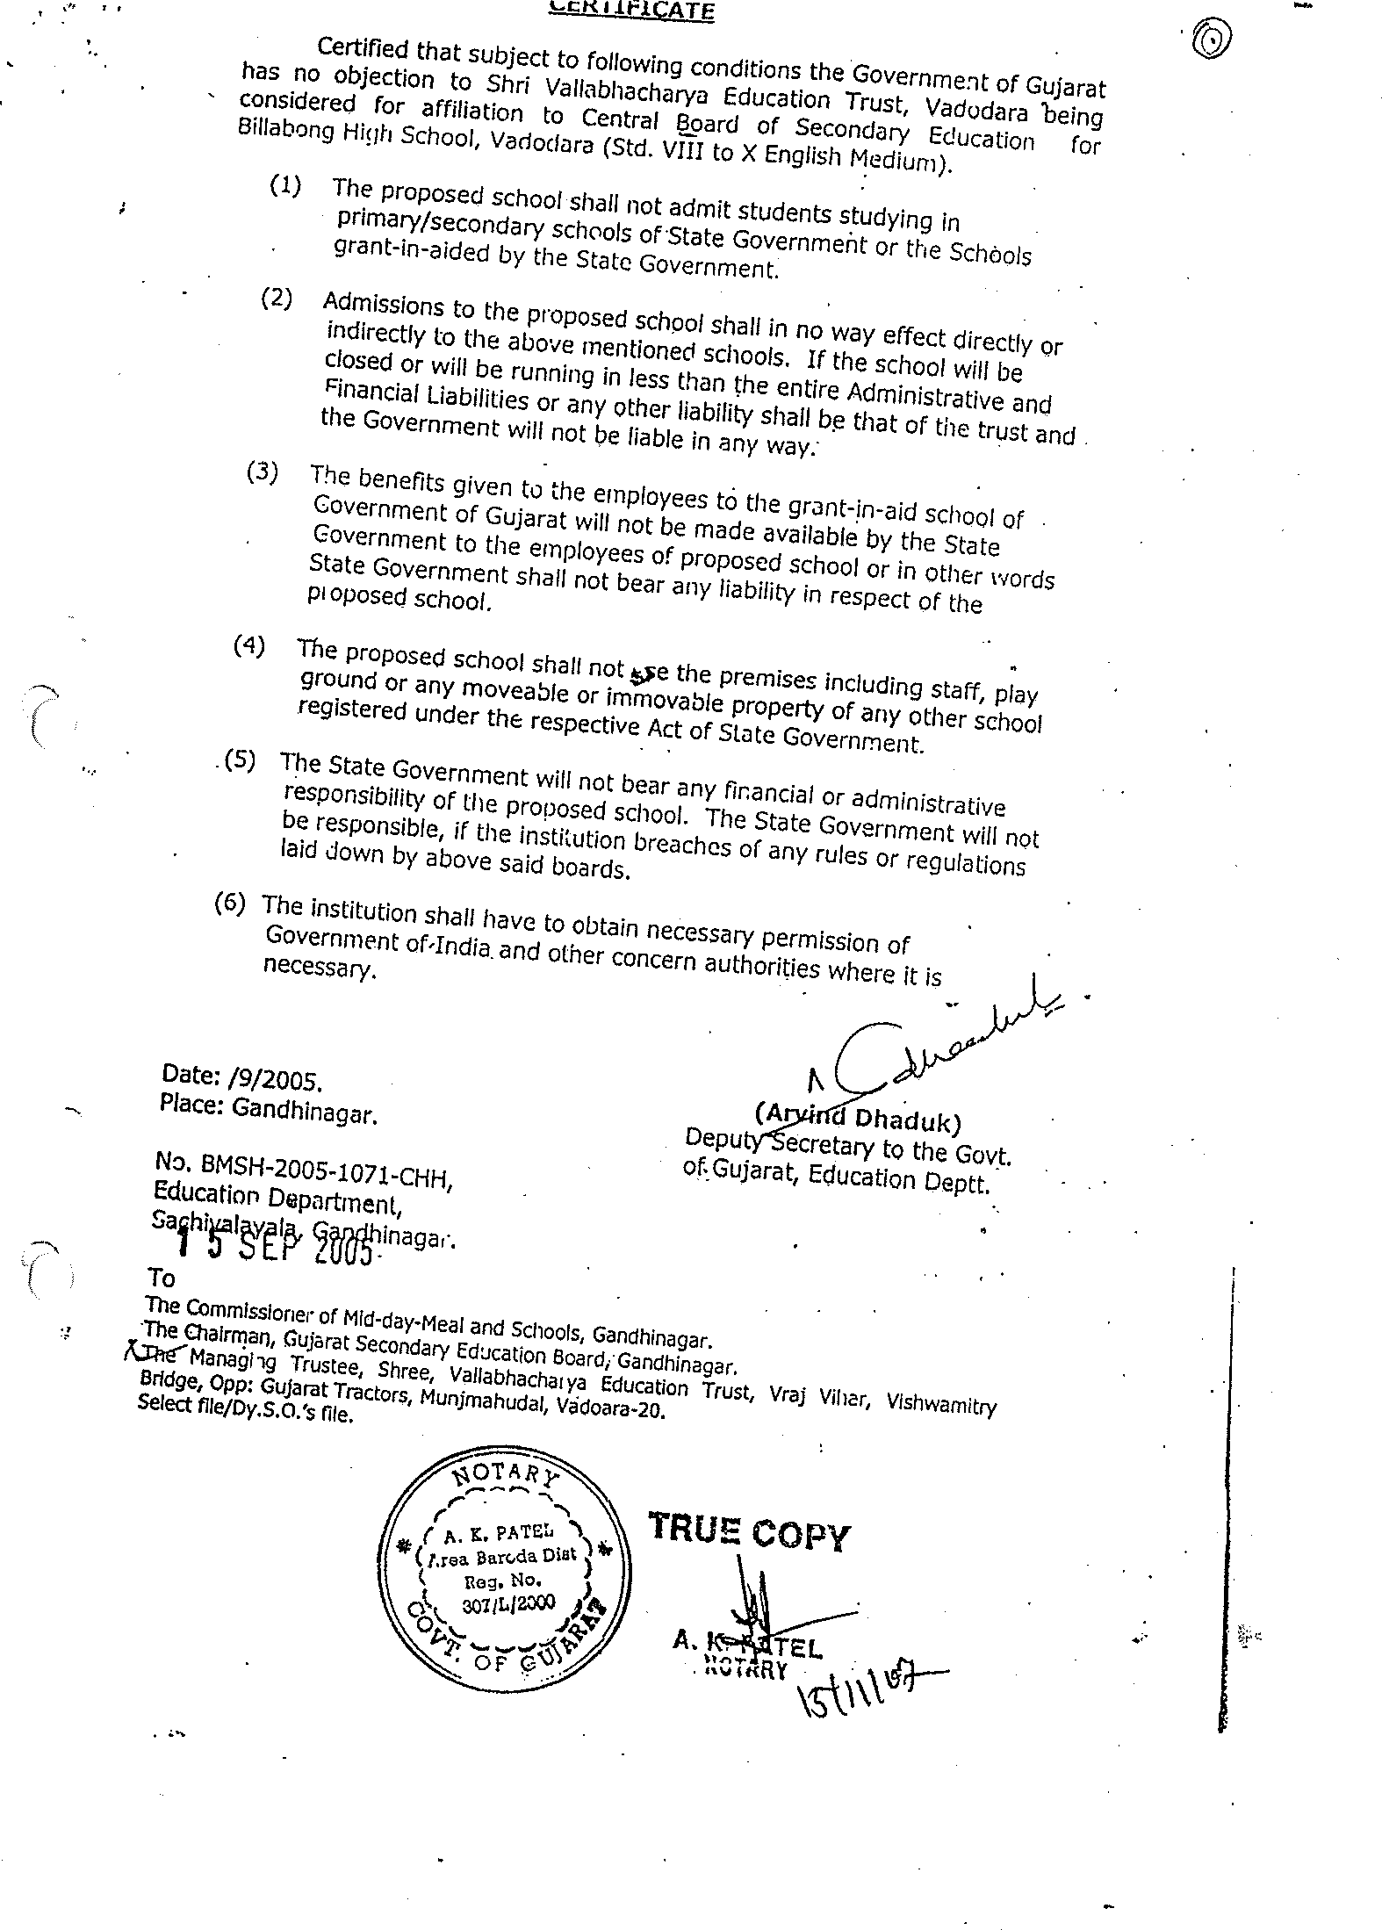

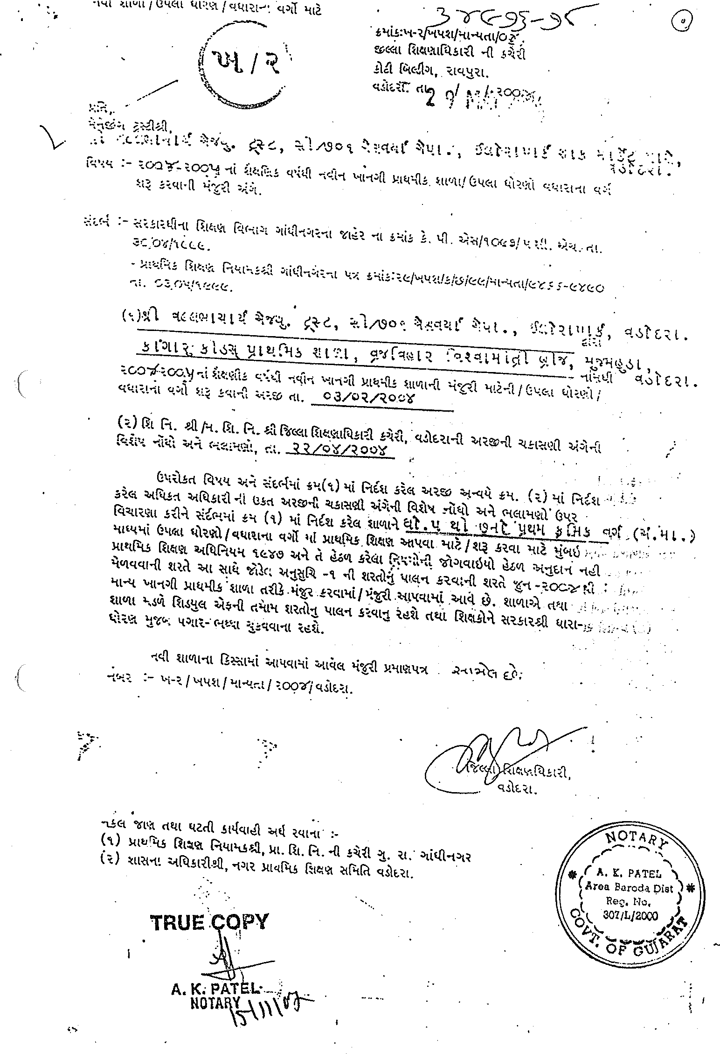
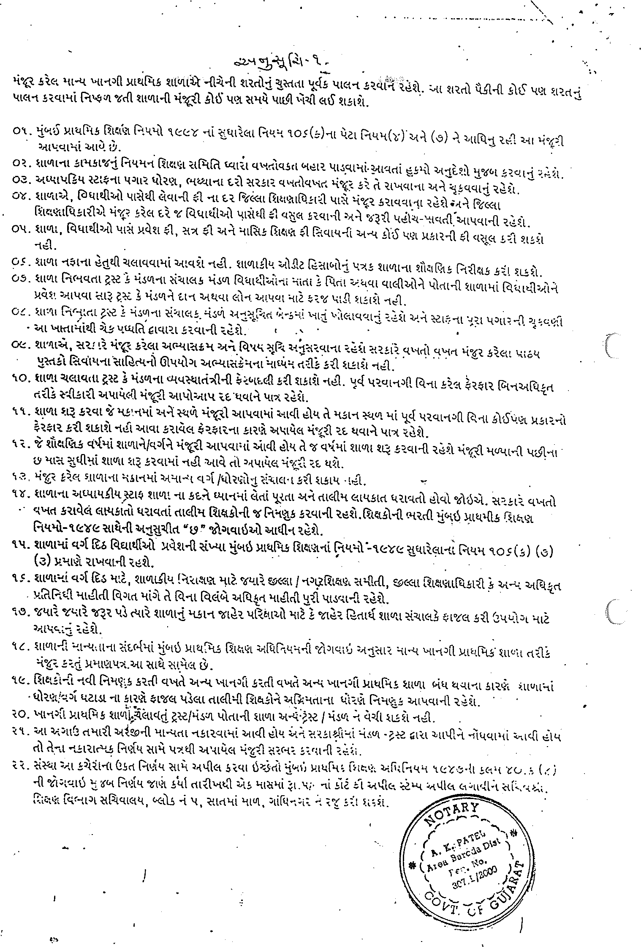

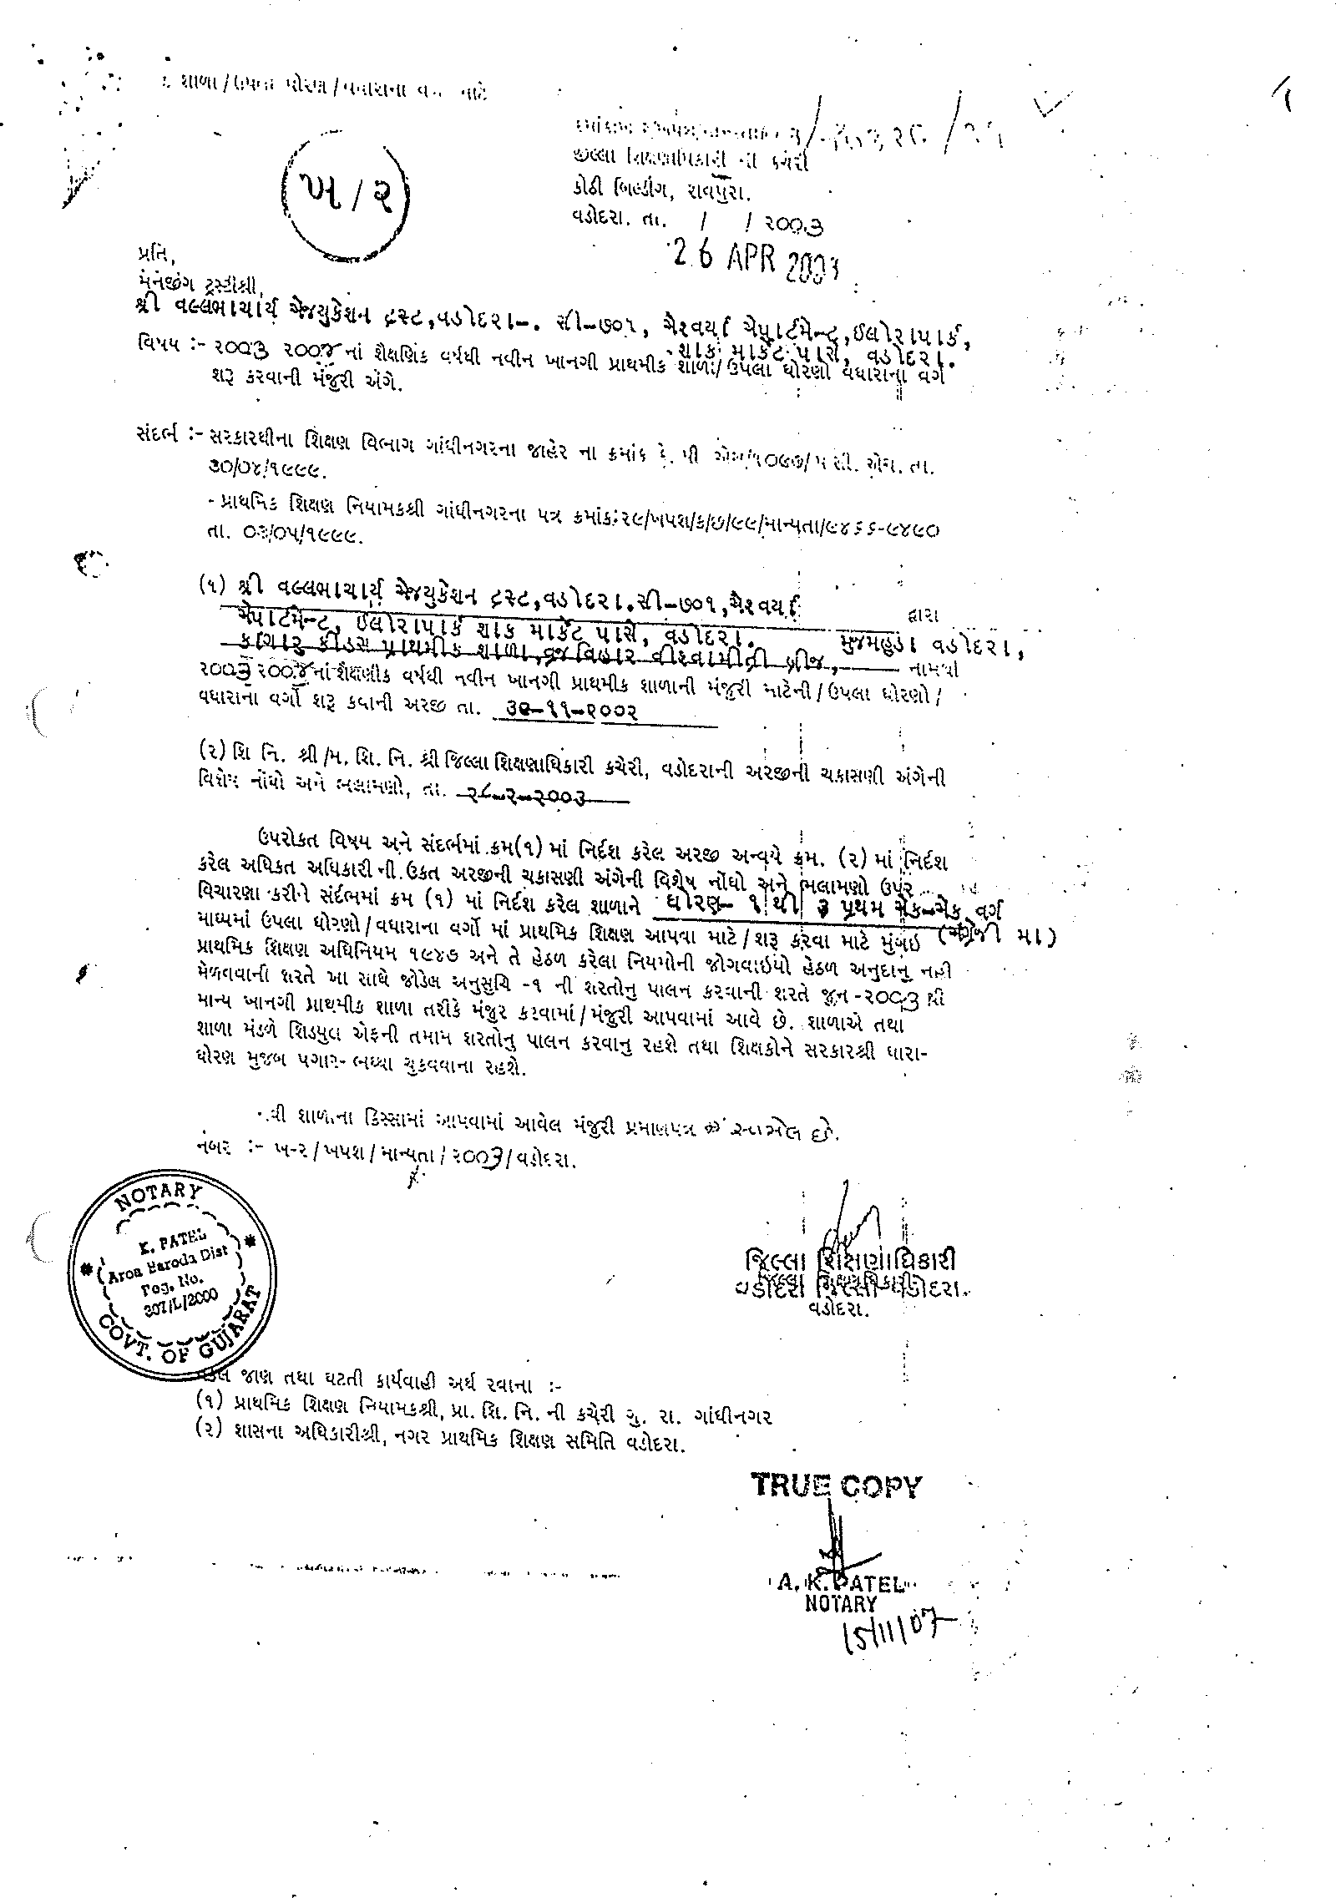

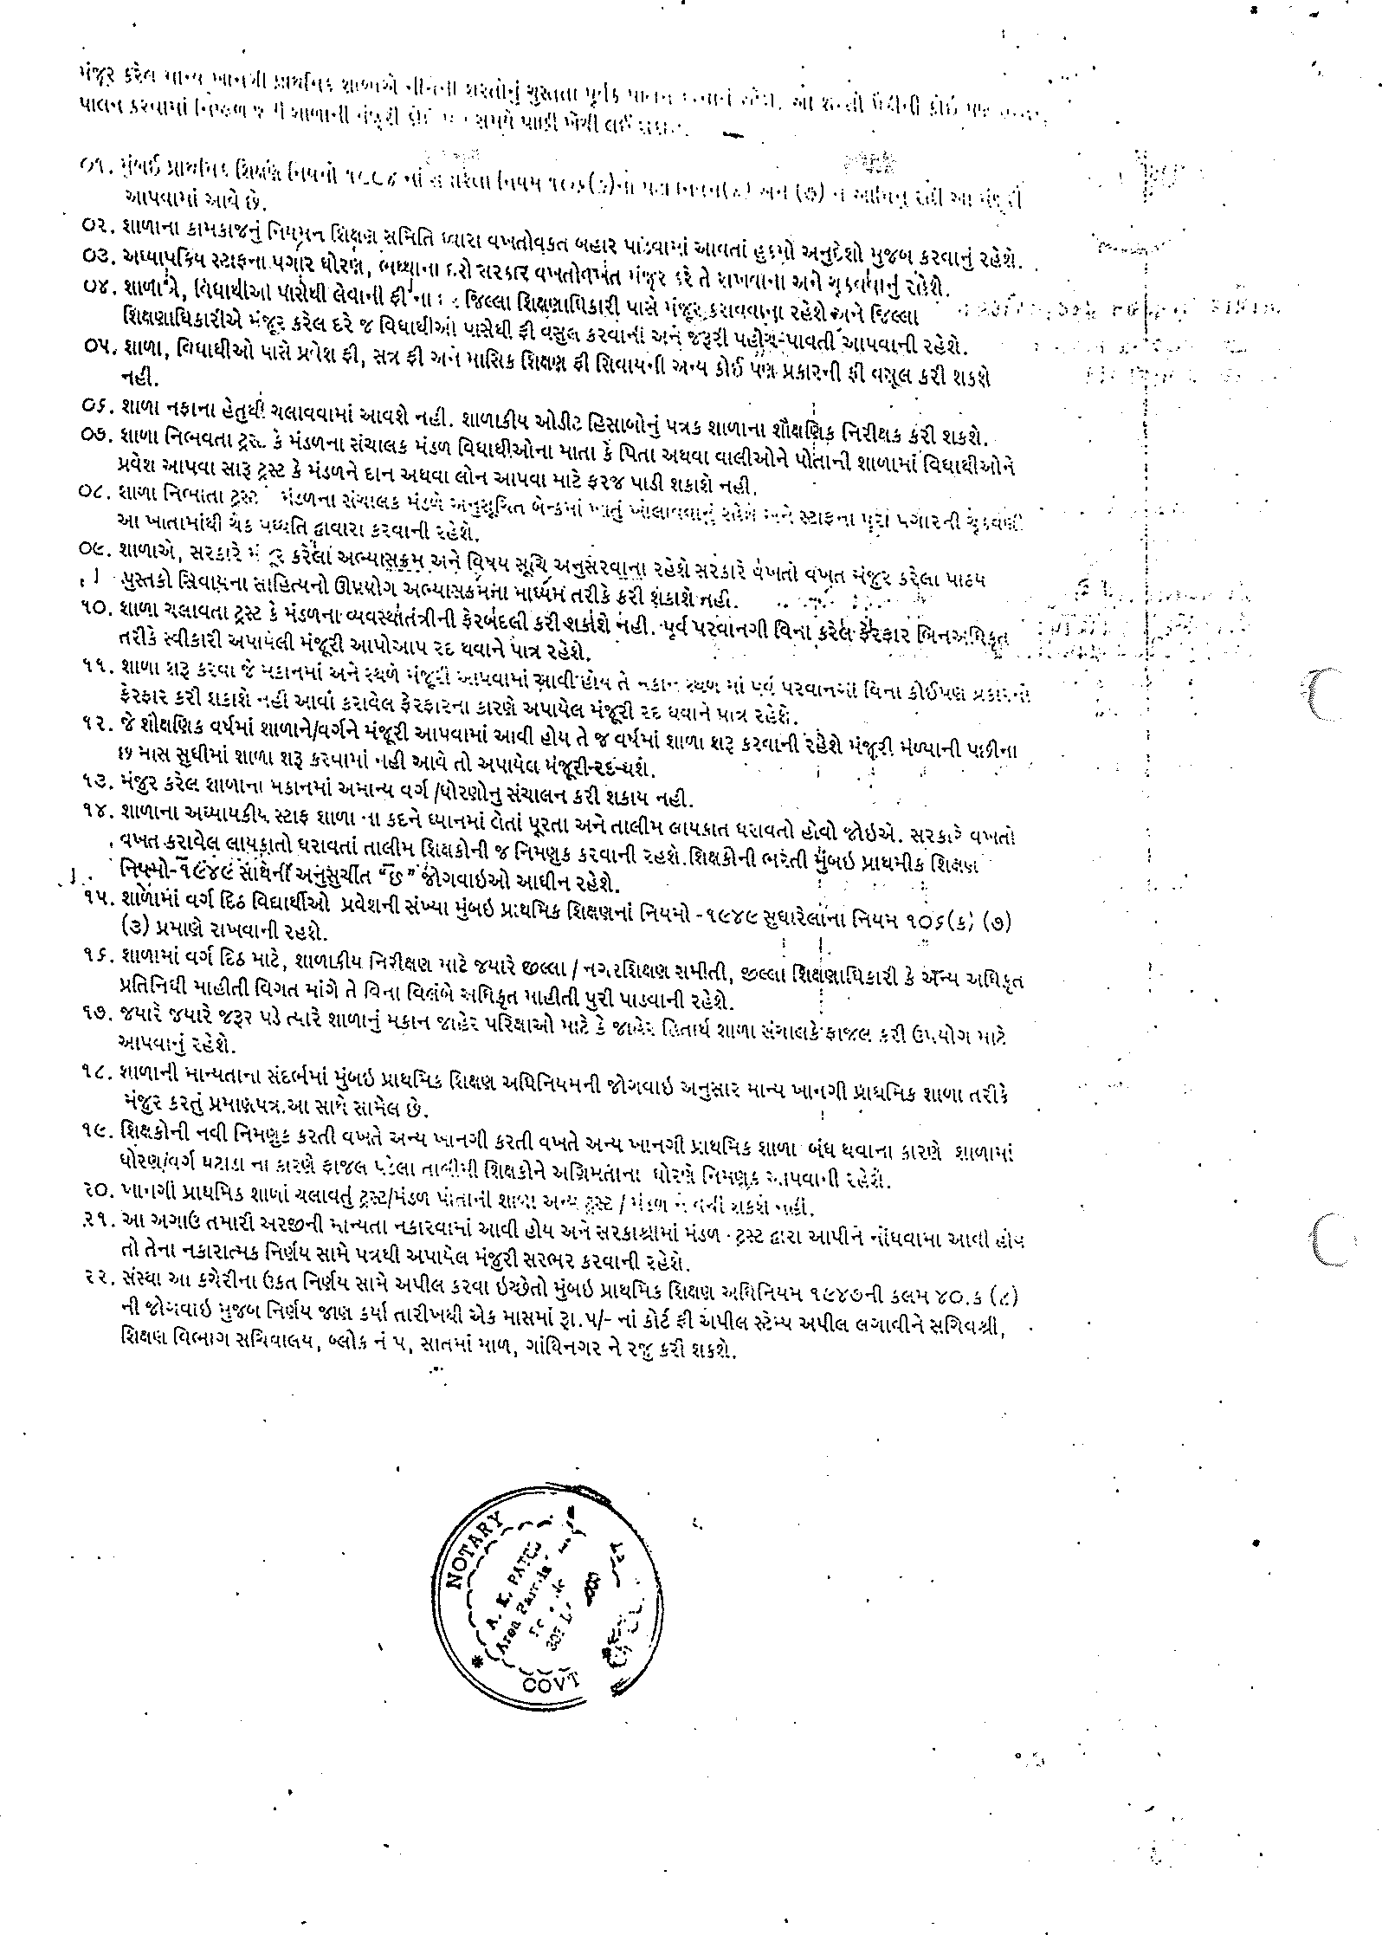

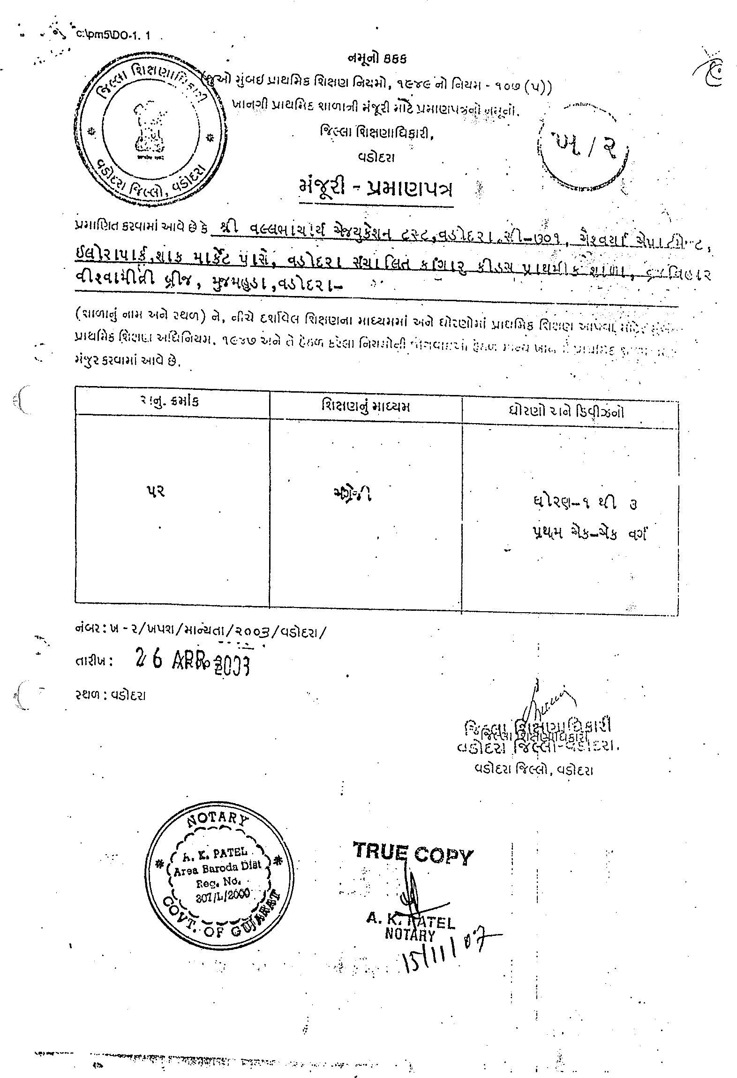

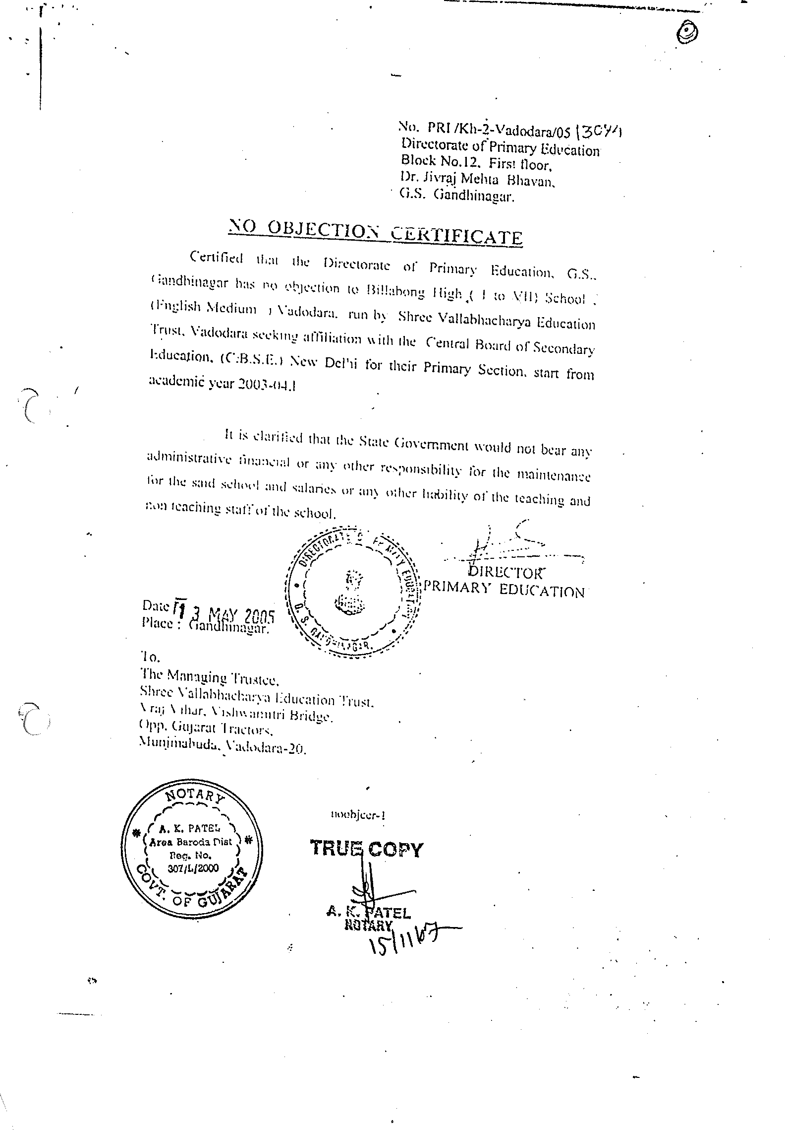

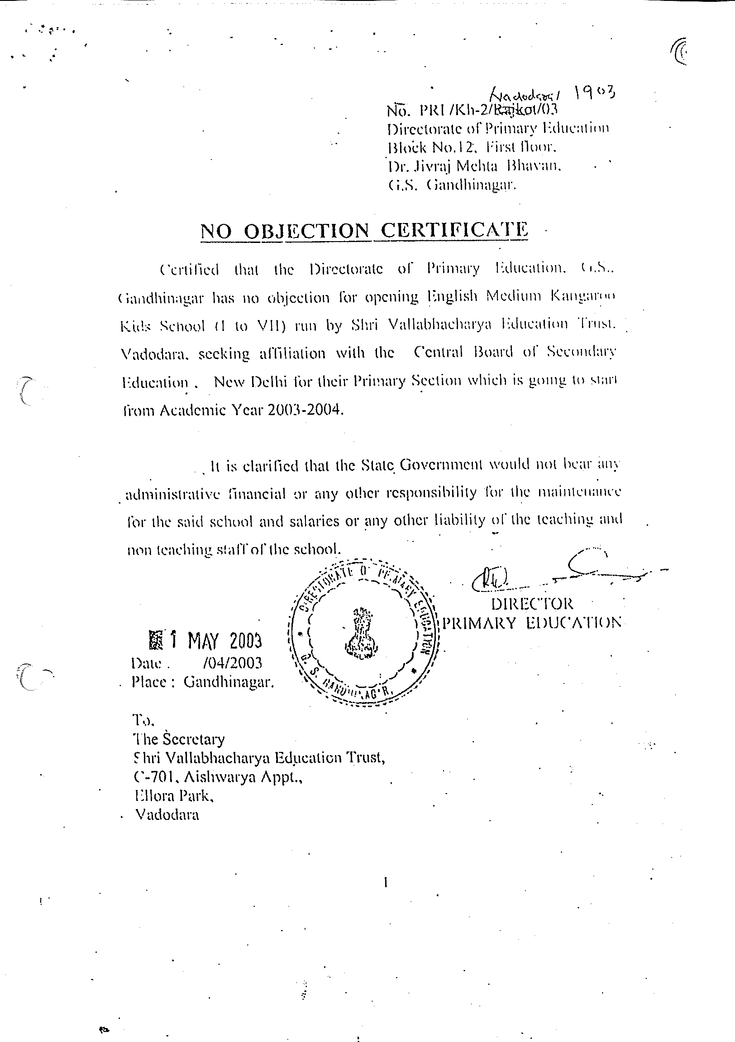

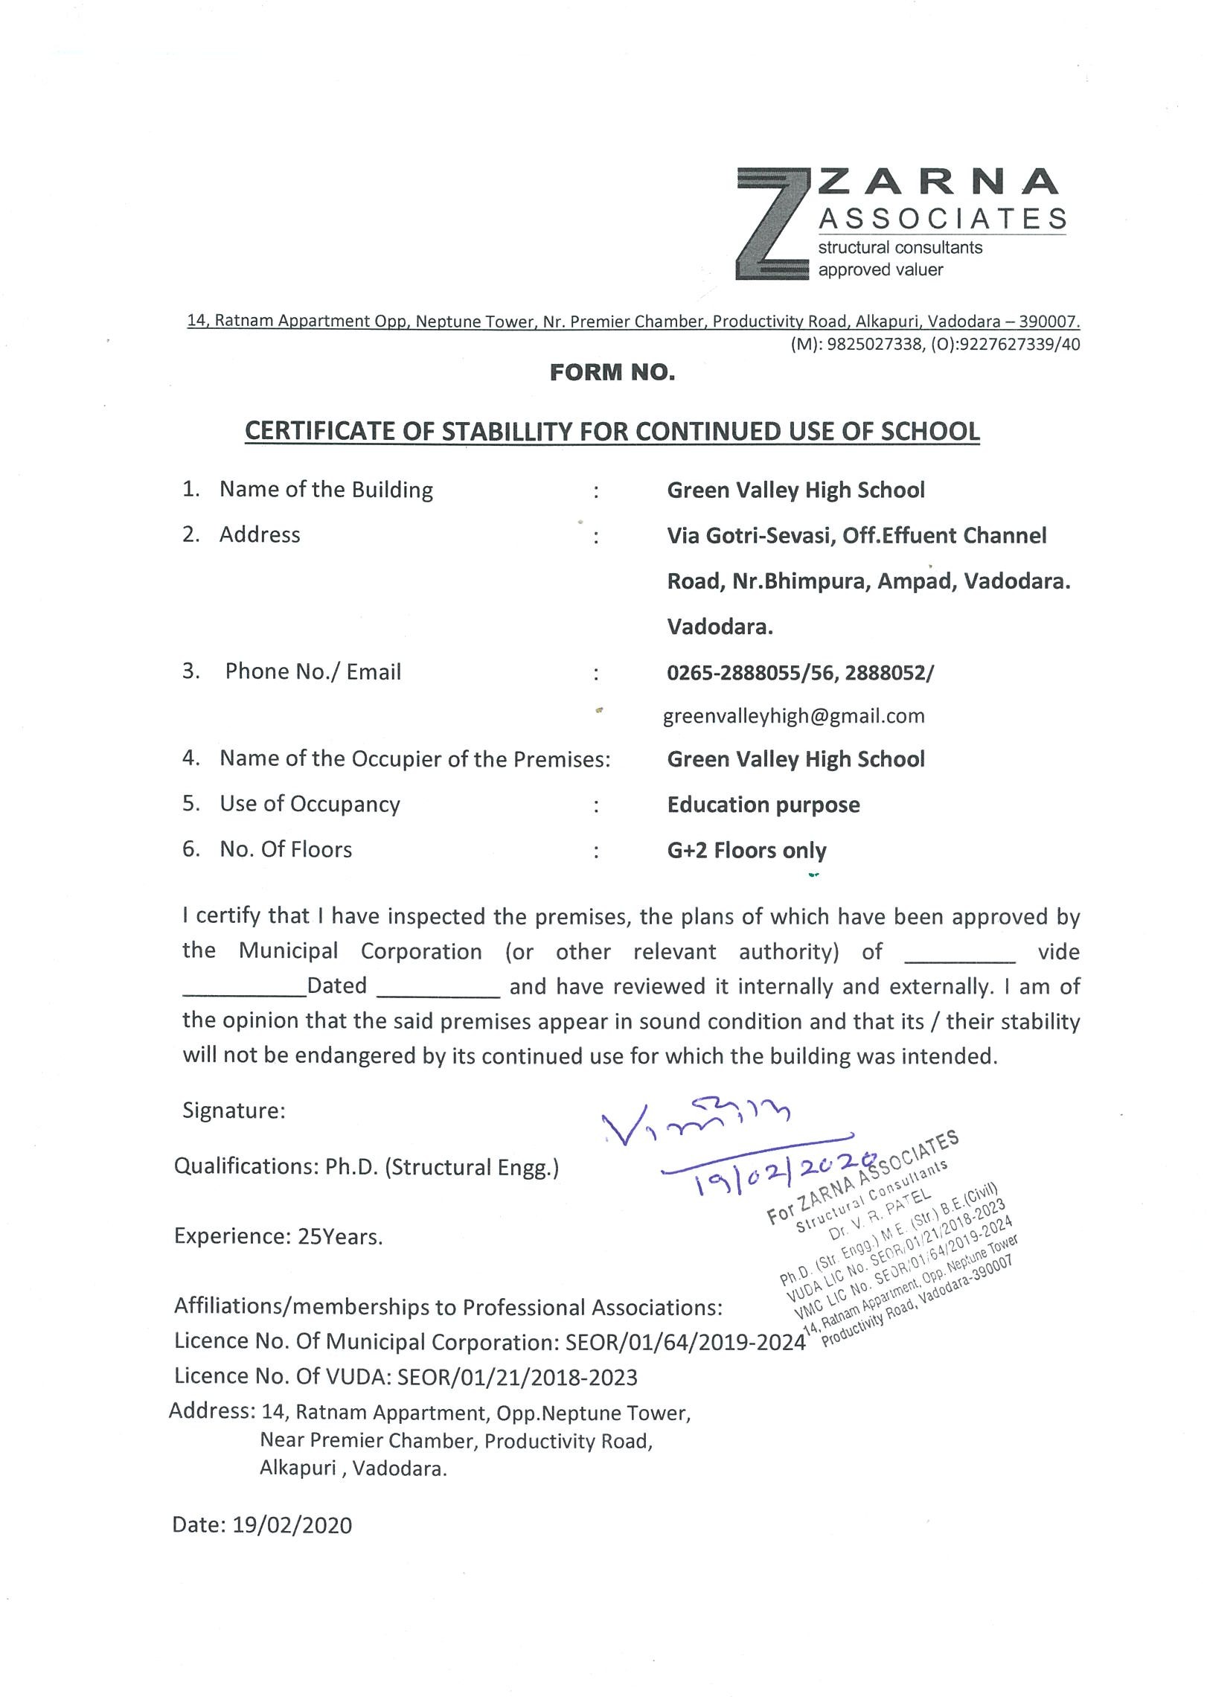

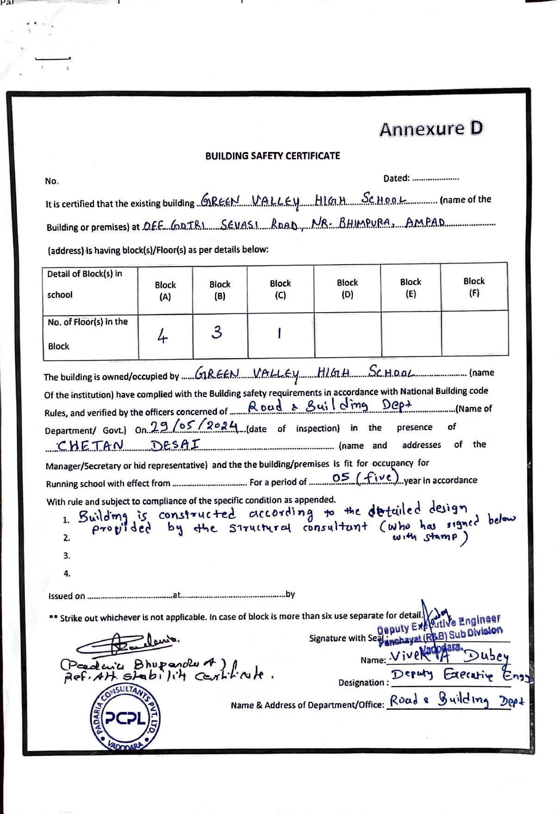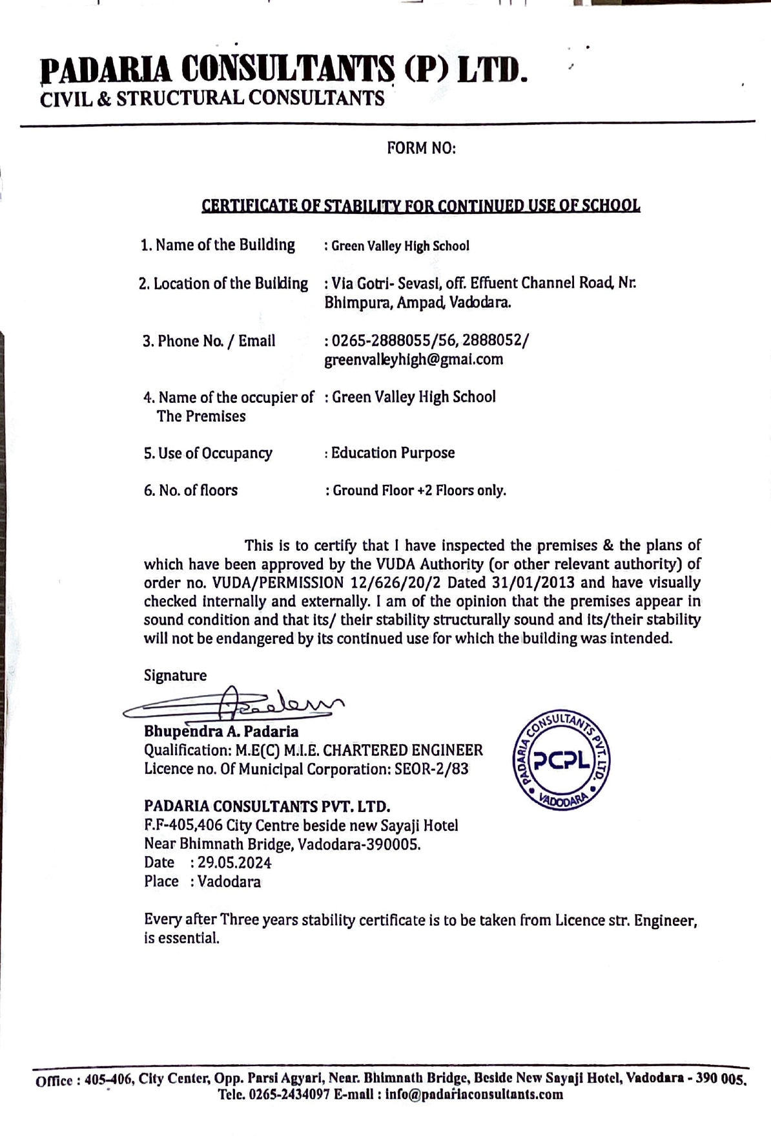
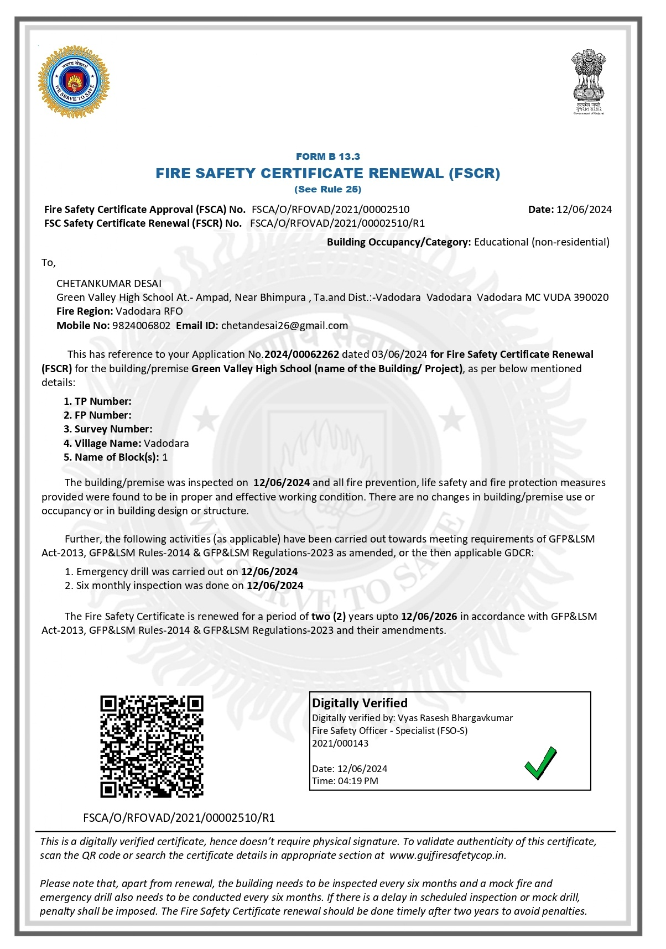
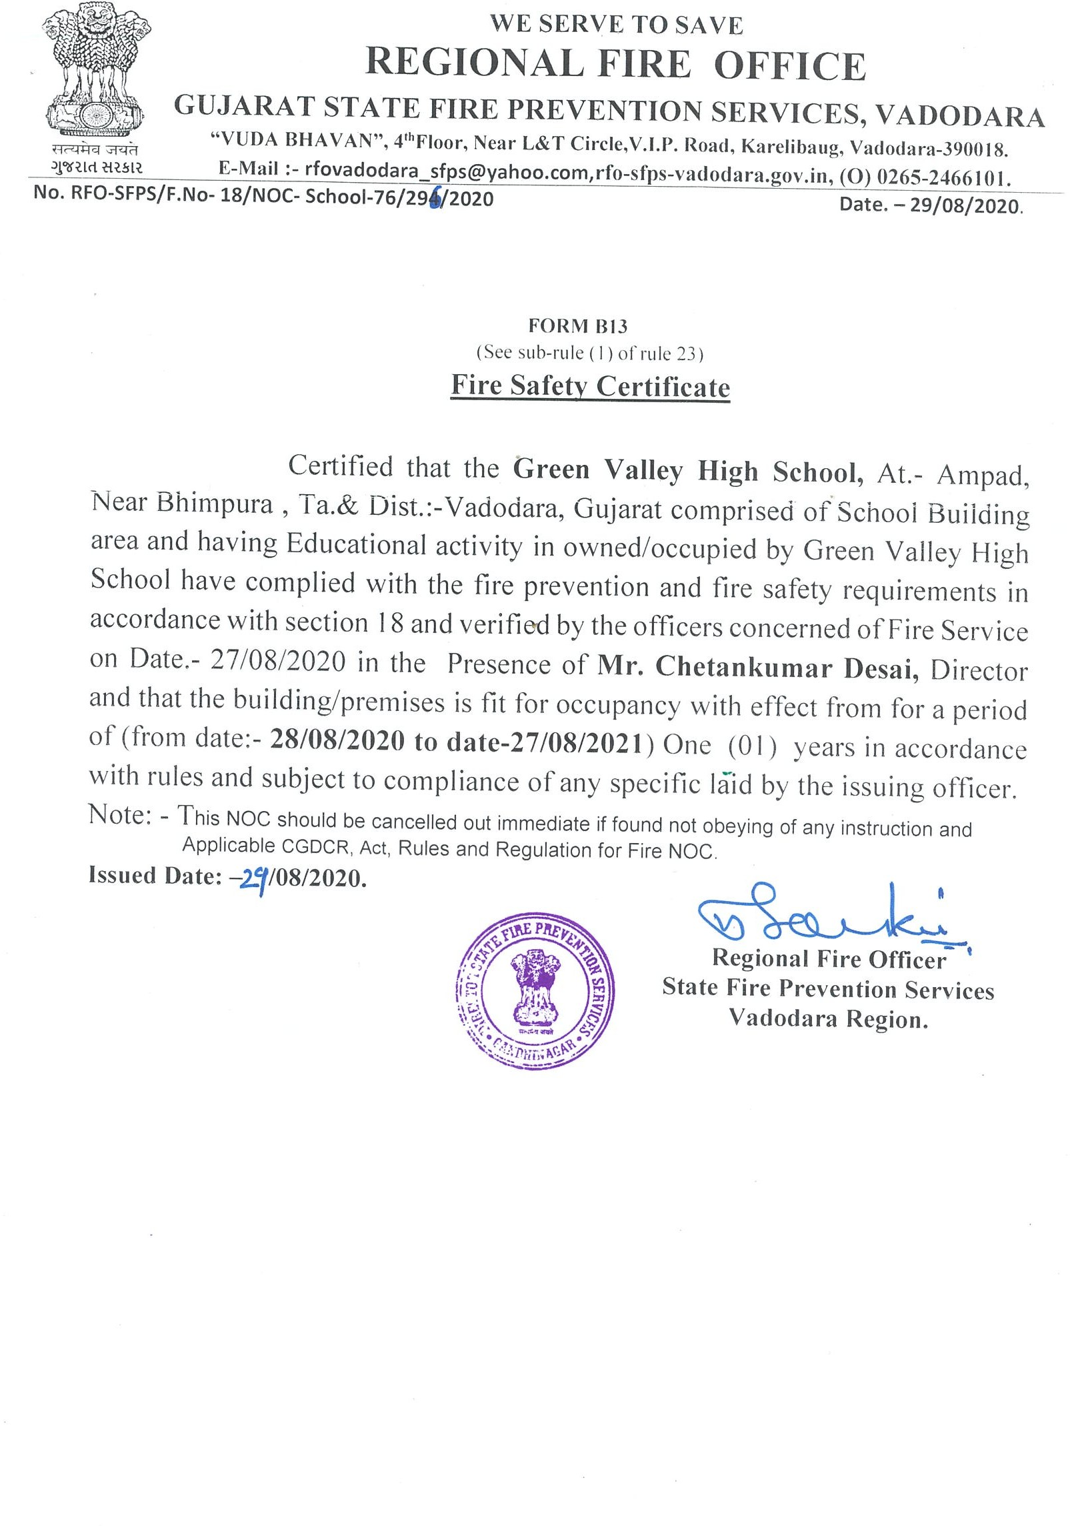

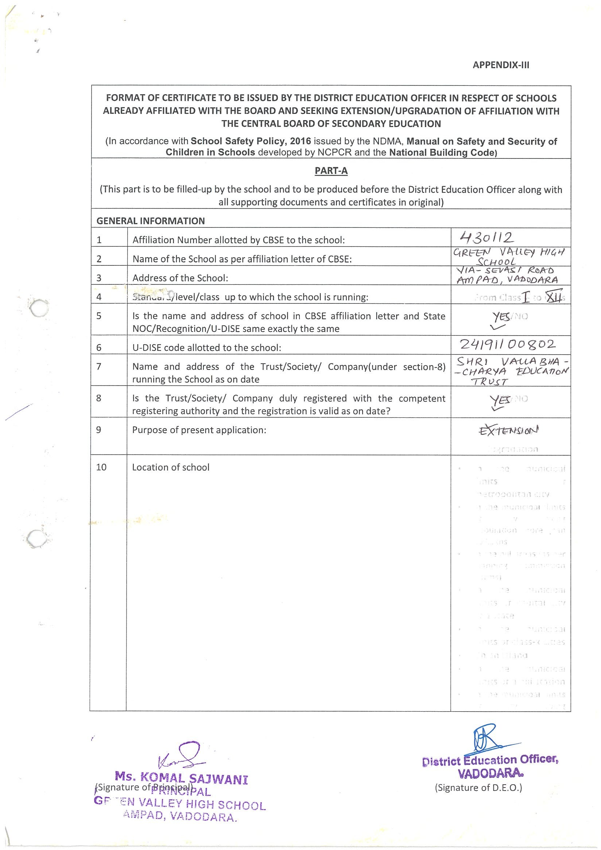

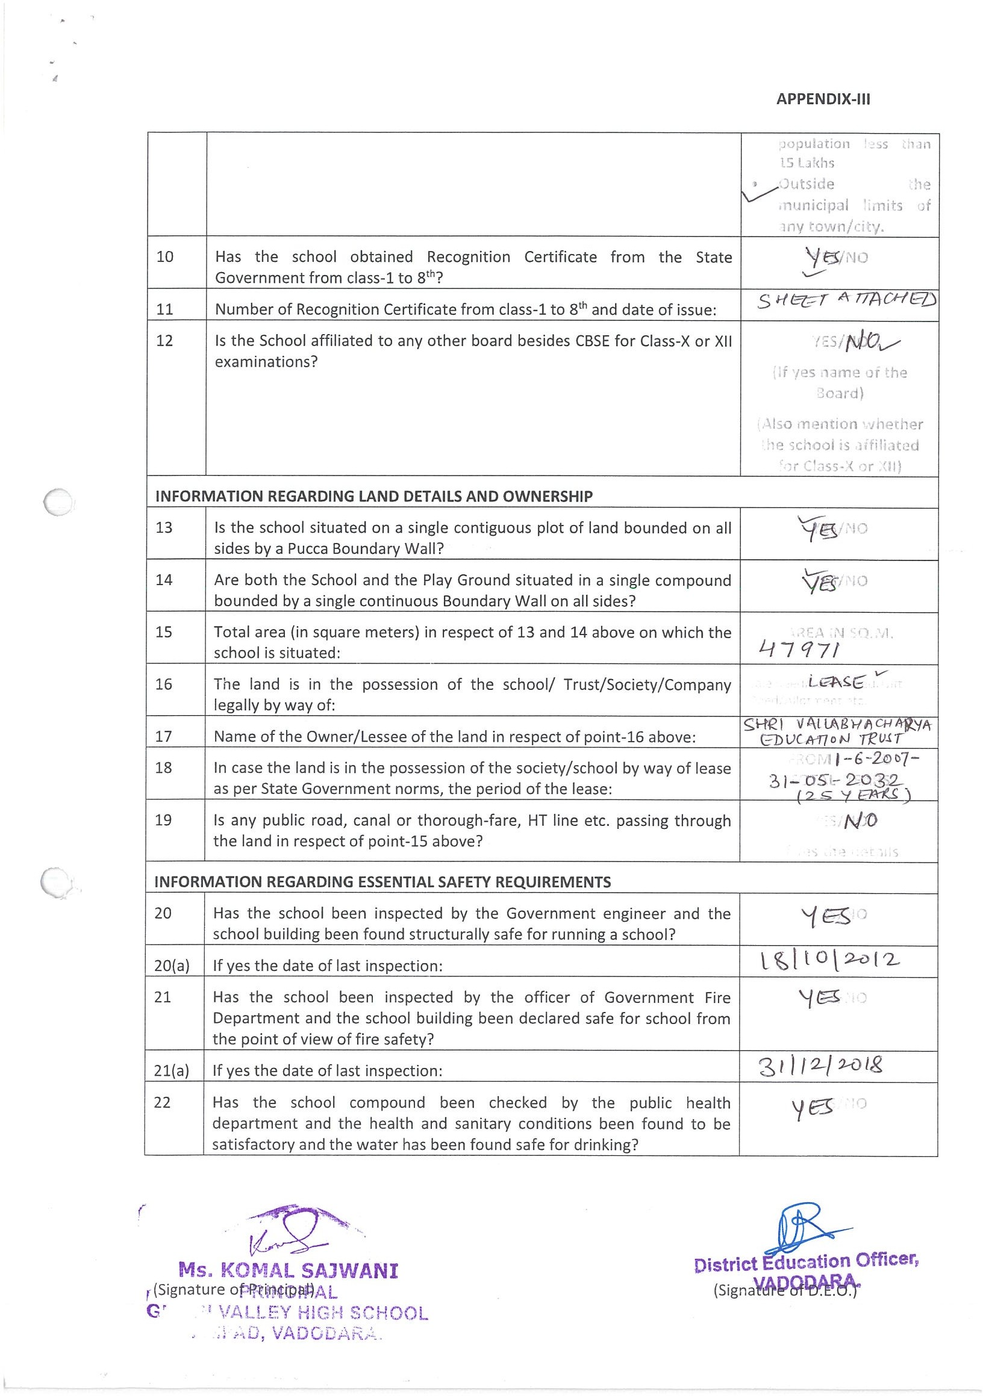

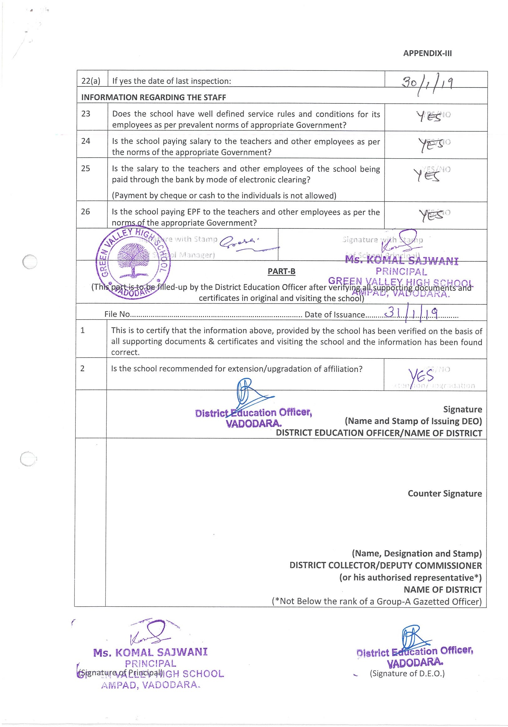

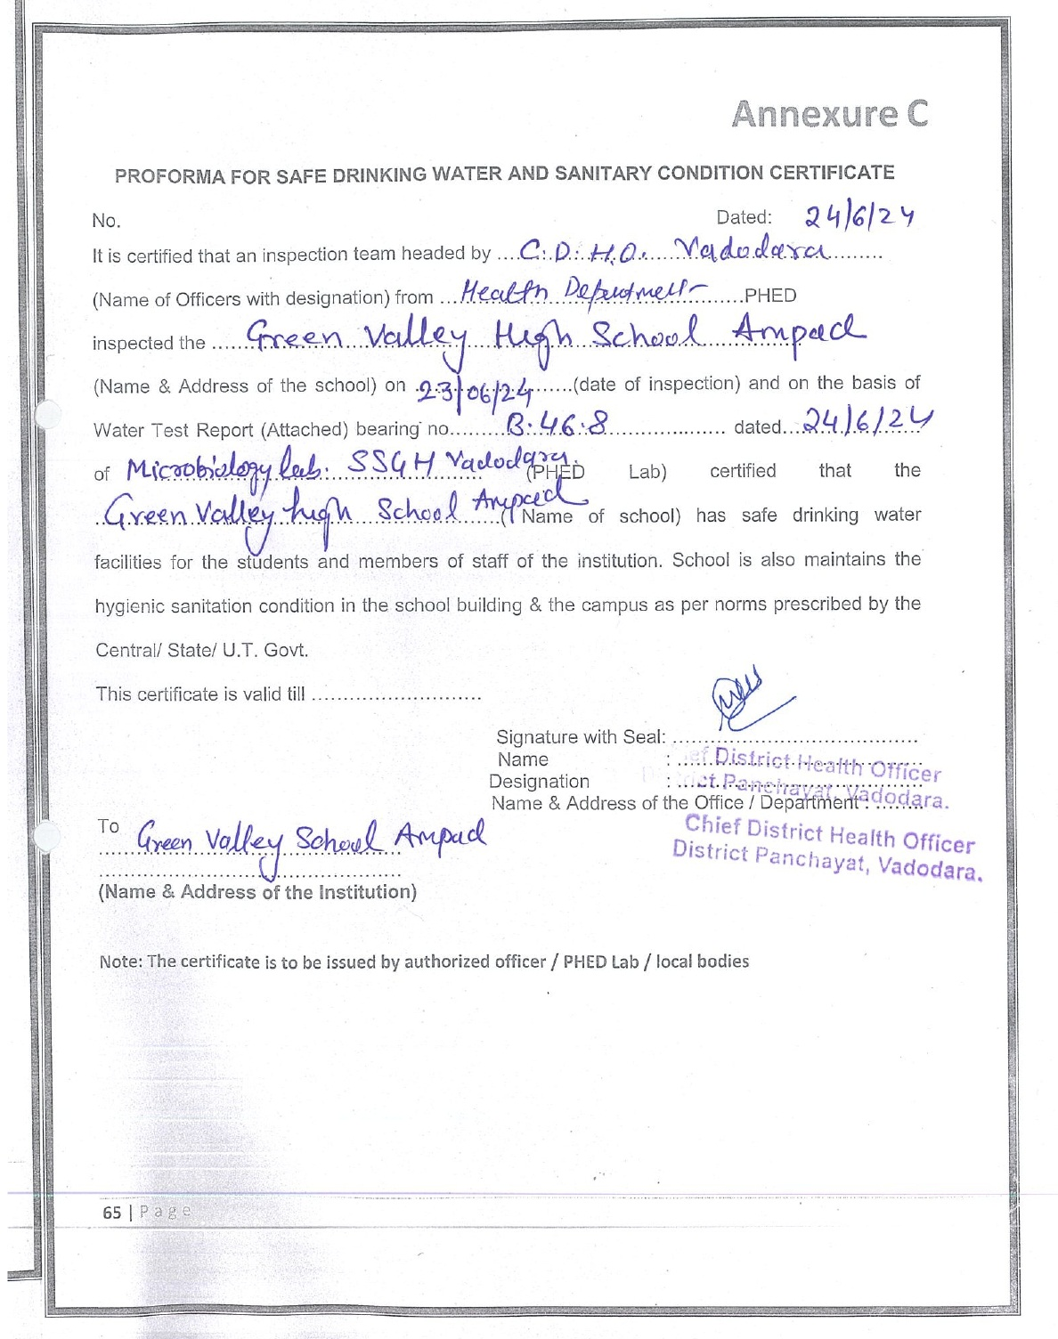

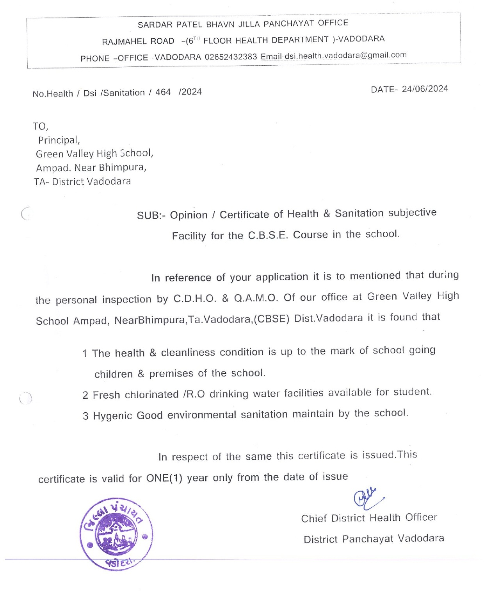
C:RESULTANDACADEMICS:

SLNO | DOCUMENTS/INFORMATION | LINKSOFUPLOADEDDOCUMENTSONYOURSCHOOL'SWEBSITE
1 | FEESTRUCTUREOFTHESCHOOL | PDF Attached --
2 | ANNUALACADEMICCALENDER | PDF Attached
3 | LISTOFSCHOOLMANAGEMENTCOMMITTEE(SMC) | PDF Attached --
4 | LISTOFPARENTSTEACHERSASSOCIATION(PTA) MEMBERS | PDF Attached --
5 | LASTTHREE-YEARRESULTOFTHEBOARDEXAMINATIONAS PER APPLICABILITY | PDF Attached

C. 1. FEESTRUCTUREOFTHESCHOOL ( 2024- 25 ) - Inserting Later

C. 2. ANNUALACADEMICCALENDER
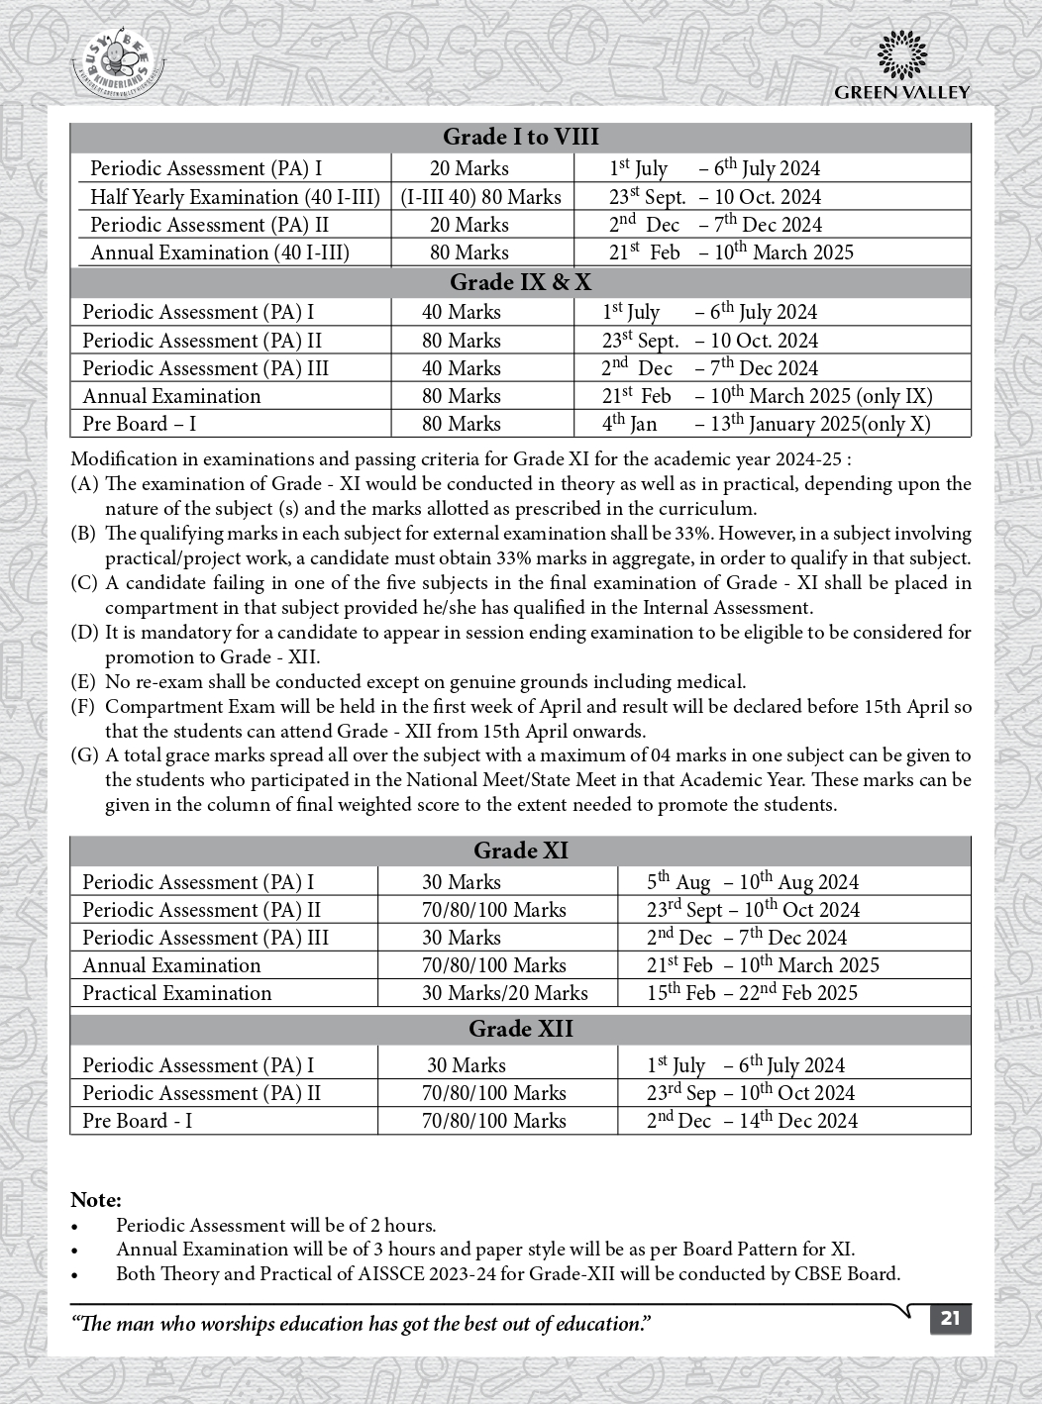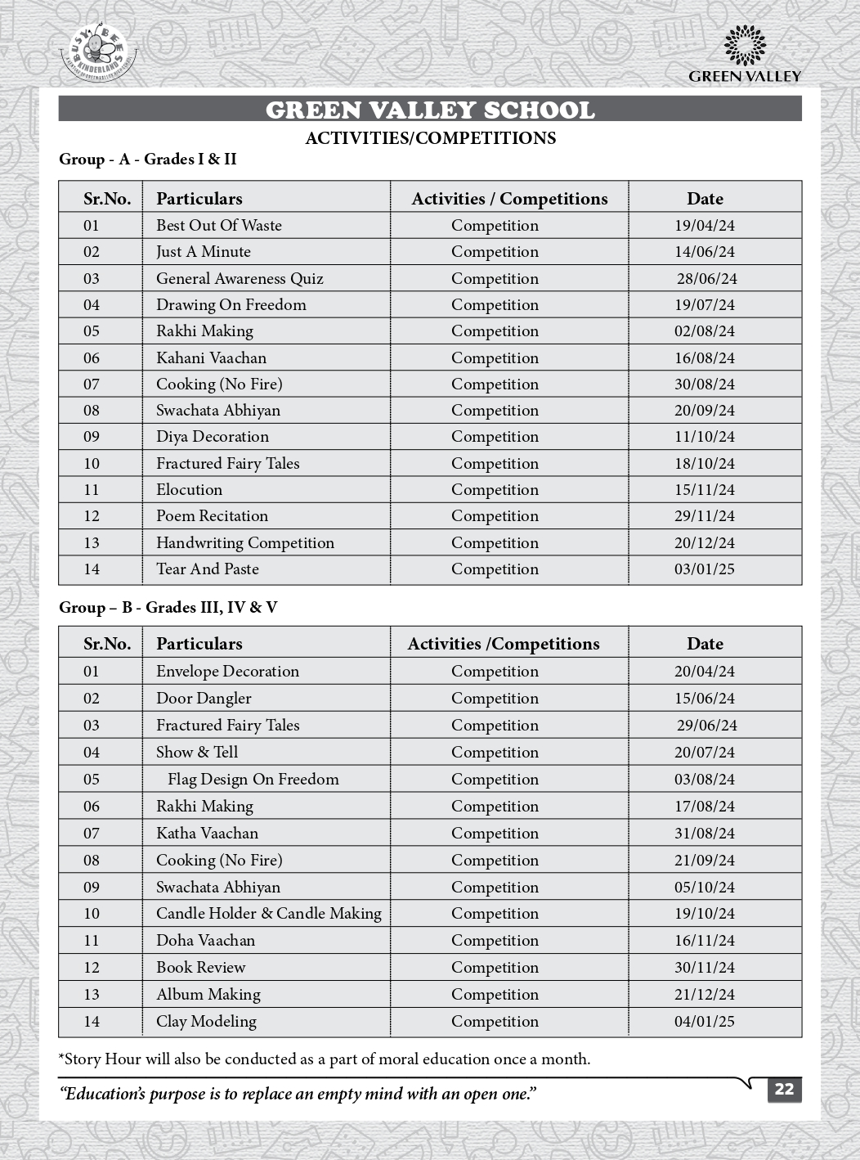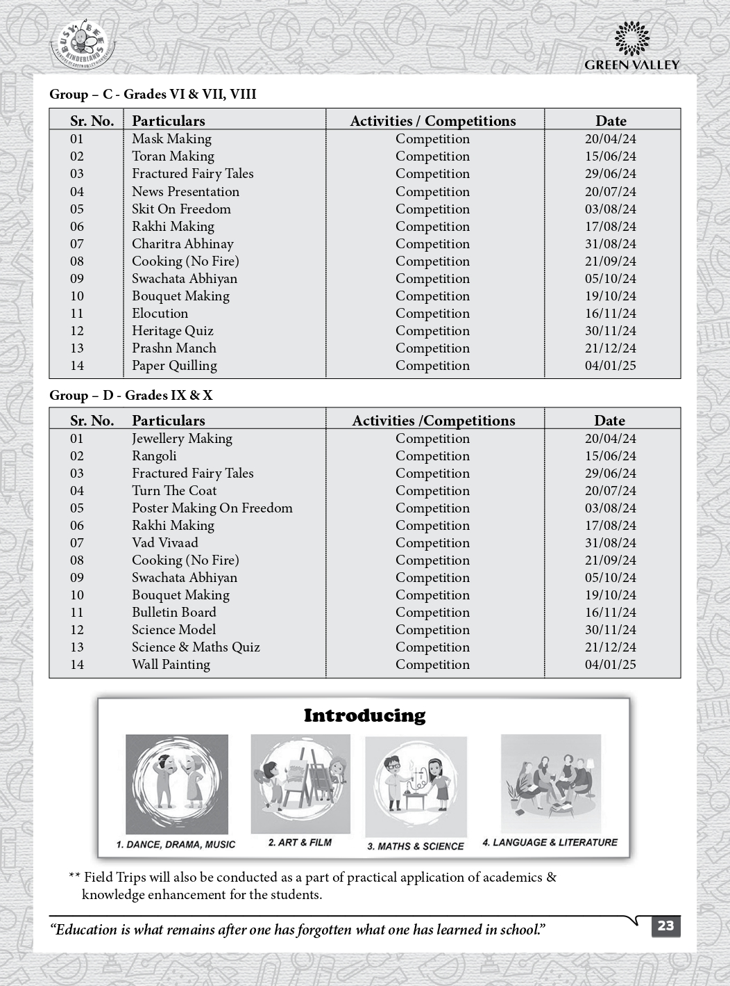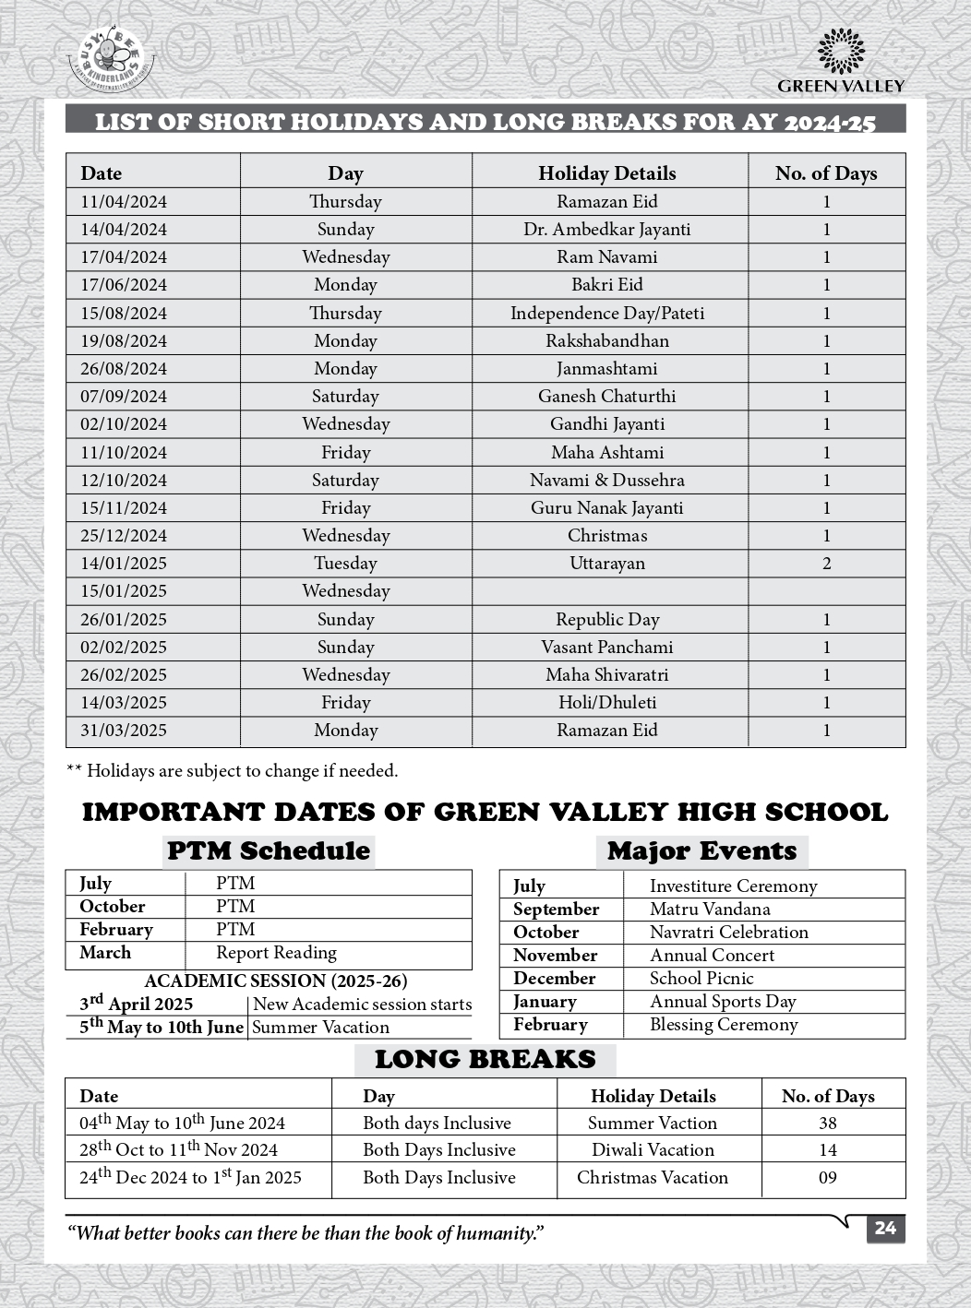

C. 3. LIST OF SCHOOL MANAGEMENT COMMITTEE (SMC)

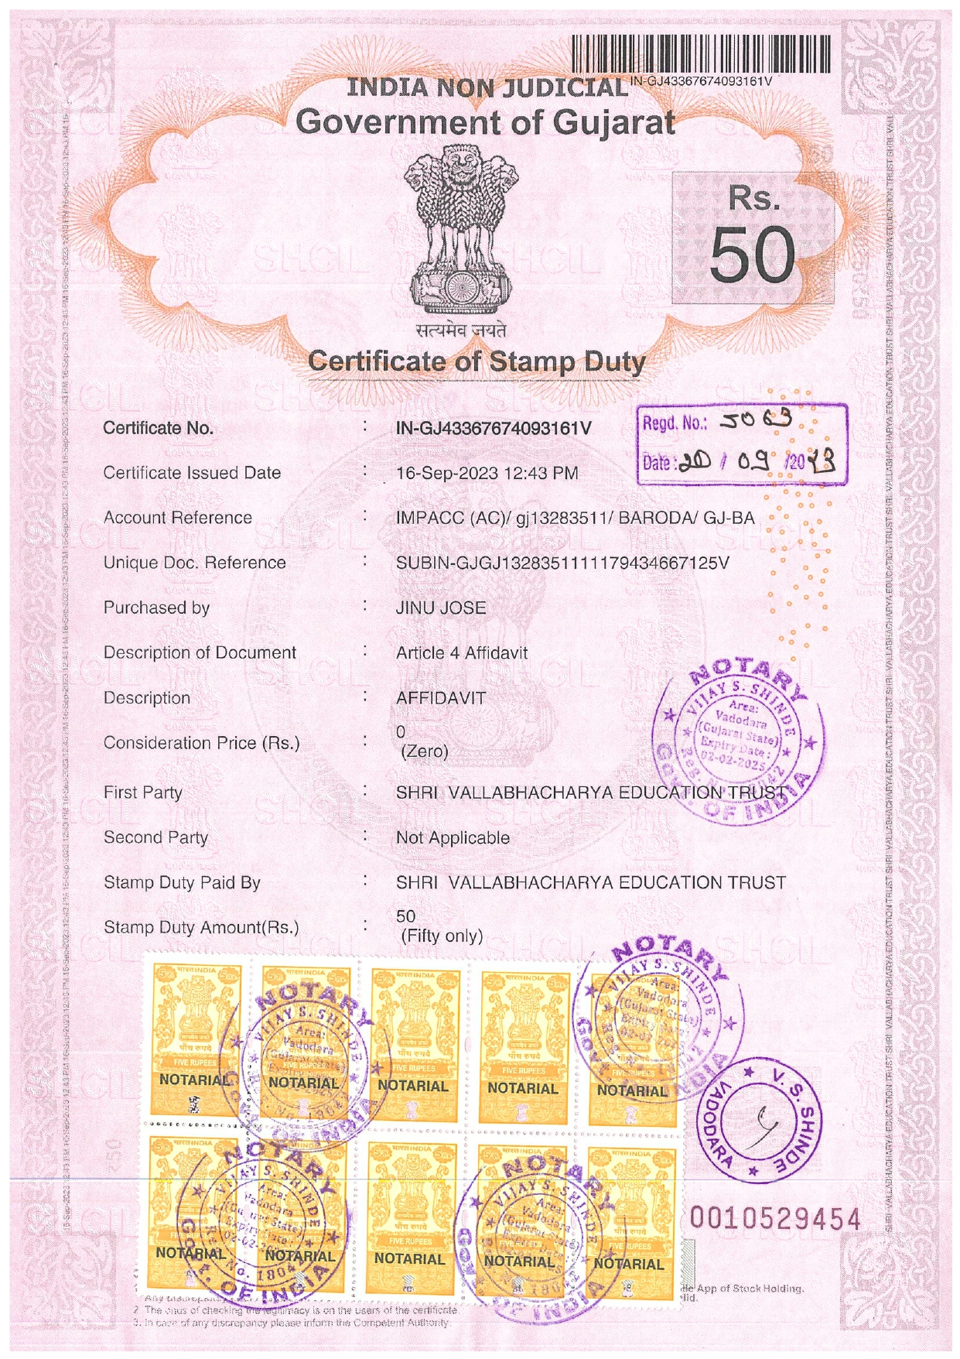

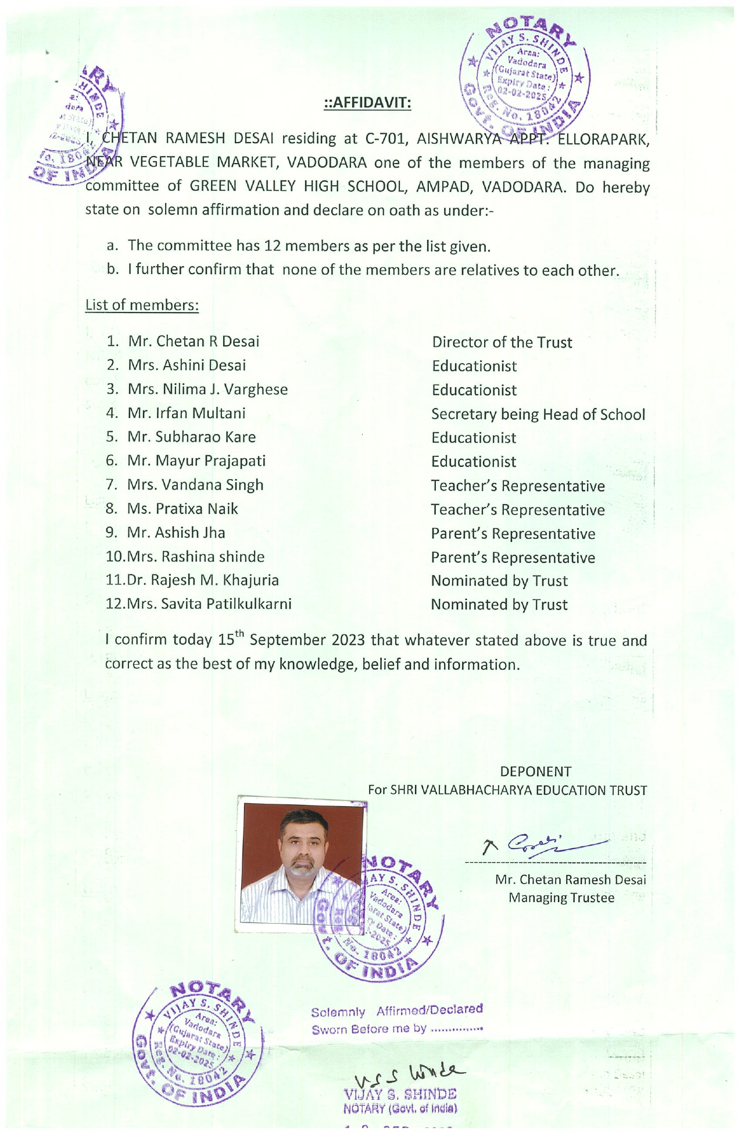

C. 4. LIST OF PARENTS TEACHERS ASSOCIATION (PTA) MEMBERS

C. 5. LAST THREE-YEAR RESULT OF THE BOARD EXAMINATION AS PER
APPLICABILITY

RESULT of CLASS: X

Sl. No. | YEAR | NO. OF REGISTERED STUDENTS | NO. OF PASSED STUDENTS | PASS PERCENTAGE | REMARKS
1. | 2020-21 | 34 | 34 | 100
2. | 2021-22 | 38 | 37 | 97.3
3. | 2022-23 | 37 | 37 | 100
4. | 2023-24 | 51 | 50 | 98.04

RESULT of CLASS XII:

Sl. No. | YEAR | NO. OF REGISTERED STUDENTS | NO. OF PASSED STUDENTS | PASS PERCENTAGE | REMARKS
1. | 2020-21 | 296 | 296 | 100
2. | 2021-22 | 320 | 316 | 98.8
3. | 2022-23 | 266 | 260 | 97.8
4. | 2023-24 | 446 | 398 | 89.24

D:STAFF(TEACHING):

SLNO | INFORMATION | DETAILS
1 | PRINCIPAL | IRFAN MULTANI
2 | TOTALNO.OFTEACHERS 49  PGT 27  TGT 14  PRT 8
3 | TEACHERS SECTIONRATIO | 1.5:1
4 | DETAILSOFSPECIALEDUCATOR | UJALAFADIA
5 | DETAILSOFCOUNSELLORANDWELLNESSTEACHER | UJALA FADIA

E:SCHOOLINFRASTRUCTURE:

SLNO | INFORMATION | DETAILS
1 | TOTALCAMPUSAREAOFTHESCHOOL(INSQMTR) | 47971
2 | NO. AND SIZE OF THE CLASS ROOMS (IN SQMTR) | 37 & 56
3 | NO.ANDSIZEOFLABORATORIESINCLUDINGCOMPUTERLABS (IN SQ MTR) | 2 & 75
4 | INTERNETFACILITY | YES
5 | NO.OFGIRLSTOILETS | 24
6 | NO.OFBOYSTOILETS | 48
7 | LINKOFYOUTUBEVIDEOOFTHE  INSPECTIONOFSCHOOLCOVERINGTHEINFRASTRUCTURE OFTHE SCHOOL | Green Valley High School : CBSE Inspection 2020 - YouTube  Or  In youtube, in search option type  “green valley inspection” .

