APPENDIX -IX

MANDATORY PUBLIC DISCLOSURE
A : GENERAL INFORMATION :

SL NO. | INFORMATION | DETAILS
1 | NAME OF THE SCHOOL | GREEN VALLEY HIGH SCHOOL
2 | AFFILIATION NO.(IF APPLICABLE) | 430112
3 | SCHOOL CODE (IF APPLICABLE) | 10098
4 | COMPLETE ADDRESS WITH PIN CODE | Via Sevasi Gotri, Off Effluent Channel road,  Ampad, Vadodara, Gujarat, VADODARA (BARODA) , GUJARAT - 391101
5 | PRINCIPAL NAME | IRFAN KASAM MULTANI
6 | PRINCIPAL QUALIFICATION | M.A, B.ED.
7 | SCHOOL EMAIL ID | greenvalleyhigh@gmail.com
8 | CONTACT DETAILS (LANDLINE/MOBILE) | 09409289929

B : DOCUMENTS AND INFORMATION:

SL NO. | DOCUMENTS/INFORMATION | LINKS OF UPLOADED DOCUMENTS ON YOUR SCHOOL'S WEBSITE
1 | COPIES OF AFFILIATION/UPGRADATION LETTER AND RECENT EXTENSION OF AFFILIATION, IF ANY | PDF Attached
2 | COPIES OF SOCIETIES/TRUST/COMPANY  REGISTRATION/RENEWAL CERTIFICATE, AS APPLICABLE | PDF Attached
3 | COPY OF NO OBJECTION CERTIFICATE (NOC) ISSUED, IF APPLICABLE, BY THE STATE GOVT./UT | PDF Attached
4 | COPIES OF RECOGNITION CERTIFICATE UNDER RTE ACT, 2009, AND IT’S RENEWAL IF APPLICABLE | PDF Attached
5 | COPY OF VALID BUILDING SAFETY  CERTIFICATE AS PER THE NATIONAL BUILDING CODE | PDF Attached
6 | COPY OF VALID FIRE SAFETY CERTIFICATE ISSUED BY THE COMPETENT AUTHORITY | PDF Attached
7 | COPY OF THE SELF CERTIFICATION SUBMITTED BY THE SCHOOL FOR  AFFILIATION/UPGRADATION/EXTENSION OF AFFILIATION | PDF Attached
8 | COPIES OF VALID WATER, HEALTH AND SANITATION CERTIFICATES | PDF Attached --
NOTE:

THE SCHOOLS NEEDS TO UPLOAD THE SELF ATTESTED COPIES OF ABOVE LISTED DOCUMETNS BY CHAIRMAN/MANAGER/SECRETARY AND PRINCIPAL. IN CASE, IT IS NOTICED AT LATER STAGE THAT UPLOADED DOCUMENTS ARE NOT GENUINE THEN SCHOOL SHALL BE LIABLE FOR ACTION AS PER NORMS.

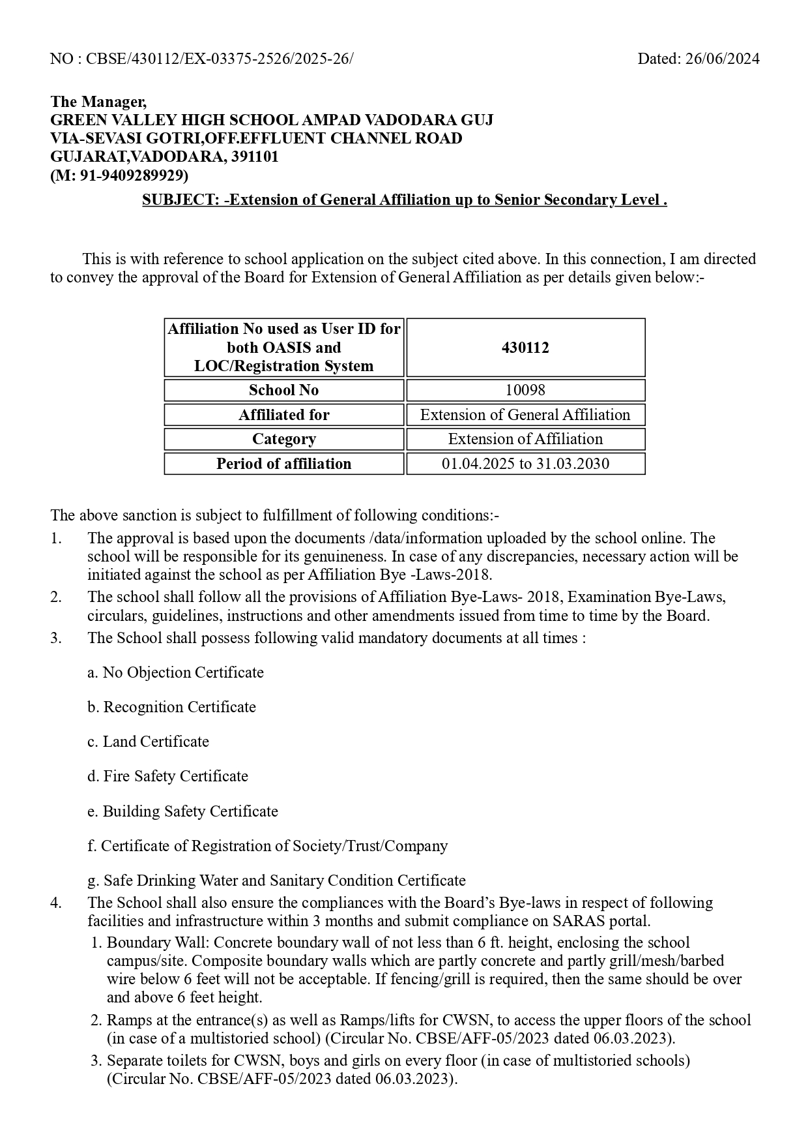
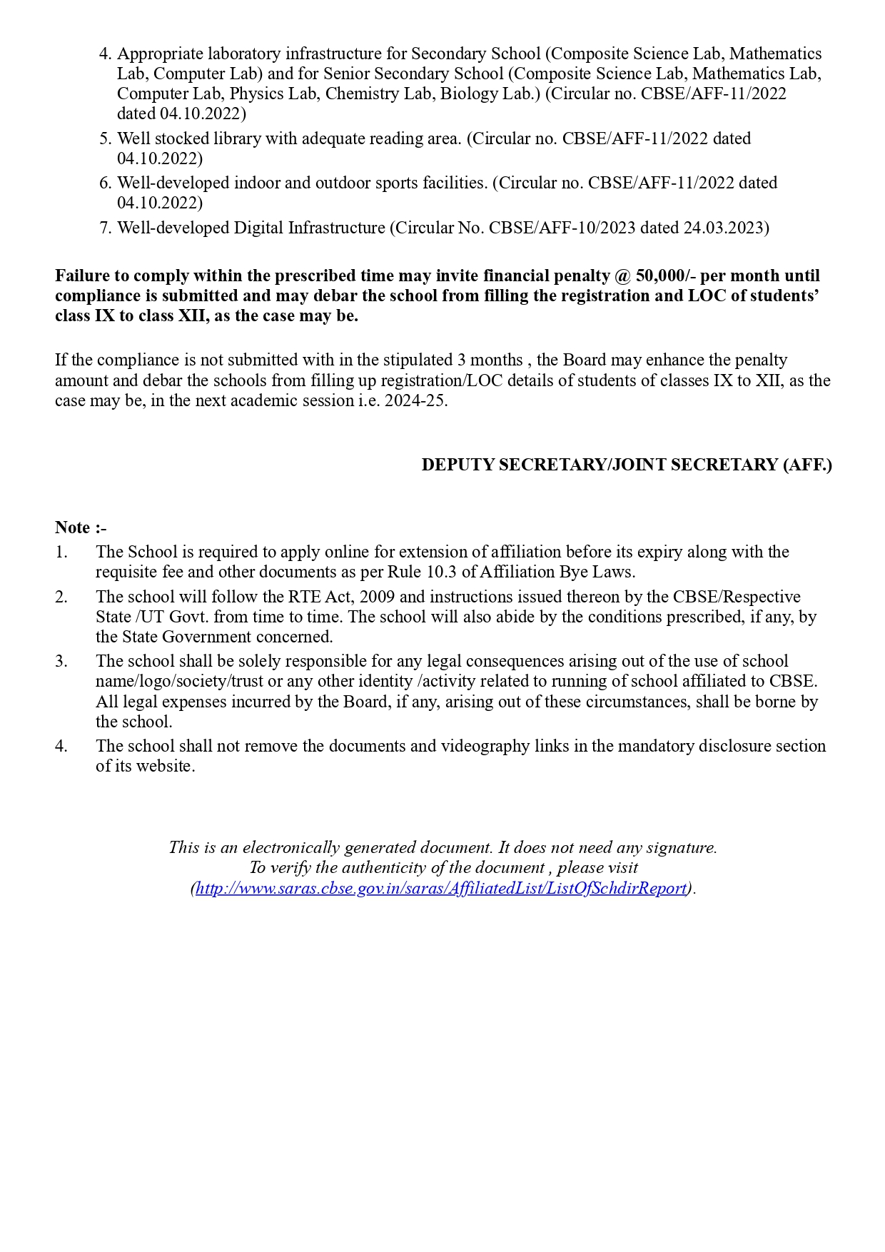
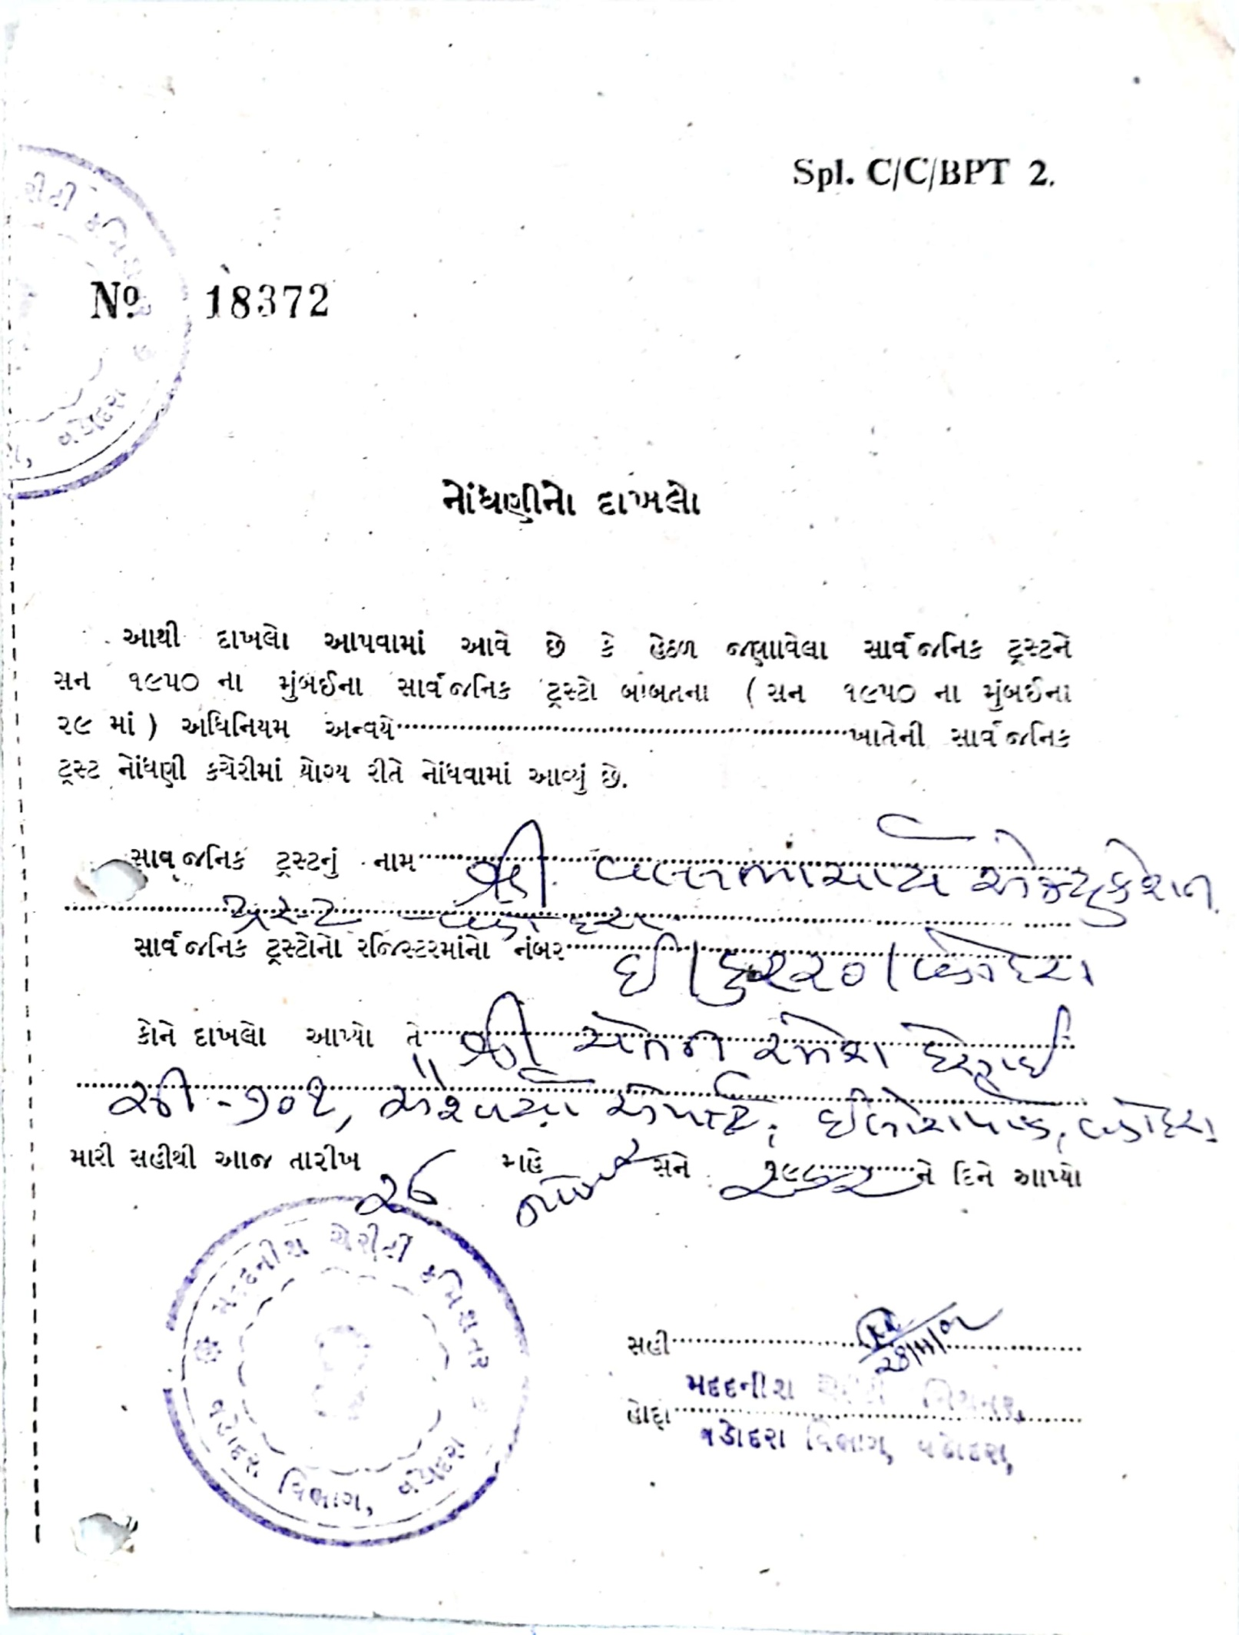

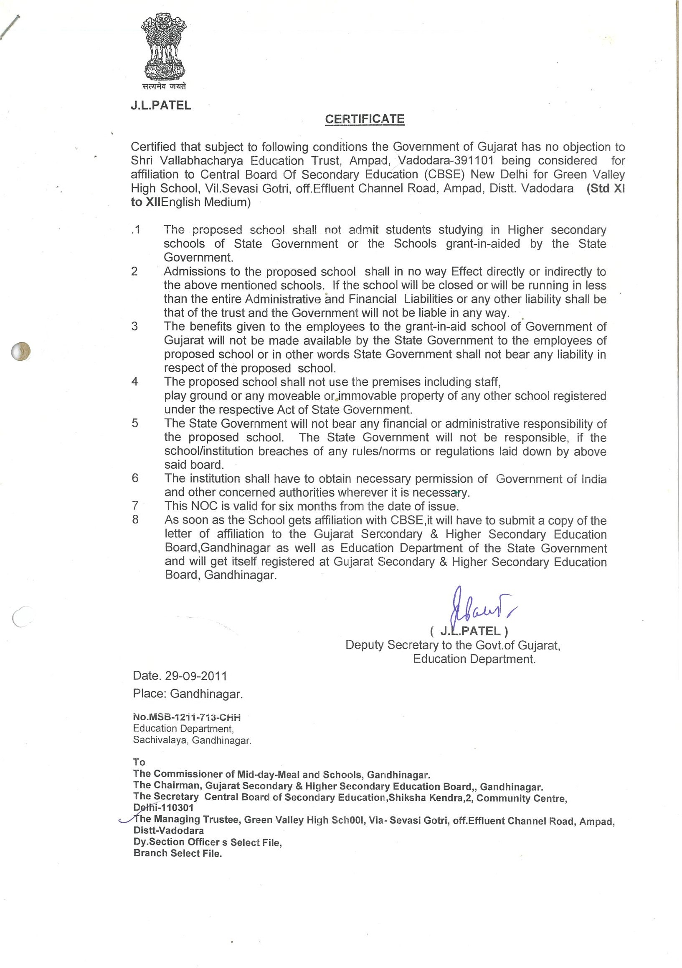

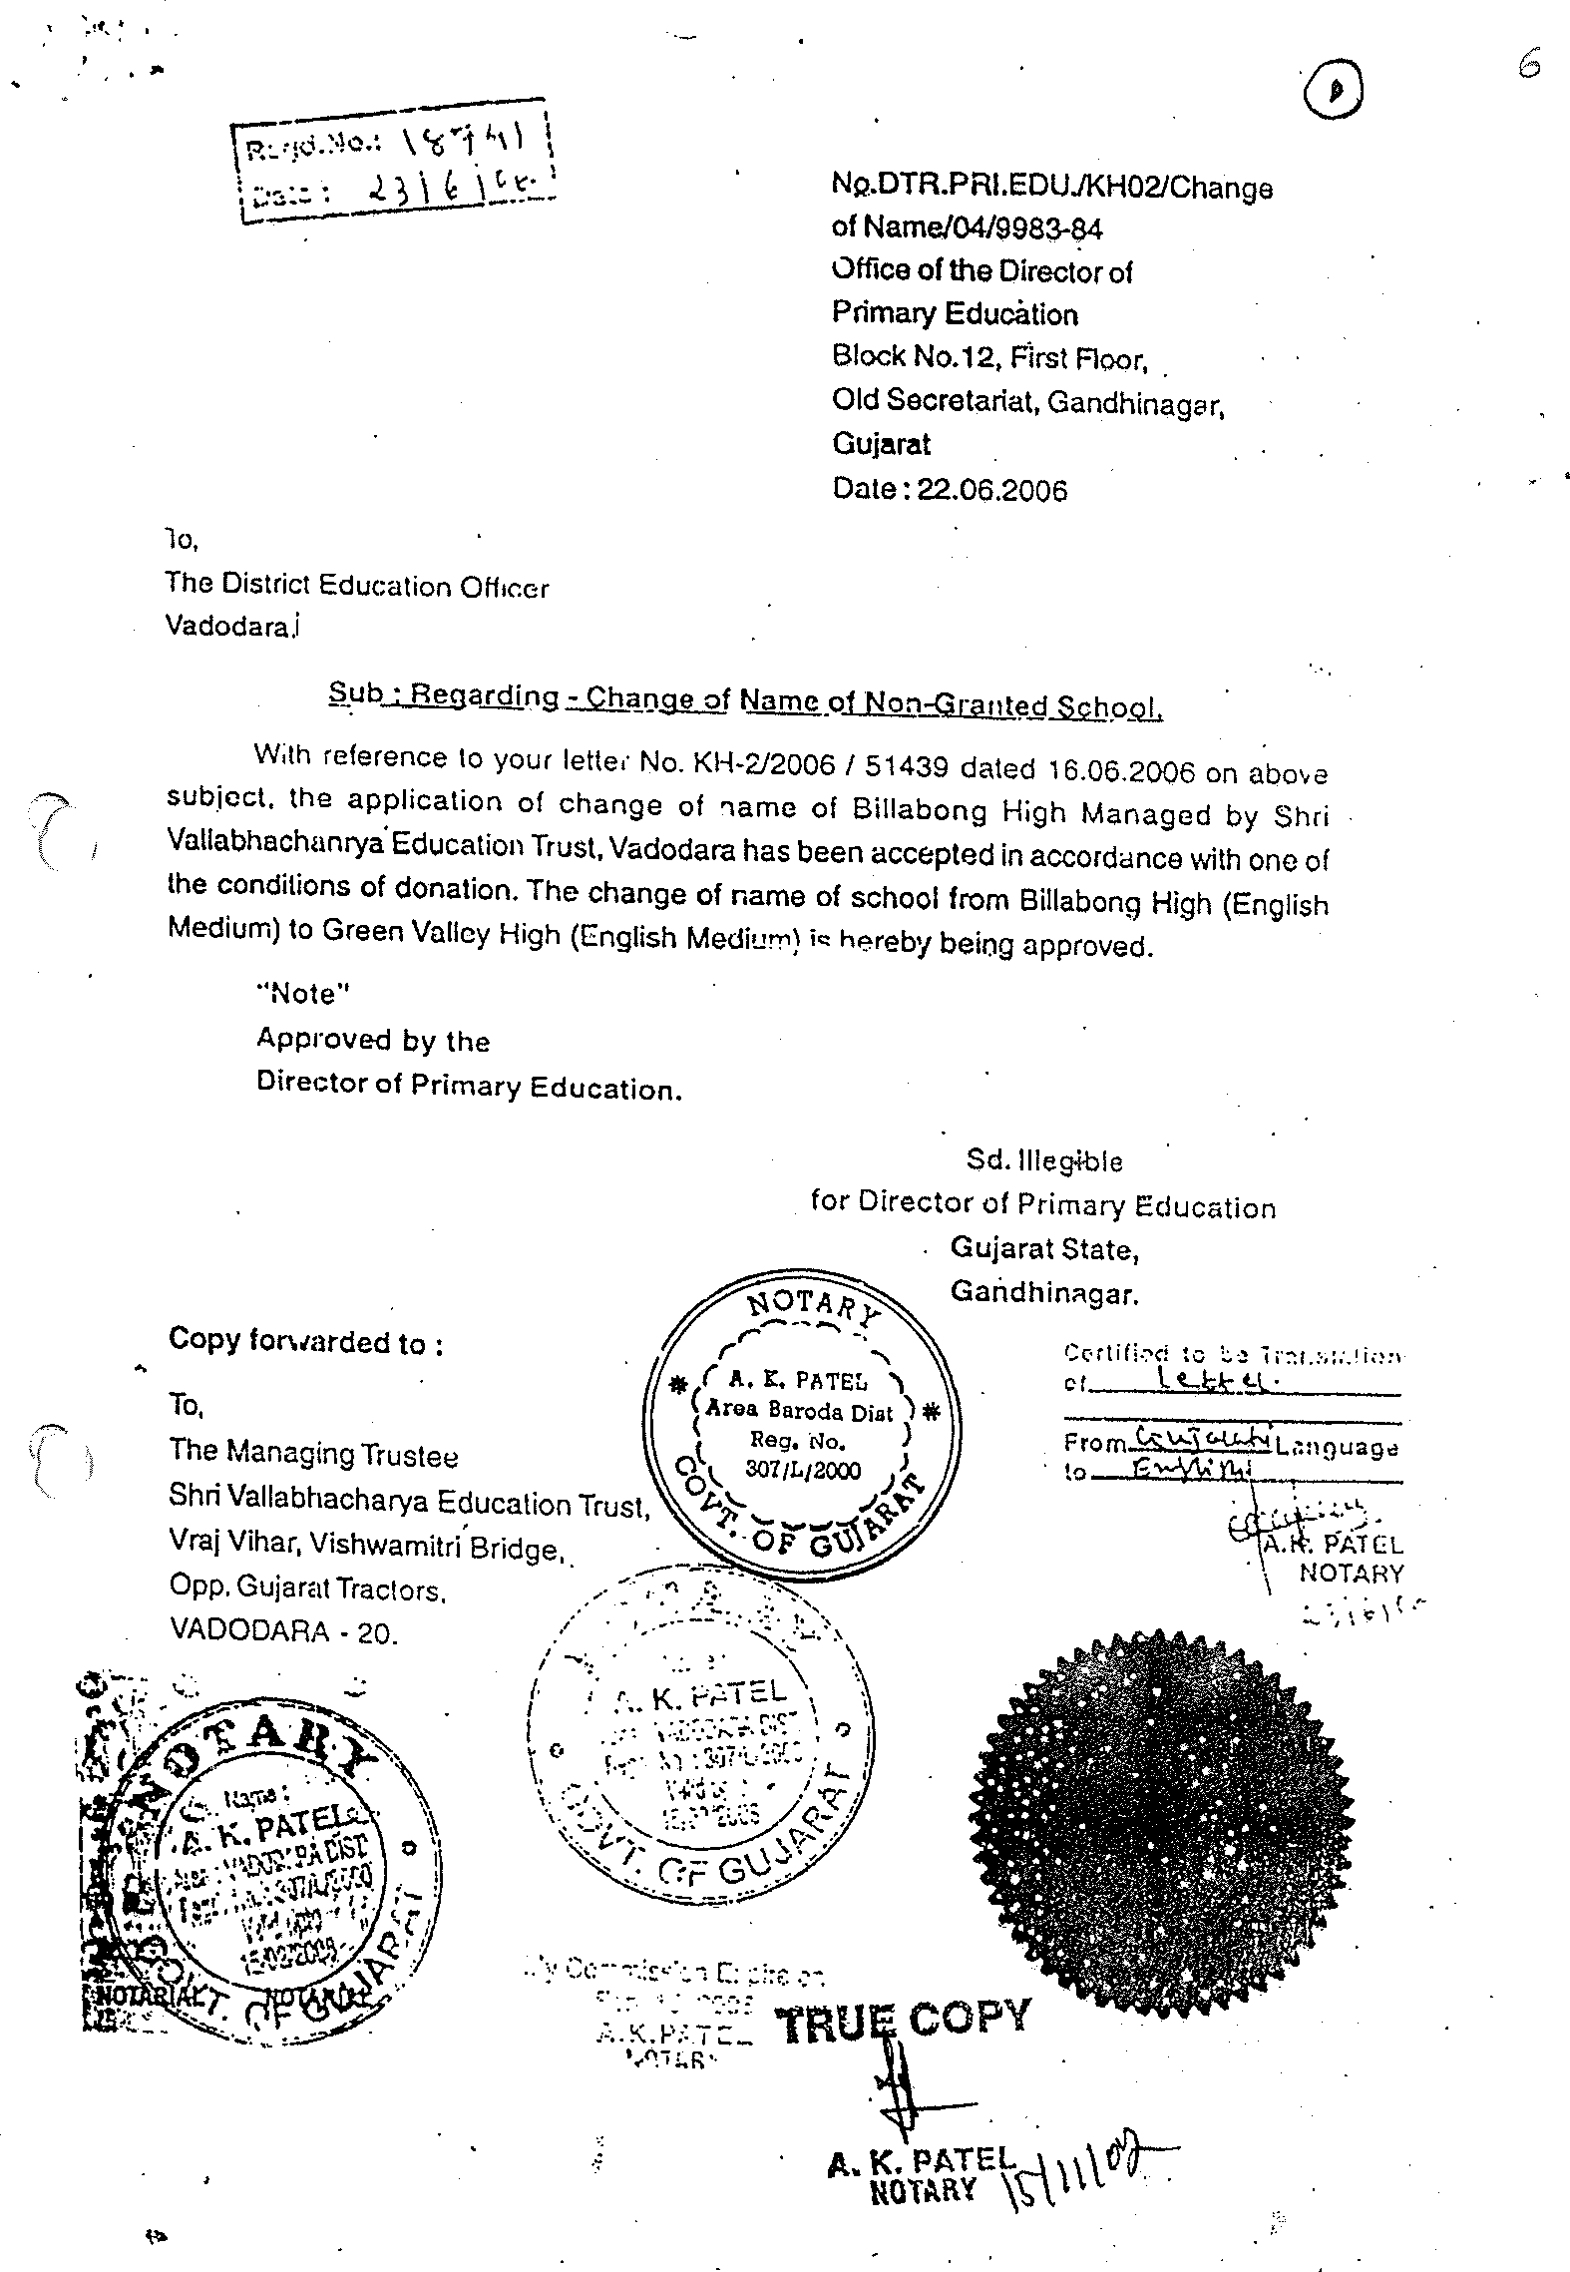

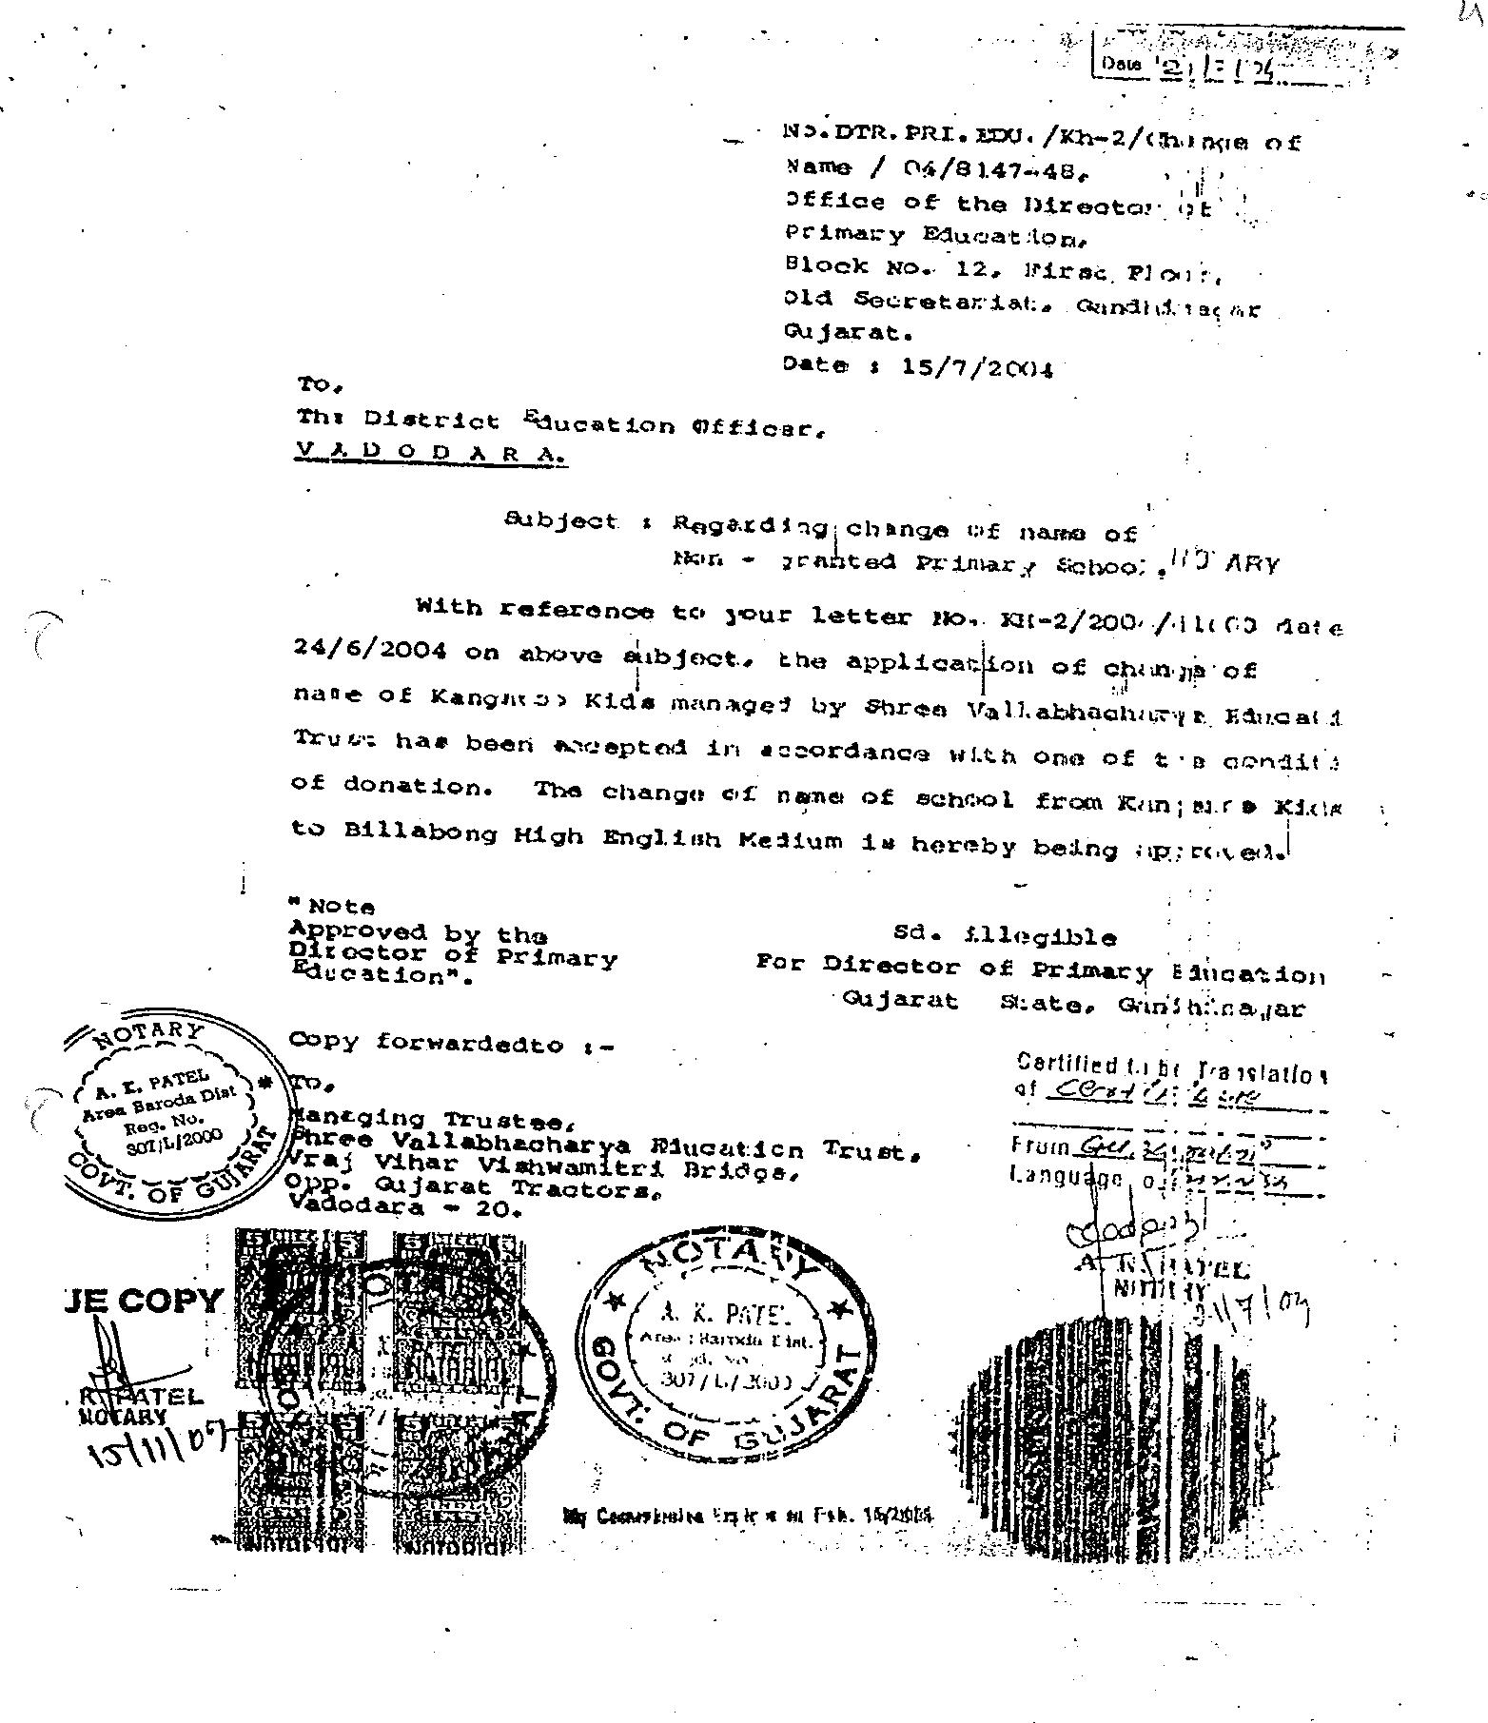

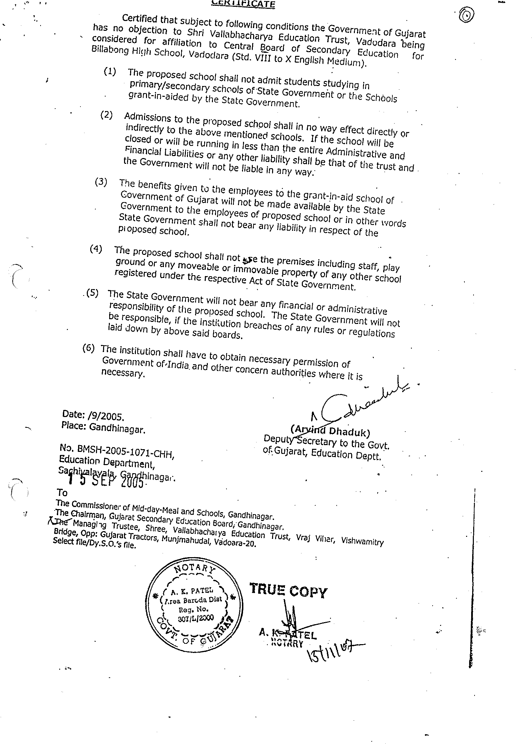

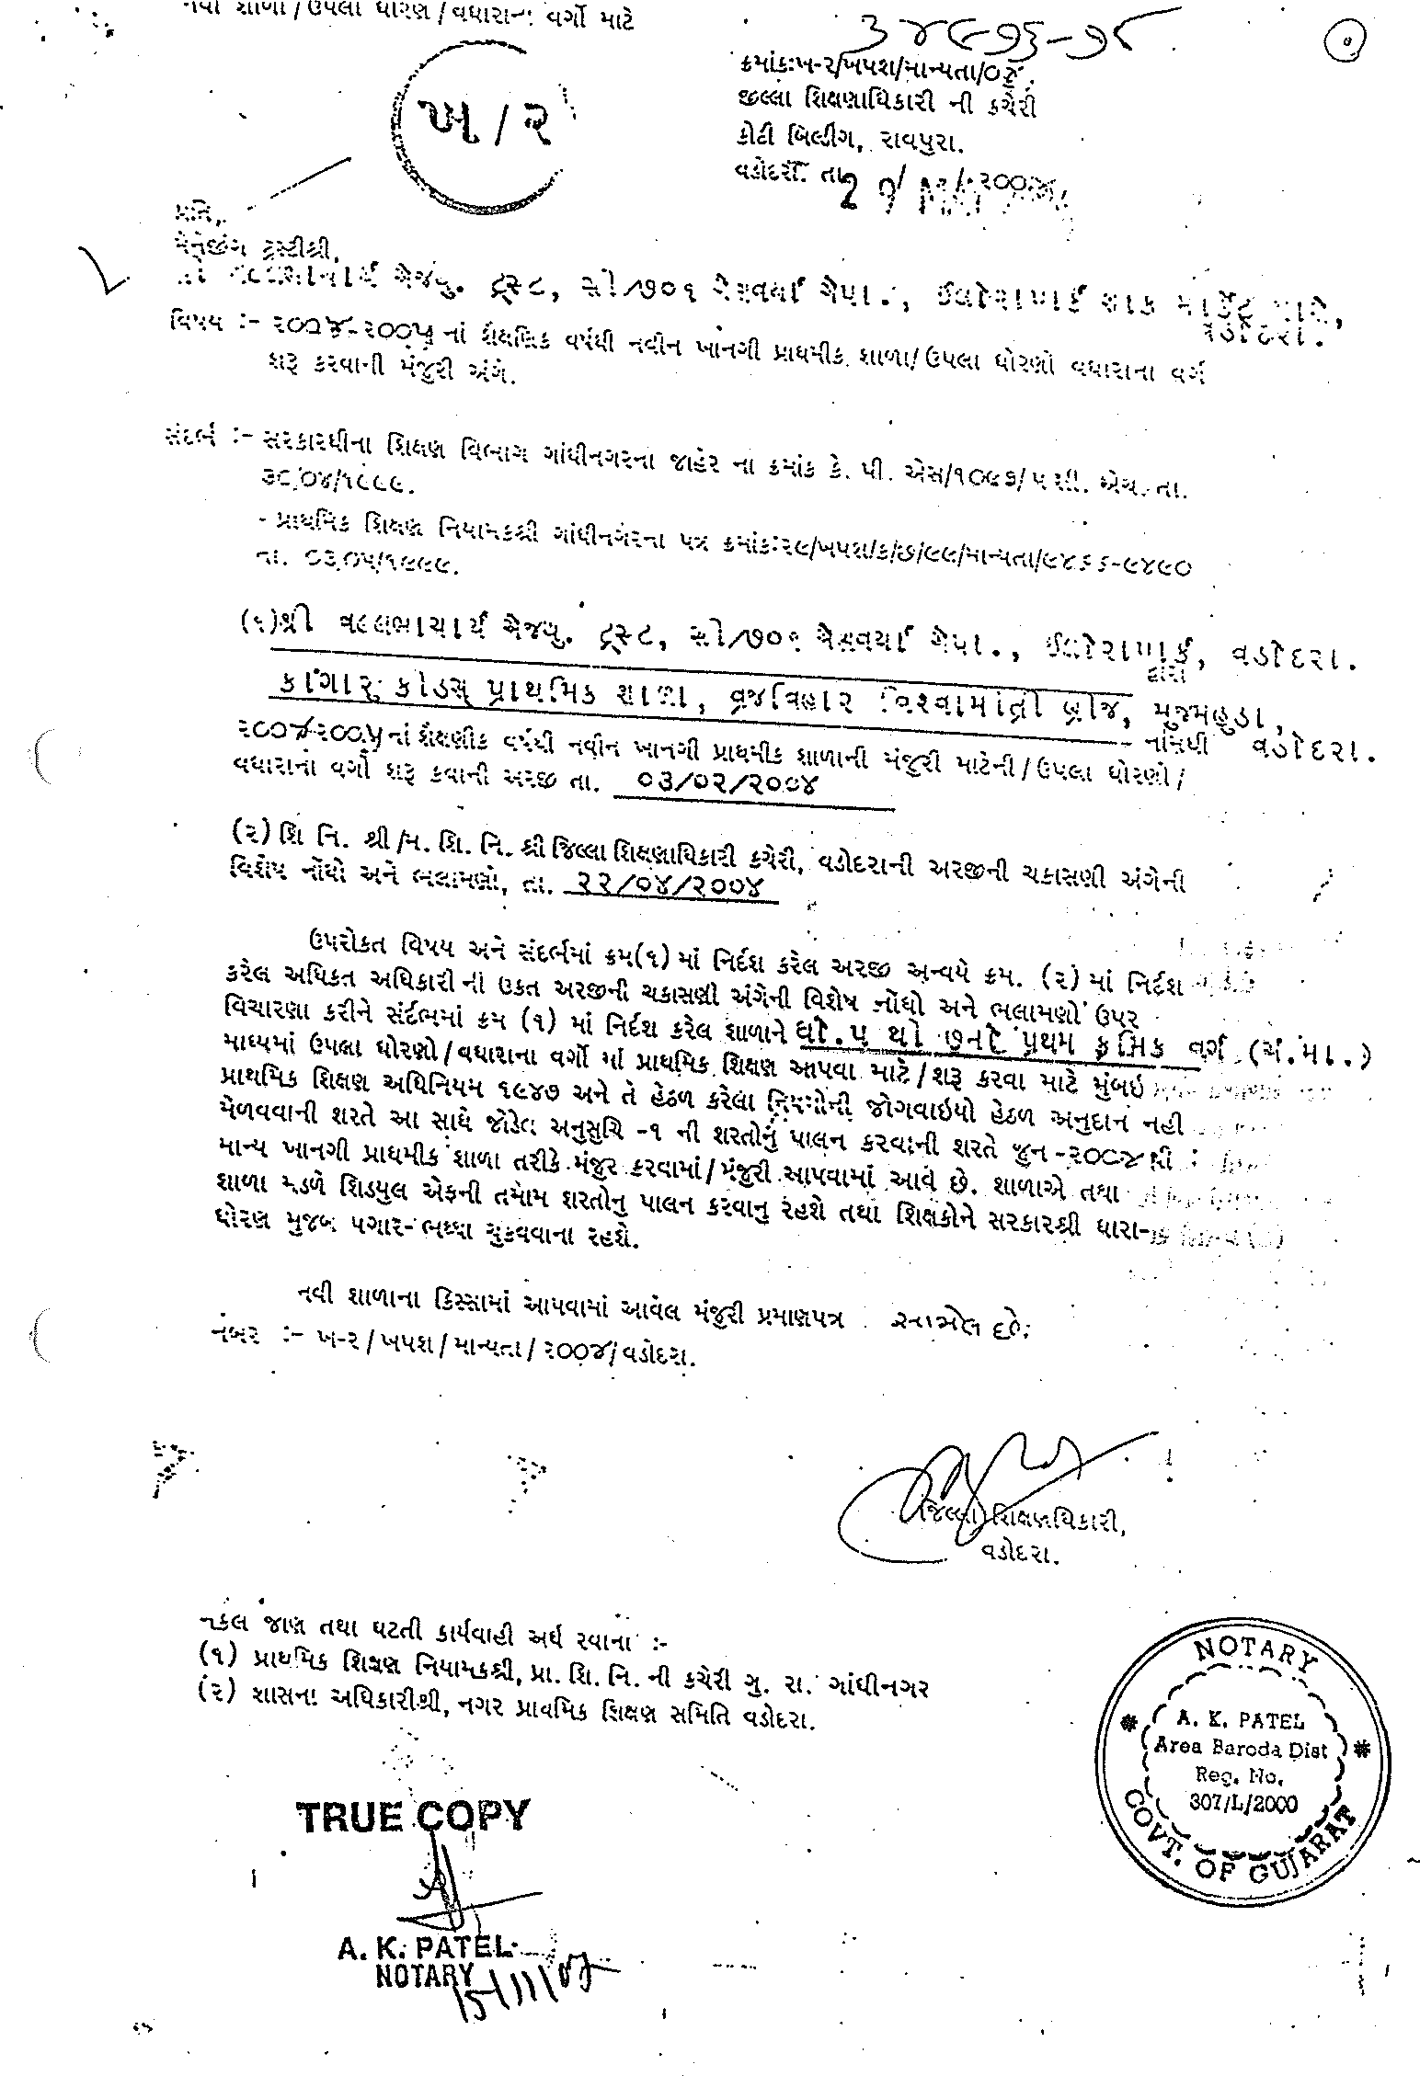
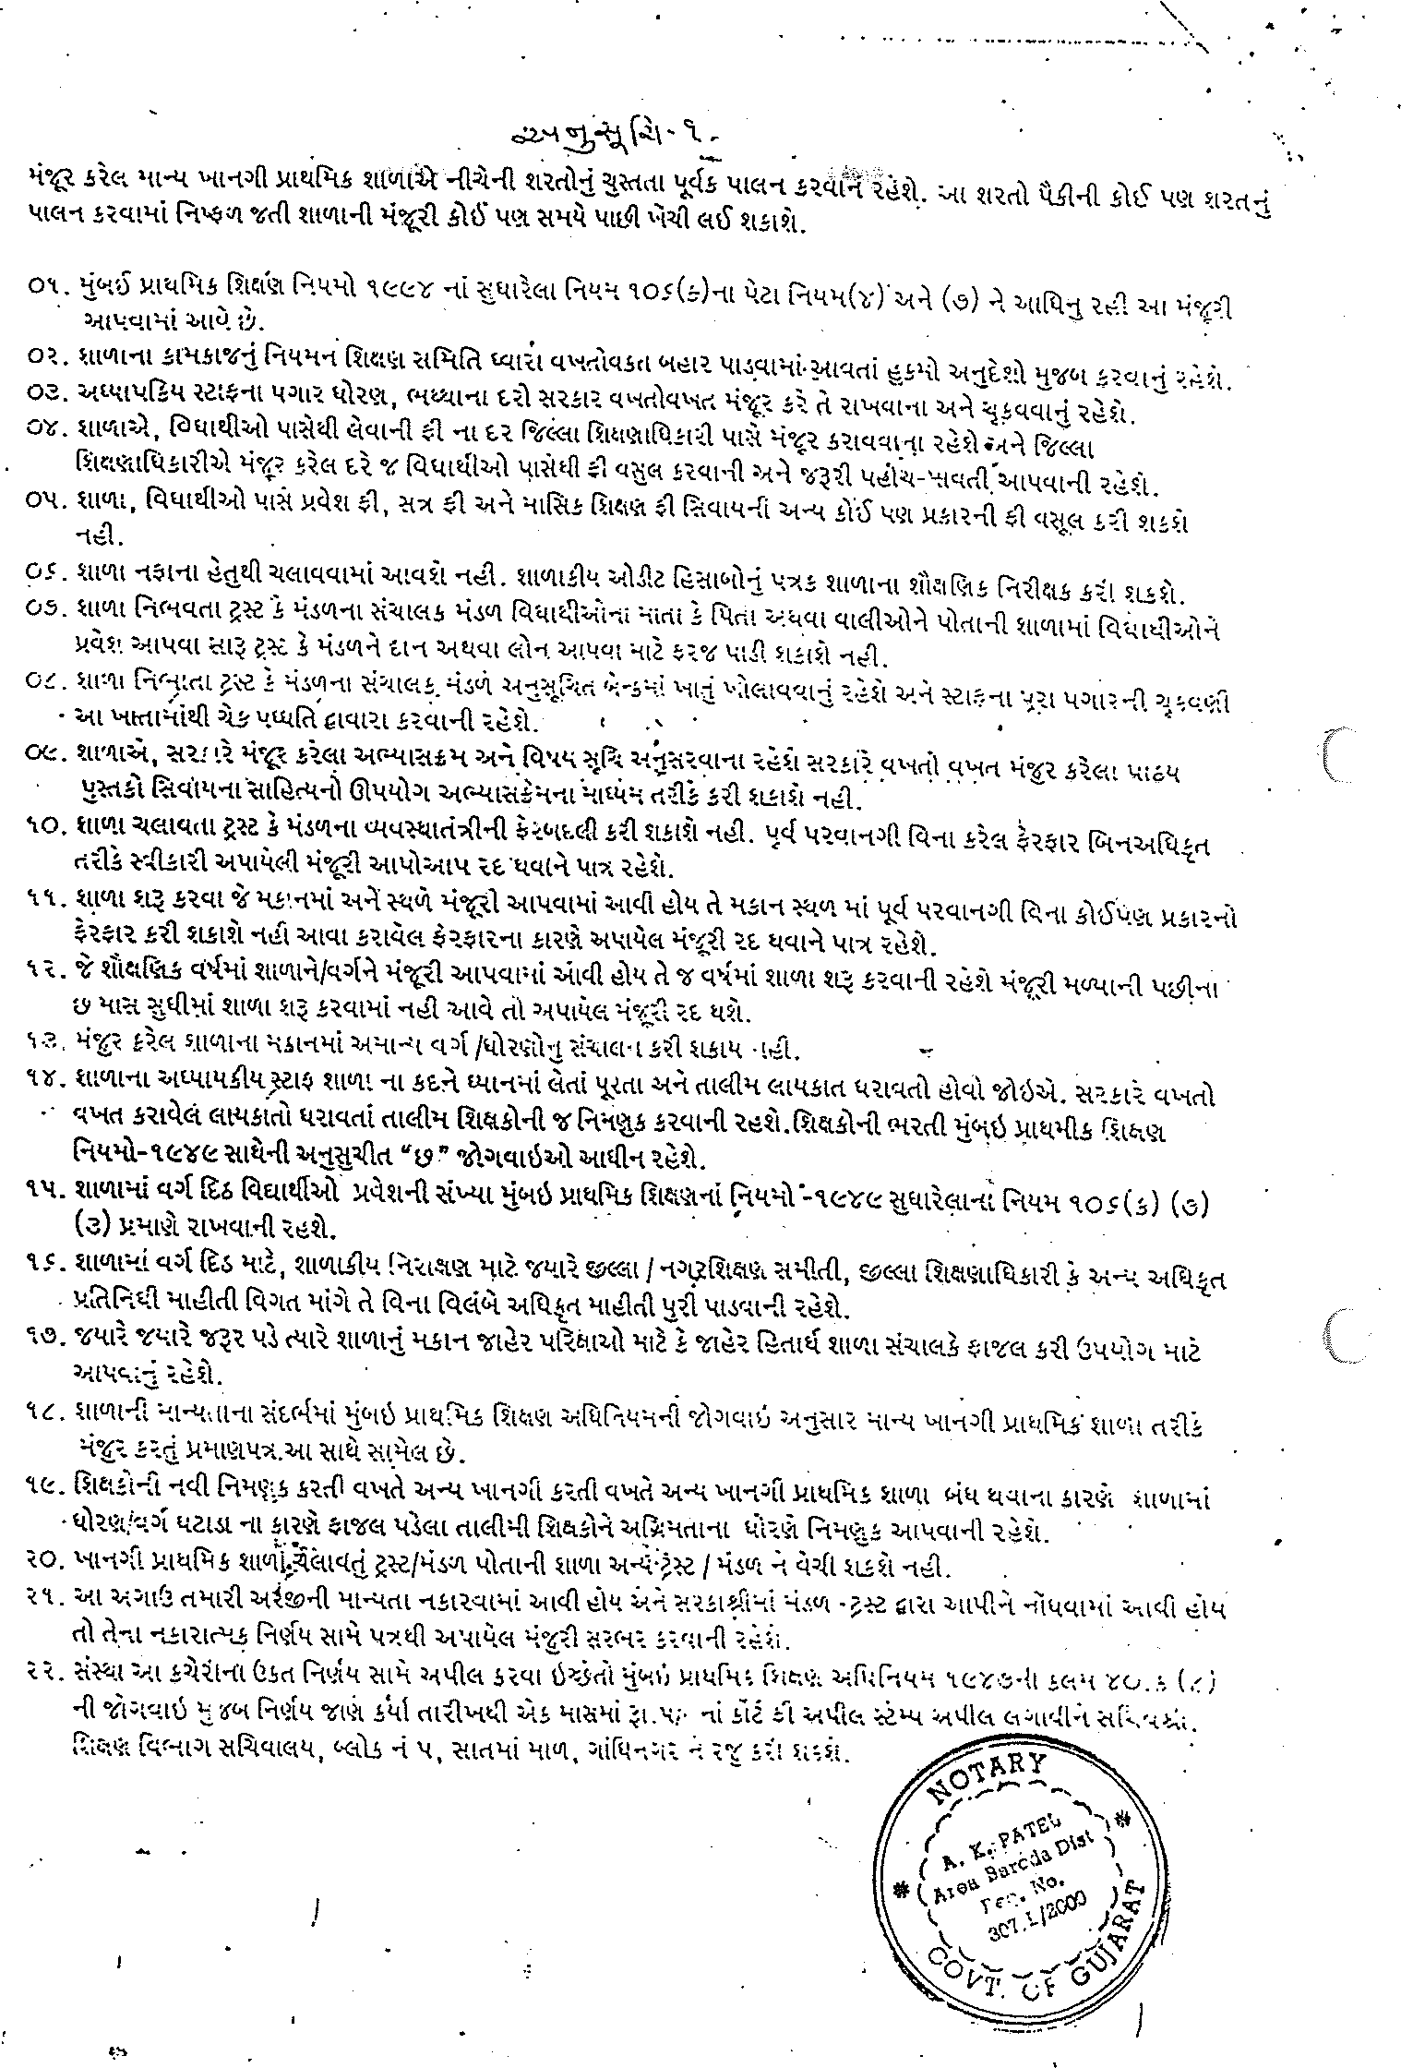

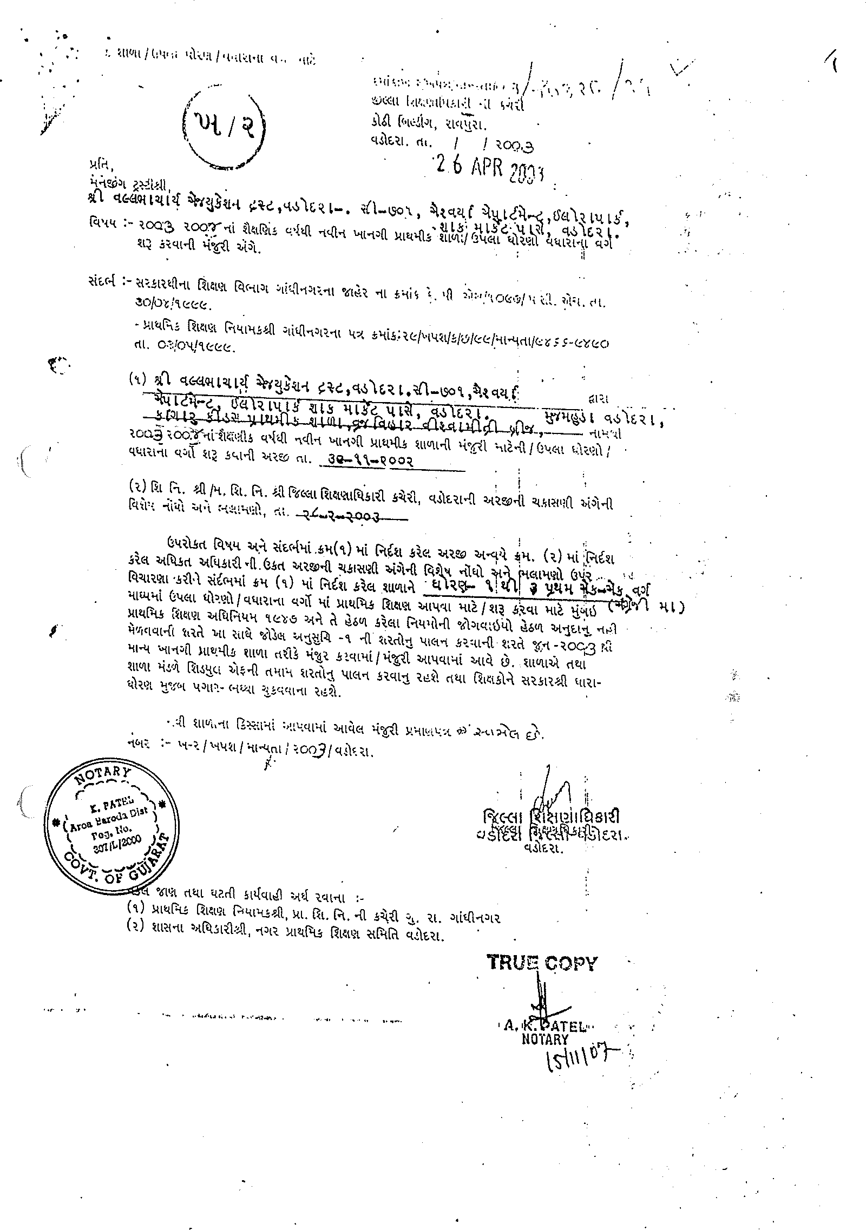

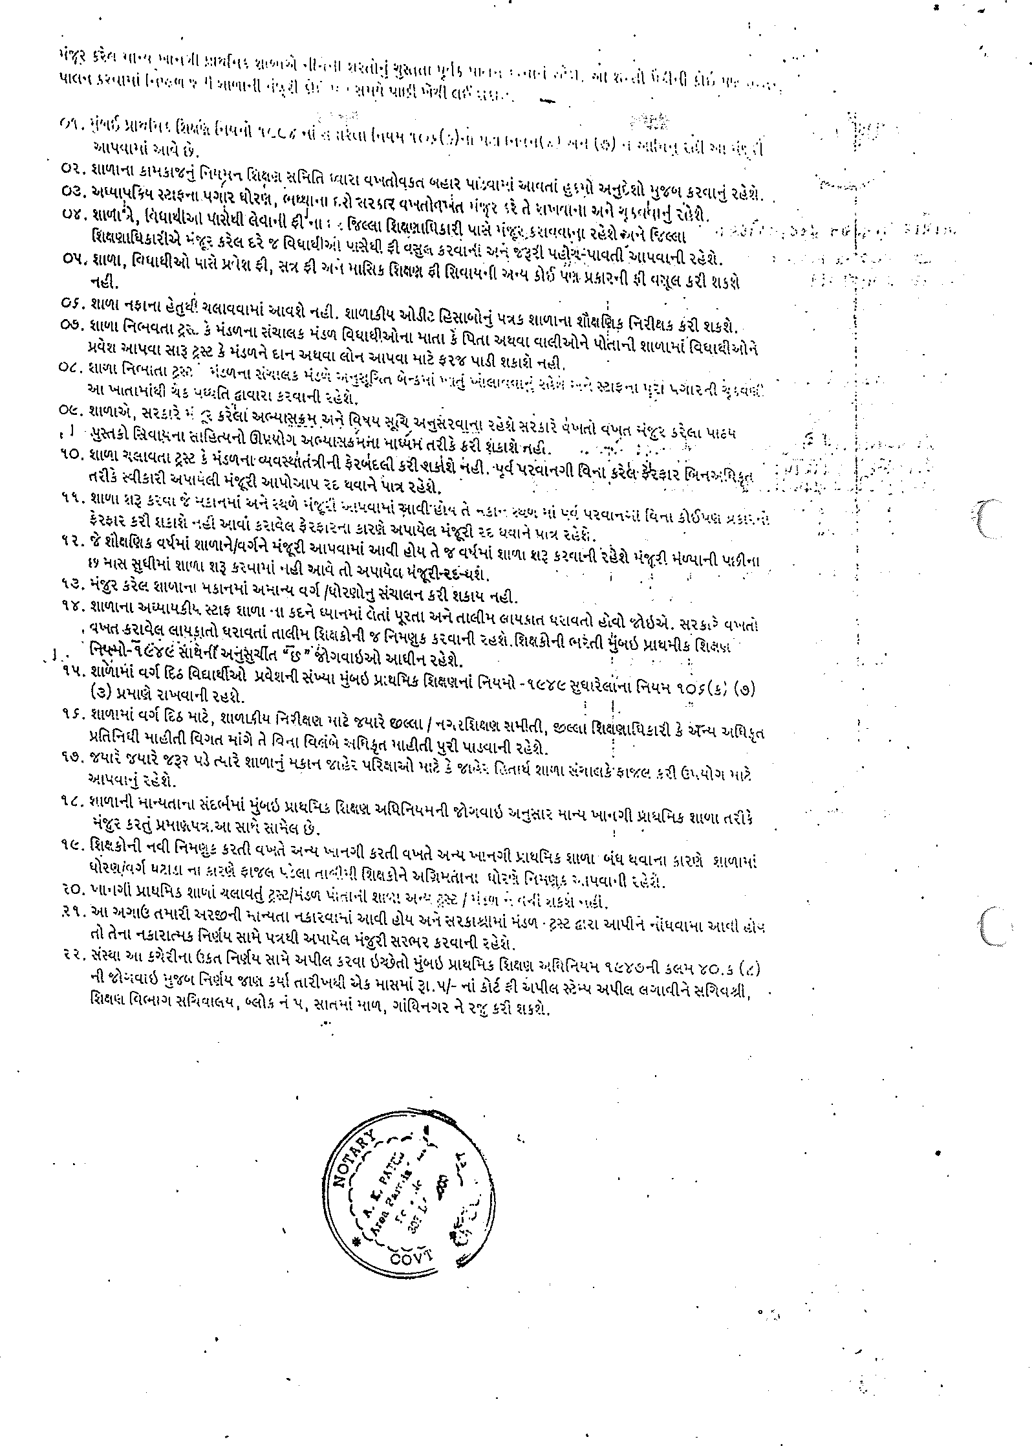

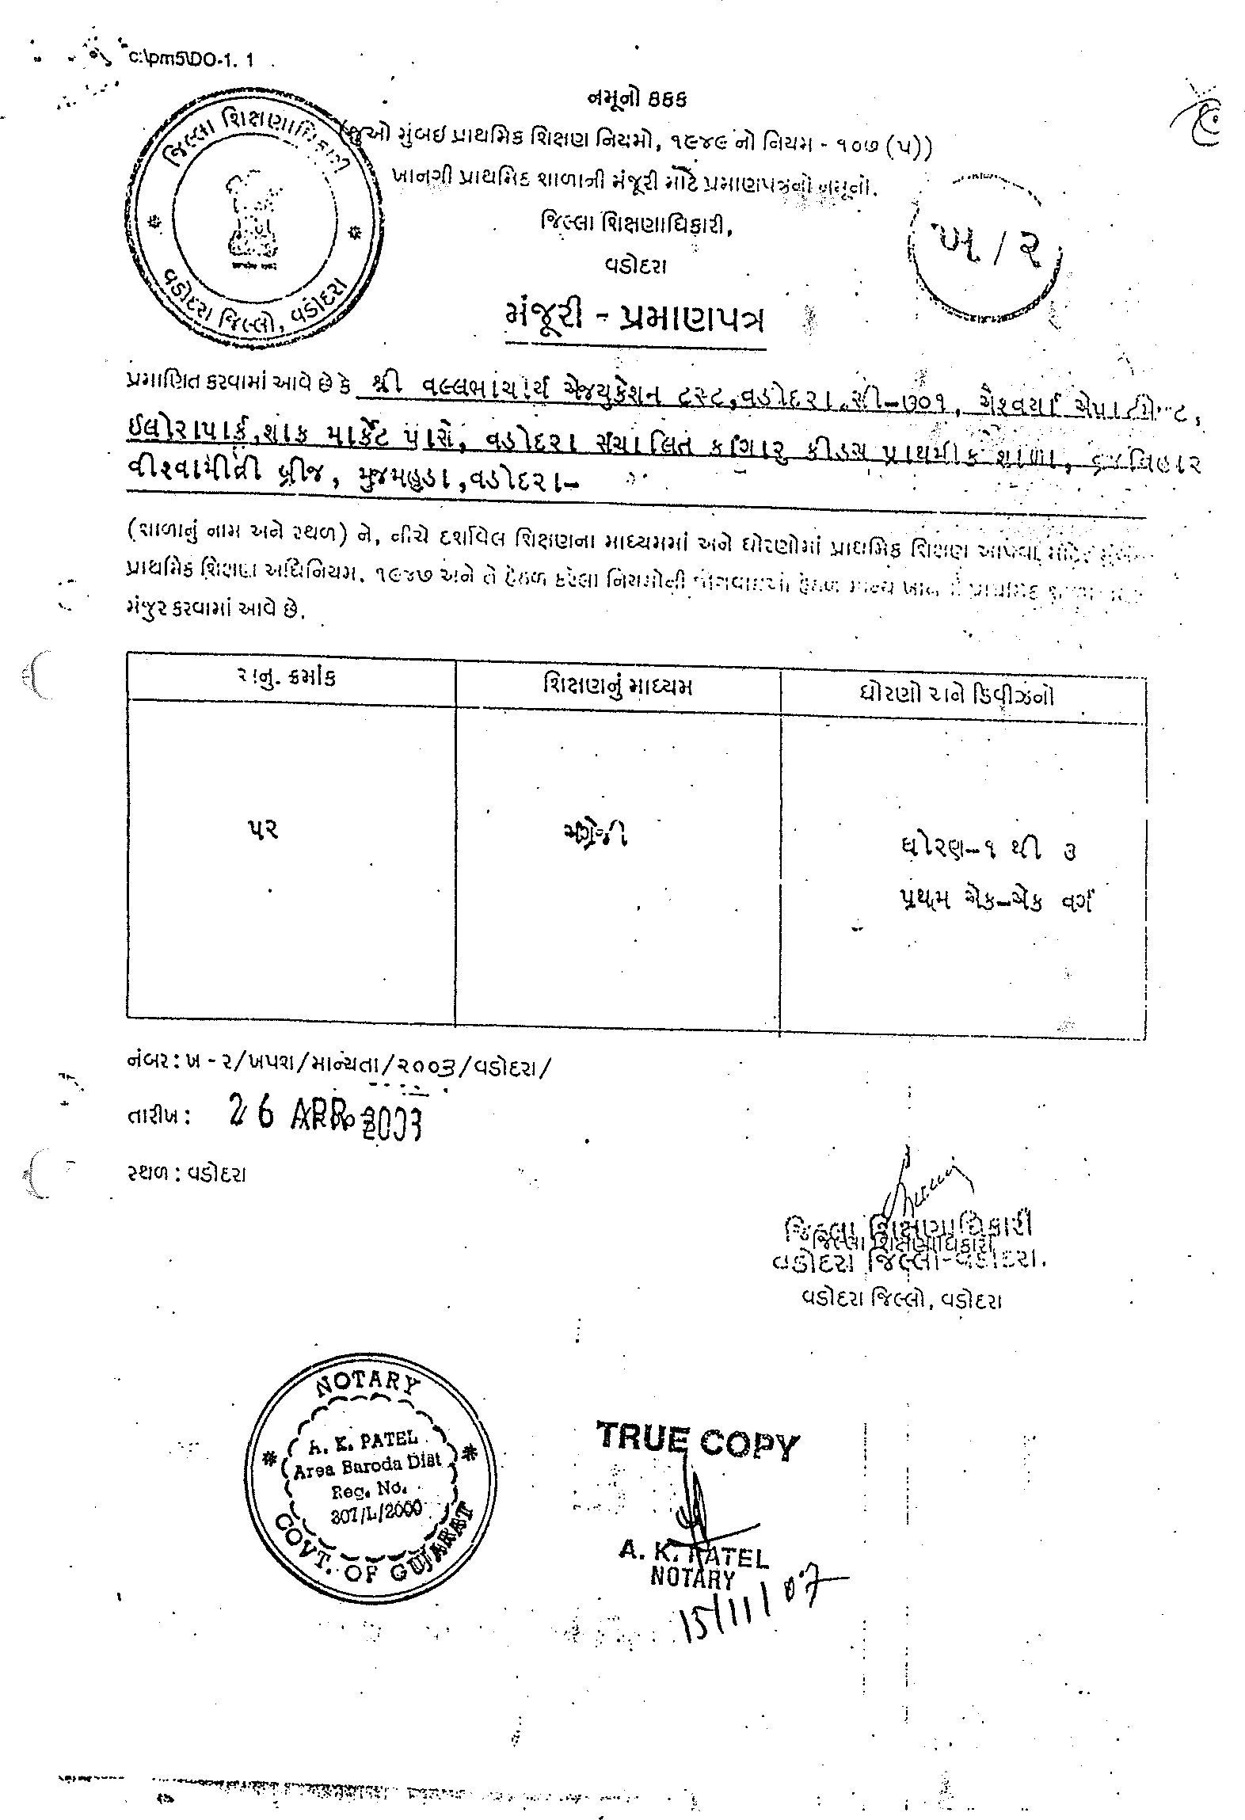

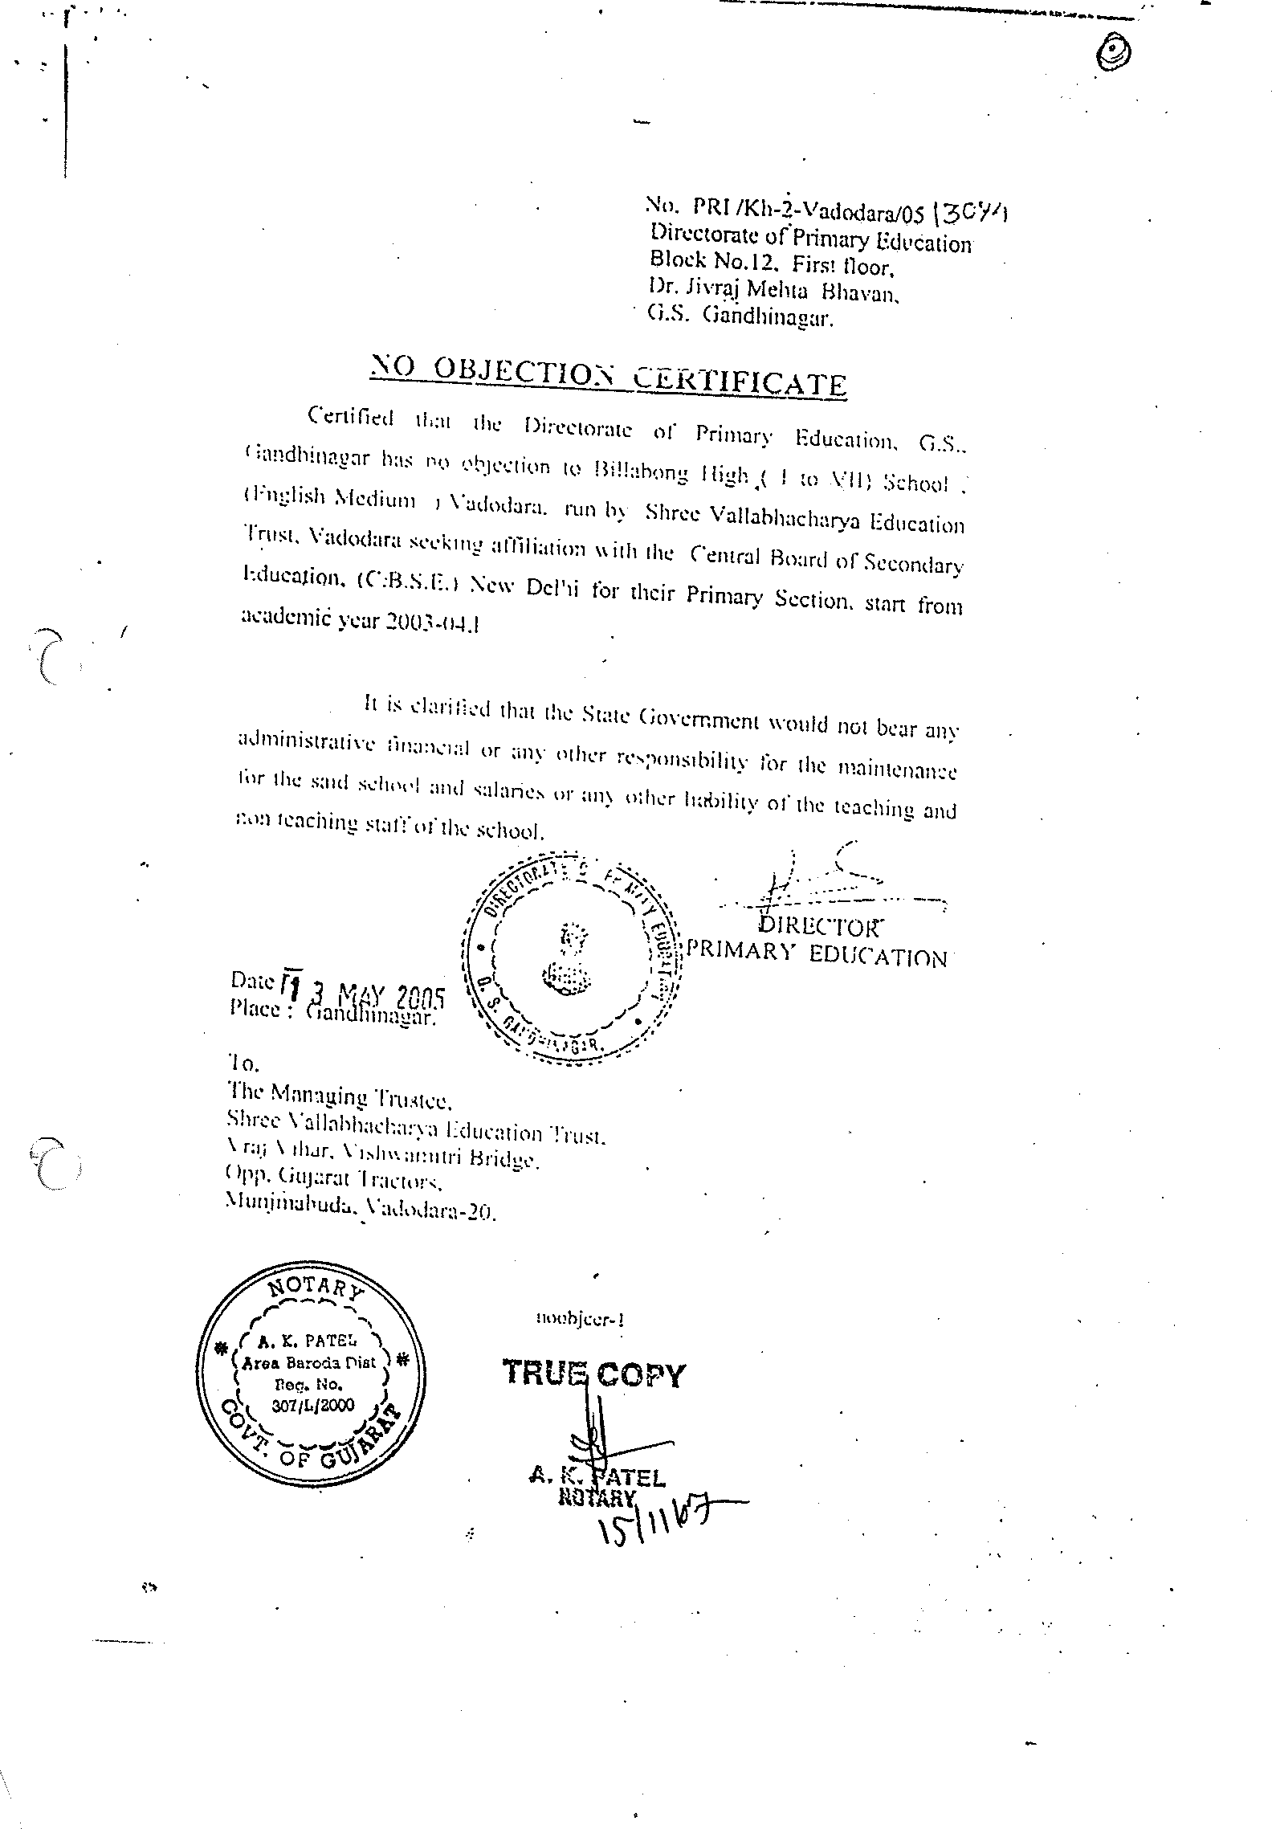

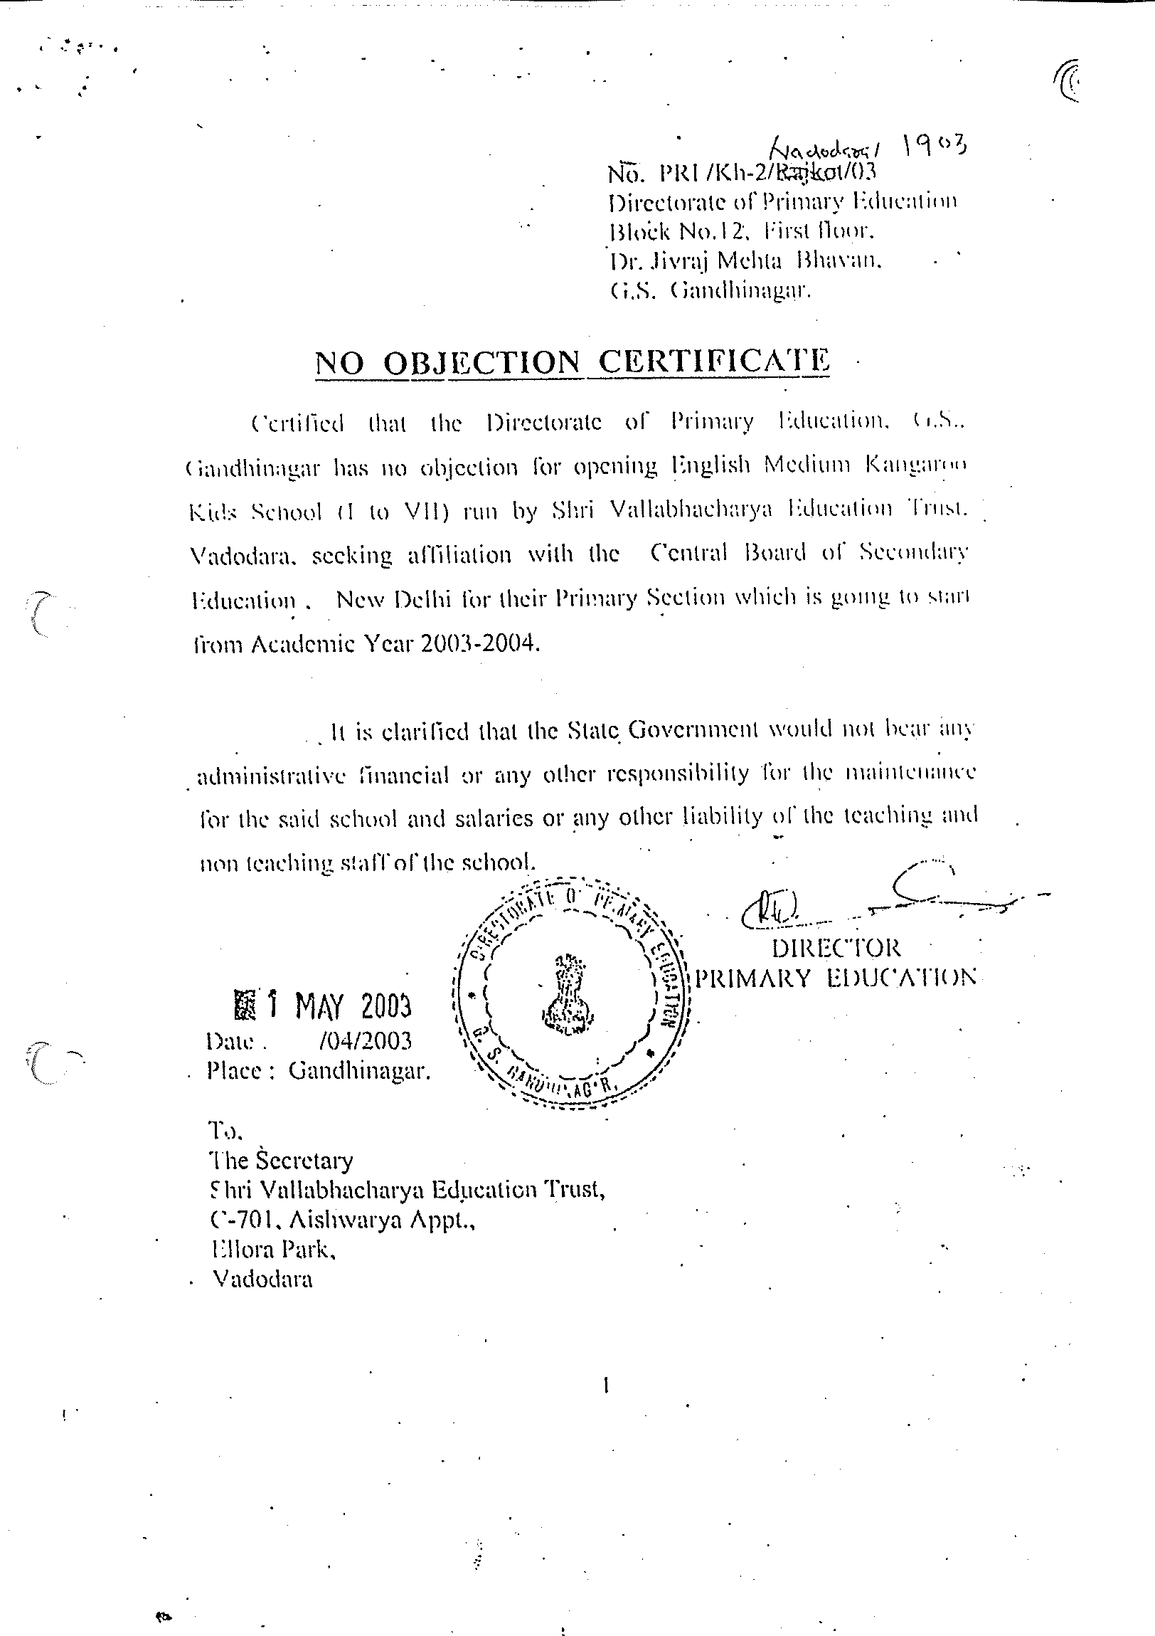

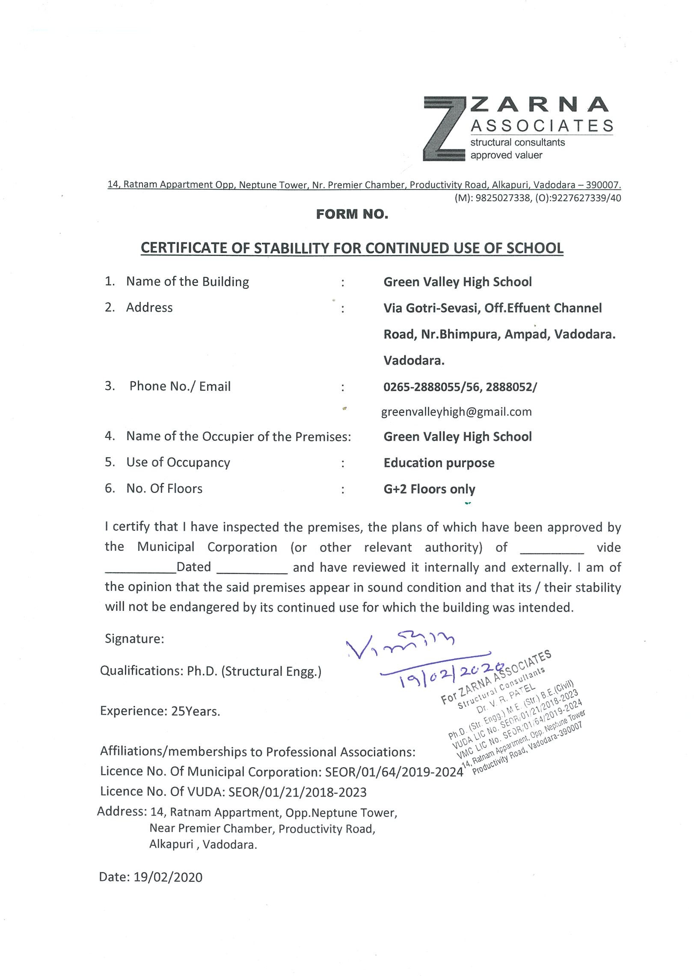

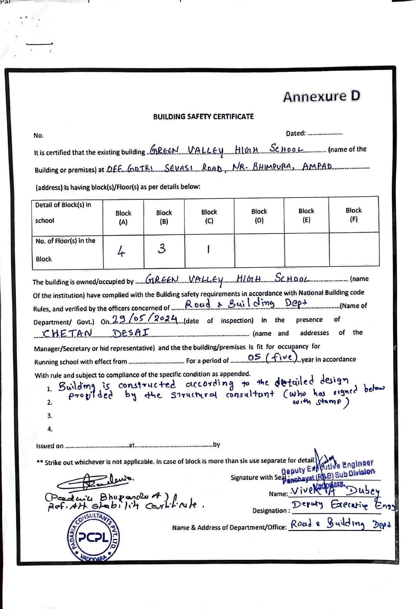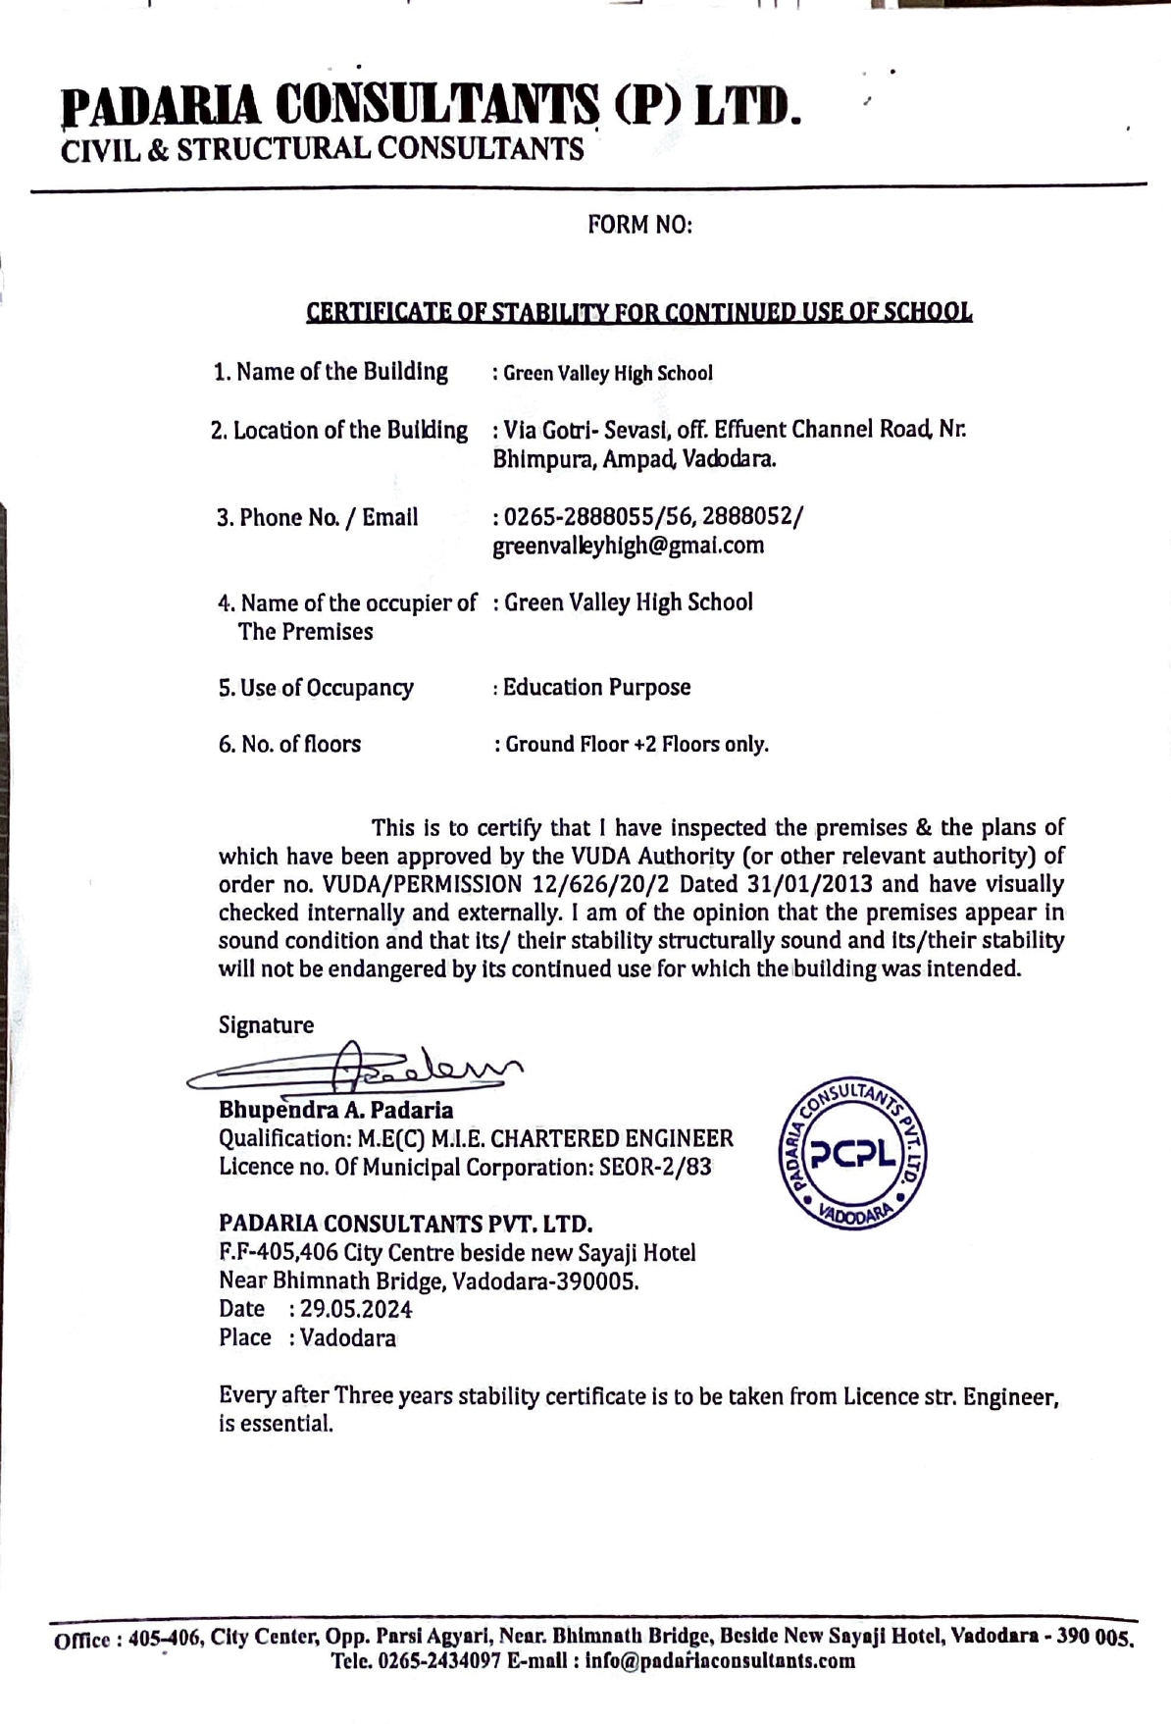
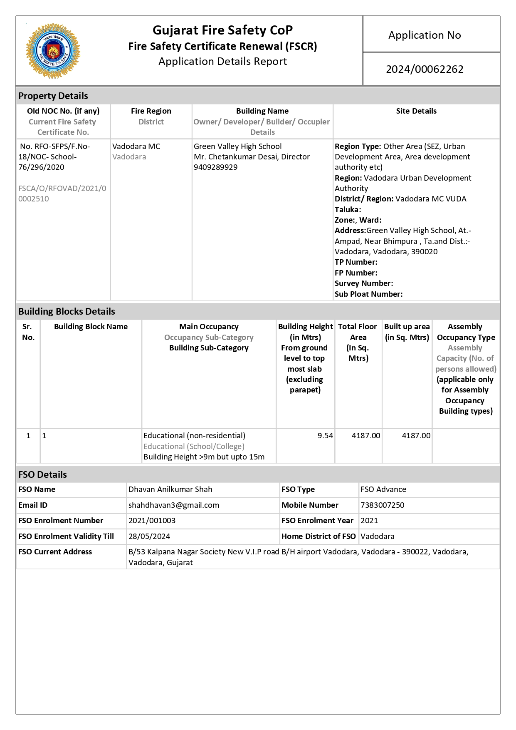
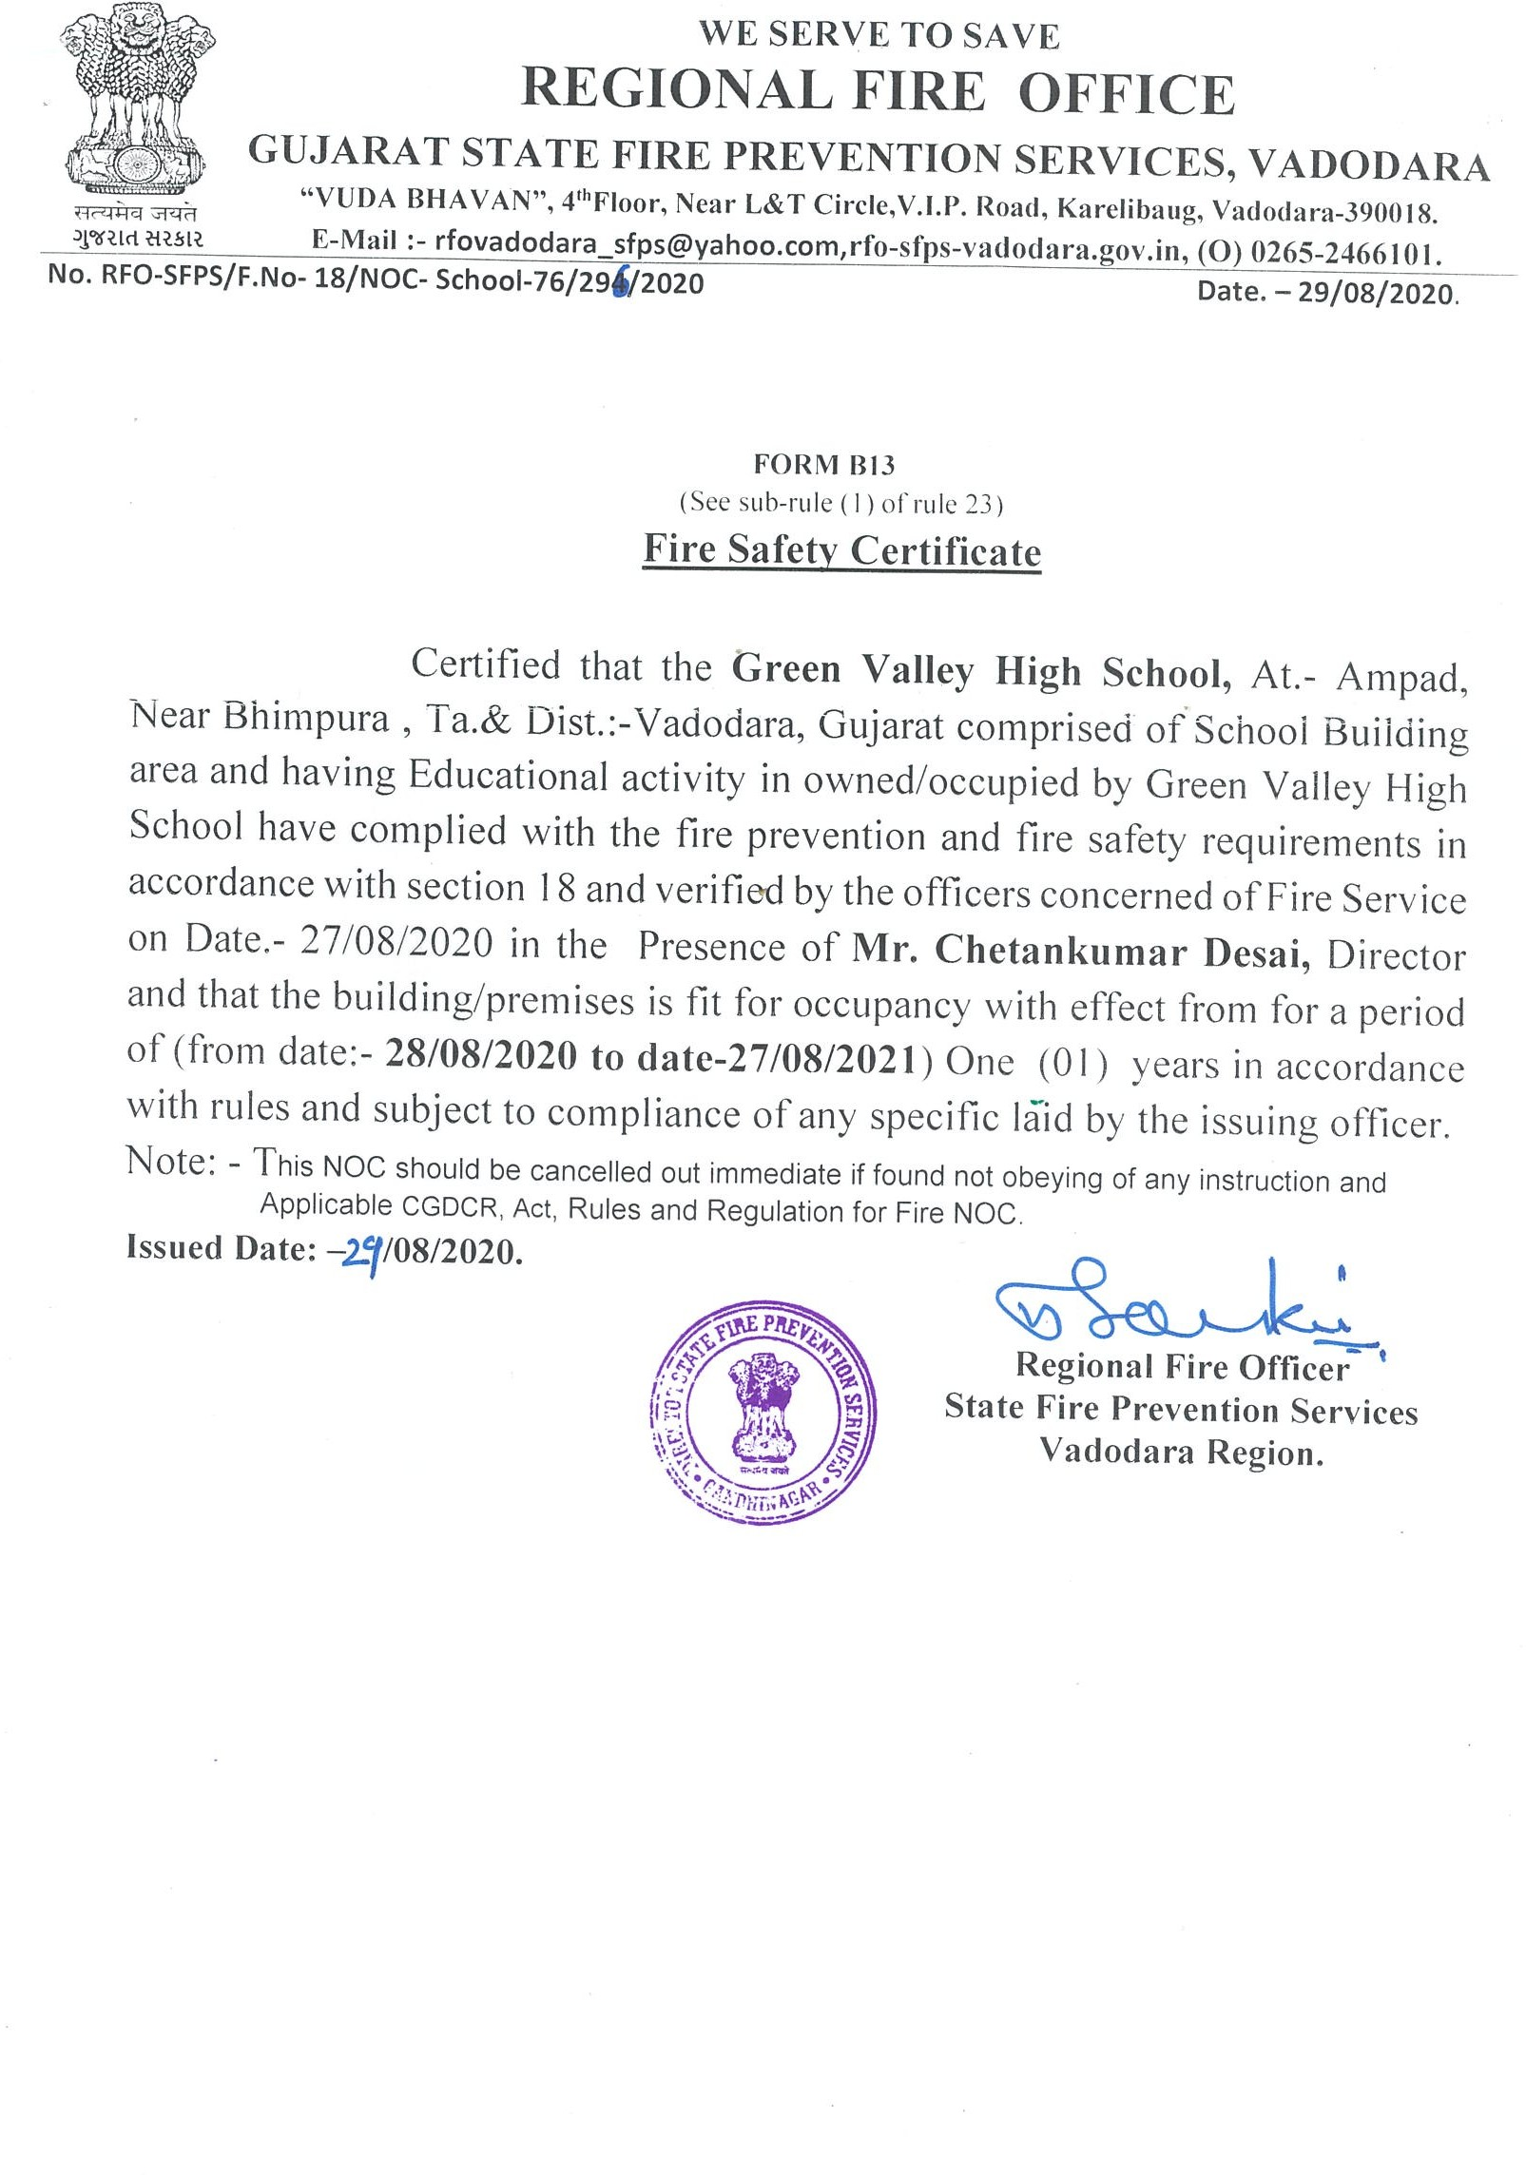

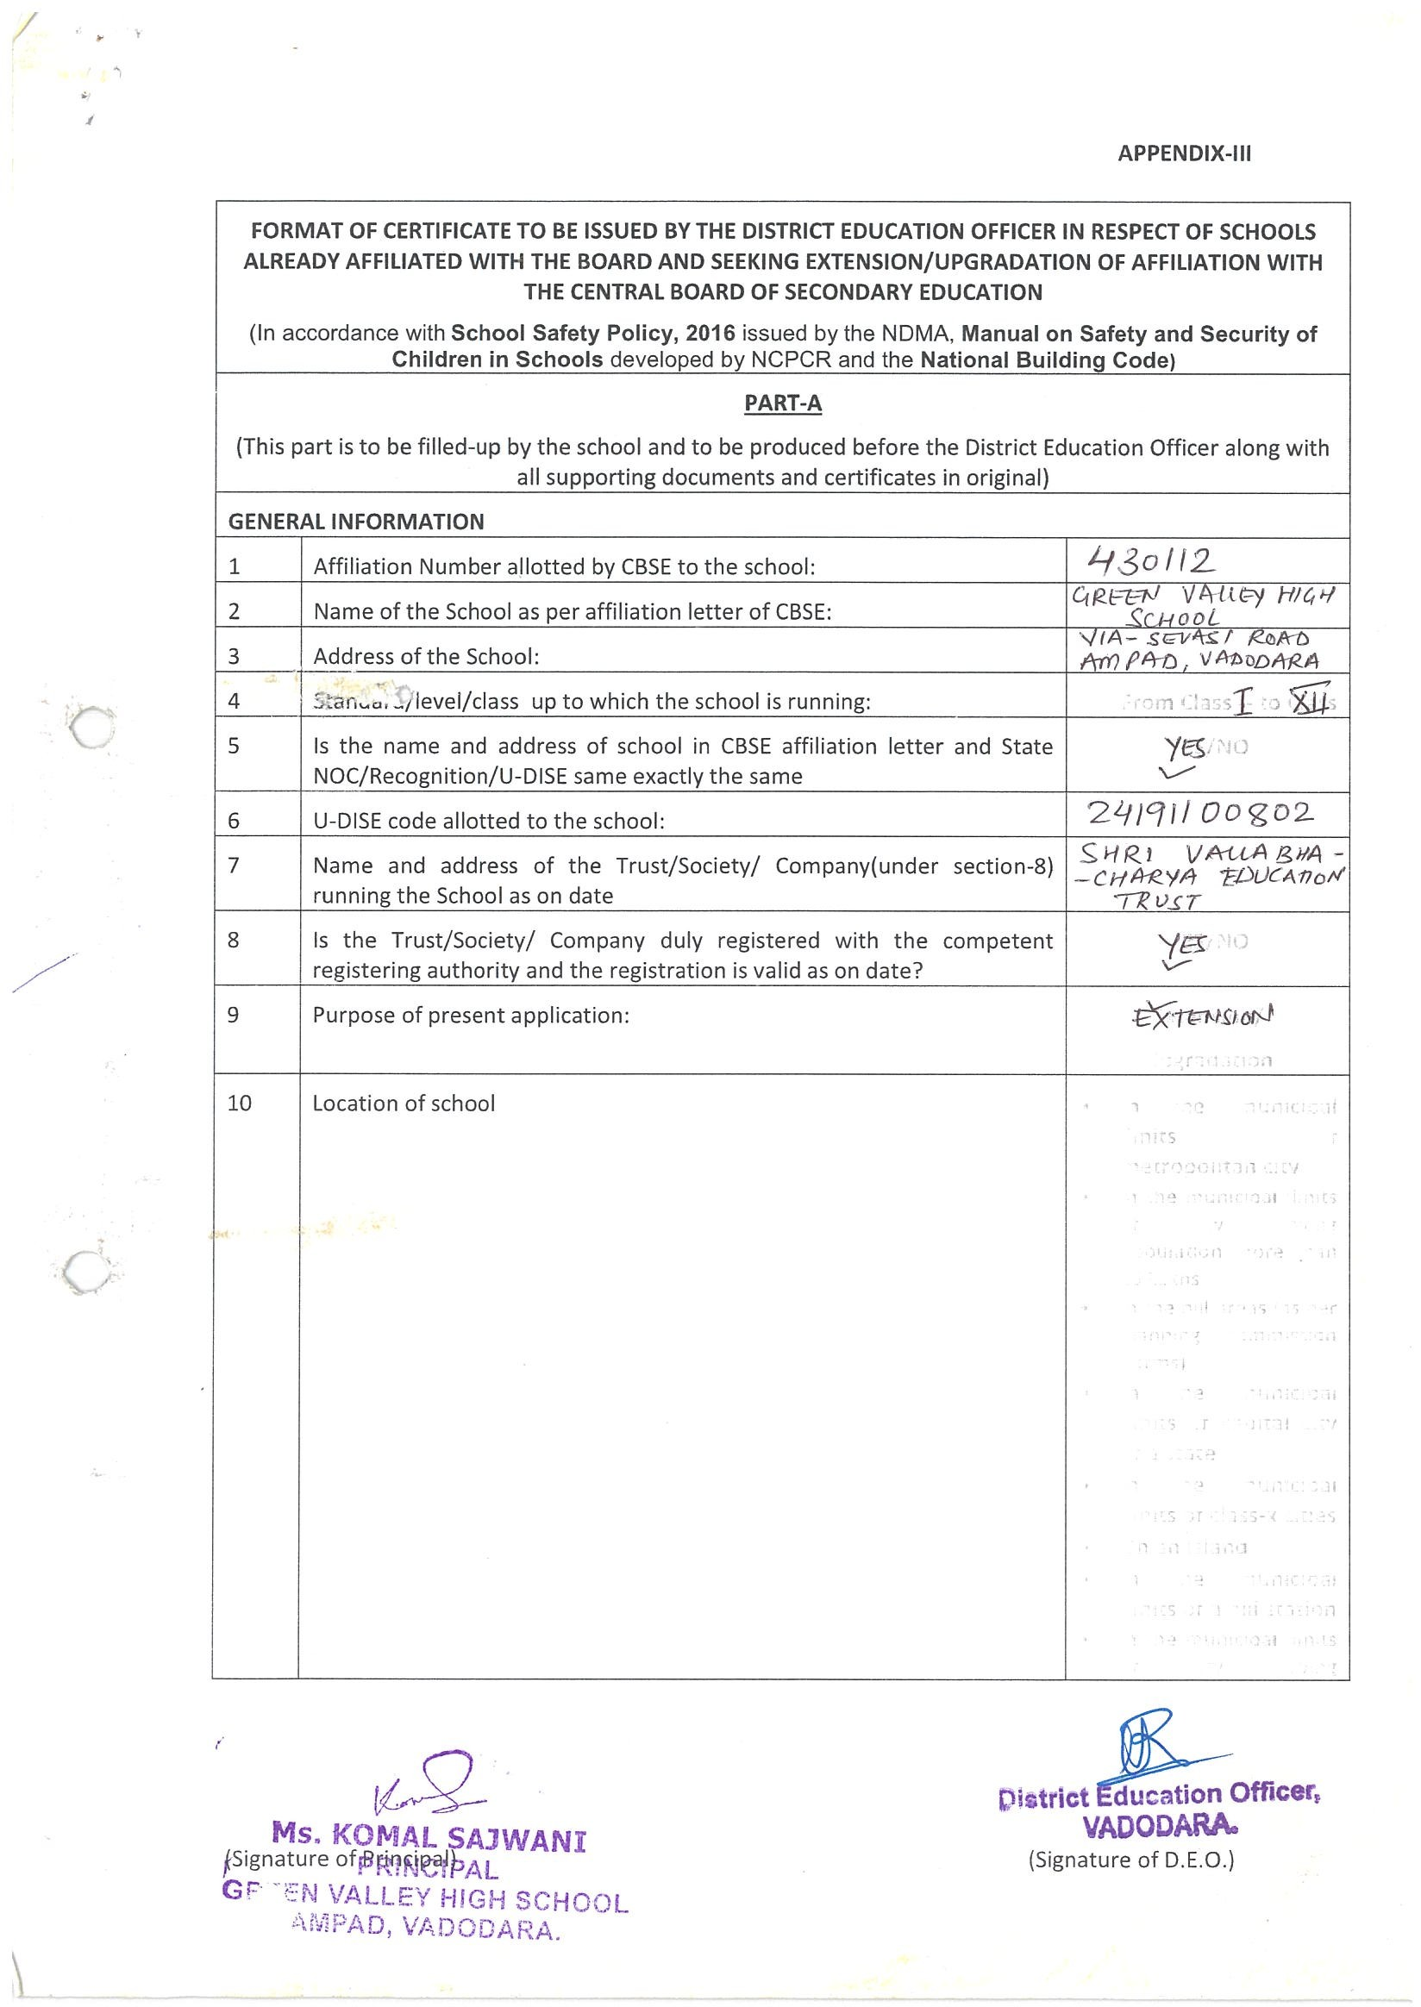

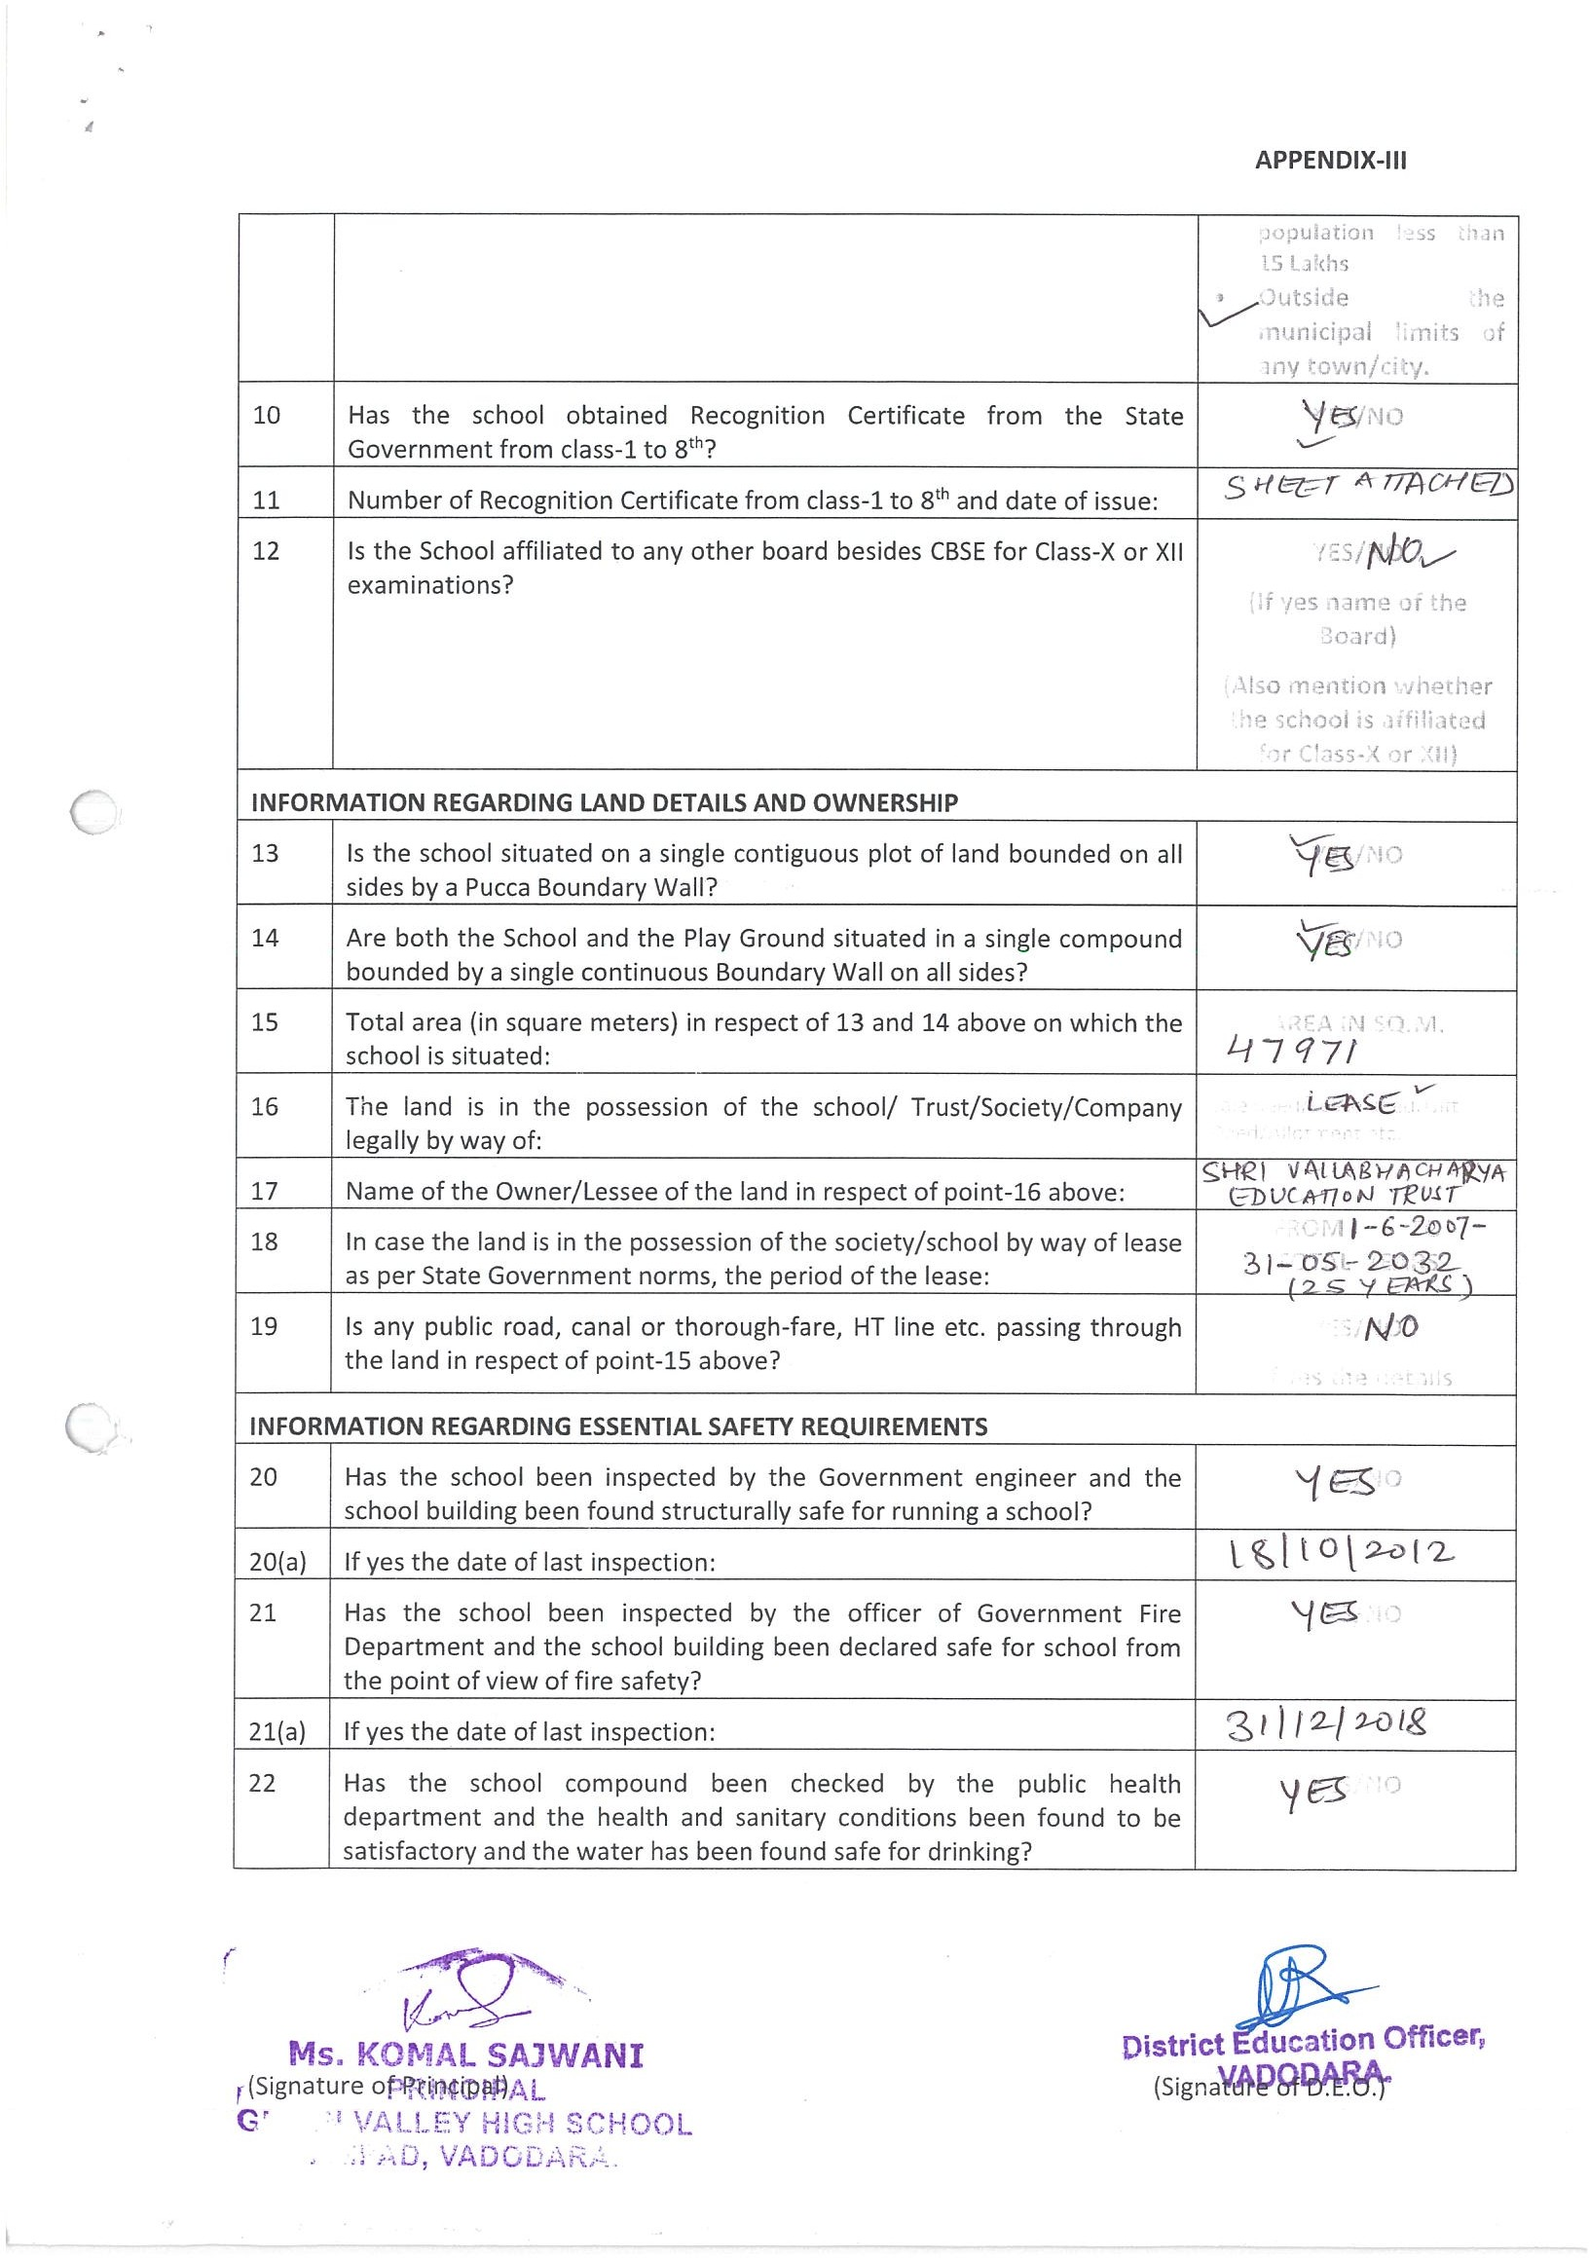

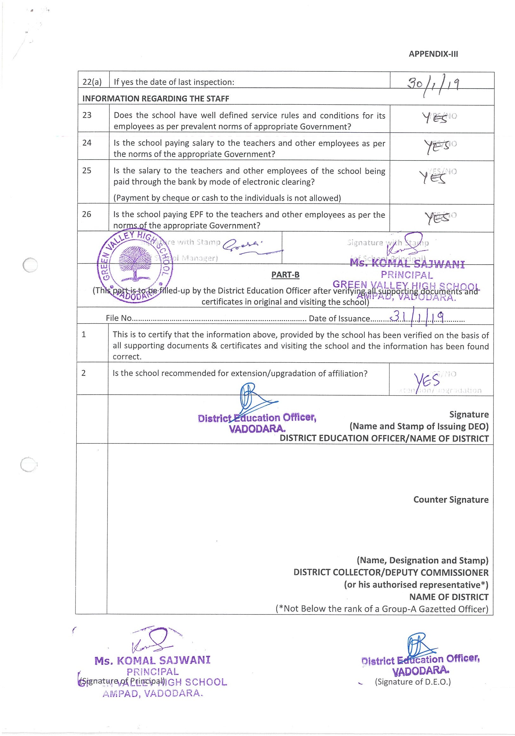

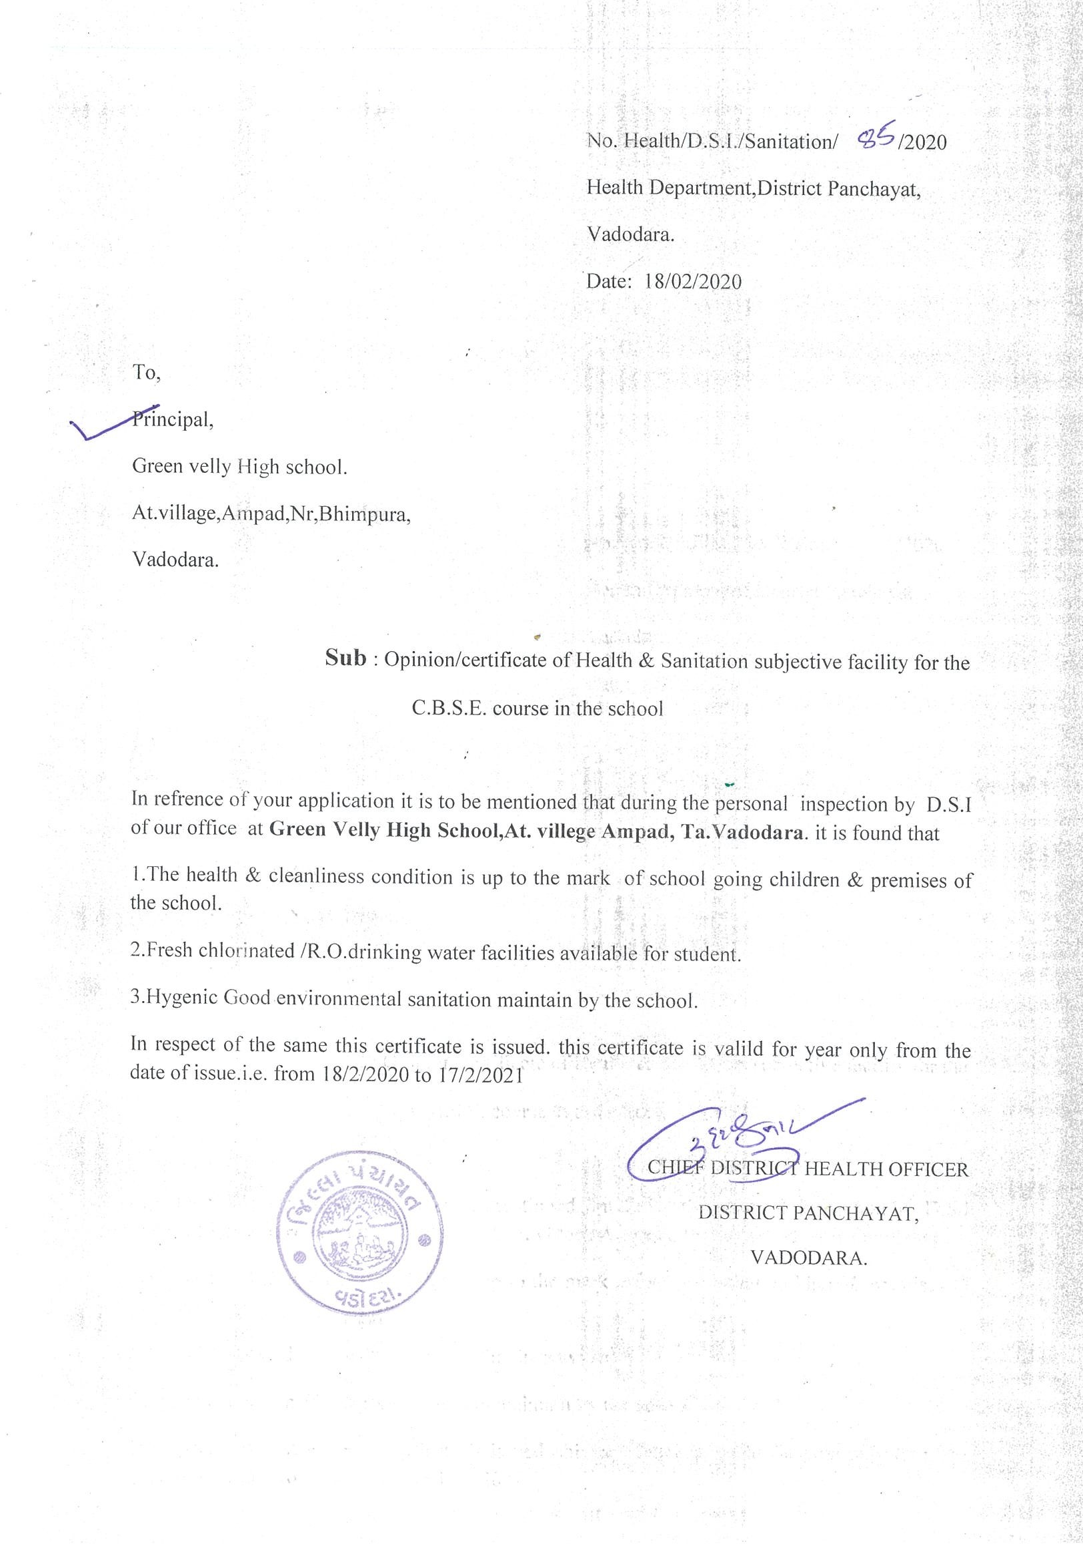

C : RESULT AND ACADEMICS :

SL NO | DOCUMENTS/INFORMATION | LINKS OF UPLOADED DOCUMENTS ON YOUR SCHOOL'S WEBSITE
1 | FEE STRUCTURE OF THE SCHOOL | PDF Attached --
2 | ANNUAL ACADEMIC CALENDER | PDF Attached
3 | LIST OF SCHOOL MANAGEMENT COMMITTEE (SMC) | PDF Attached --
4 | LIST OF PARENTS TEACHERS ASSOCIATION (PTA) MEMBERS | PDF Attached --
5 | LAST THREE-YEAR RESULT OF THE BOARD EXAMINATION AS PER APPLICABILITY | PDF Attached

C. 1. FEE STRUCTURE OF THE SCHOOL ( 2024- 25 ) - Inserting Later

C. 2. ANNUAL ACADEMIC CALENDER
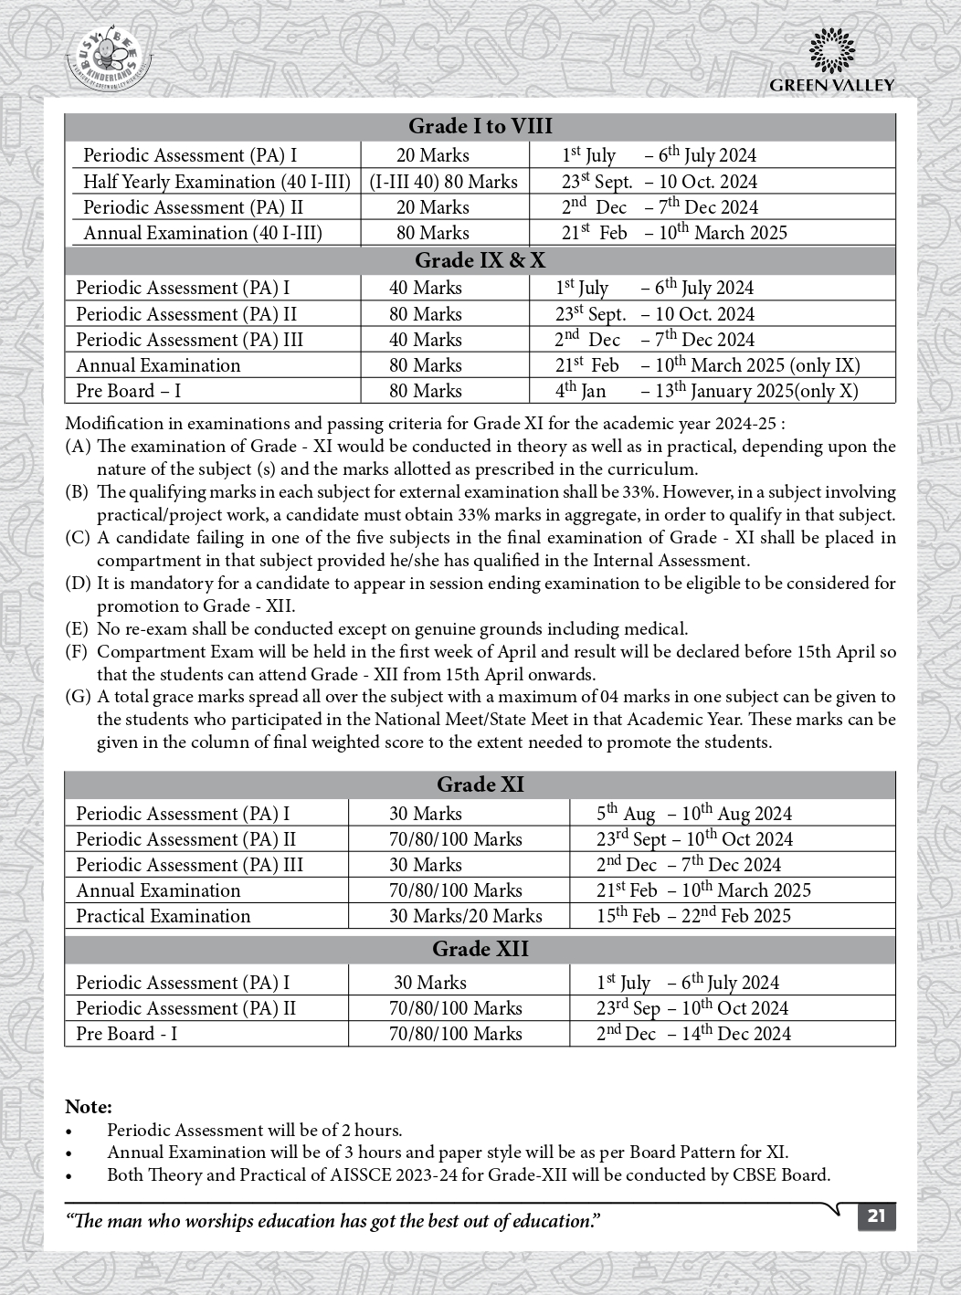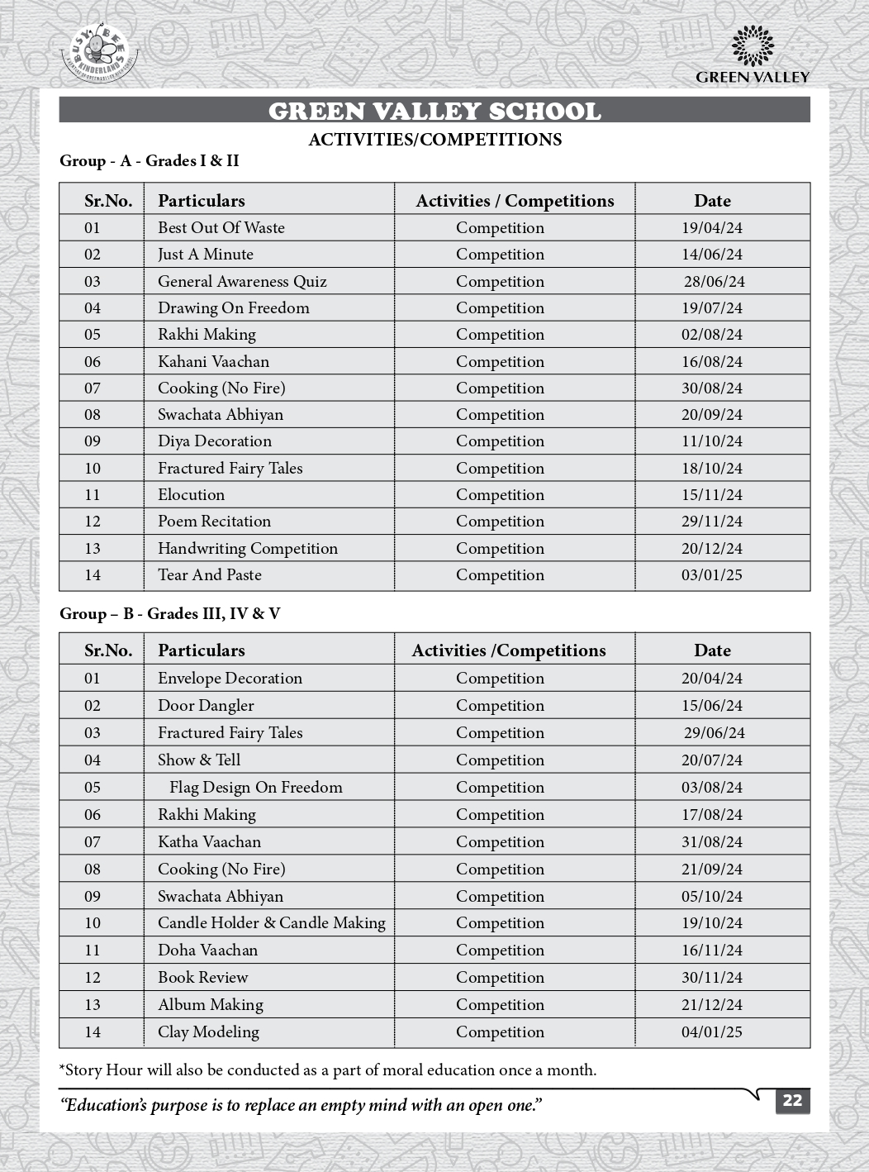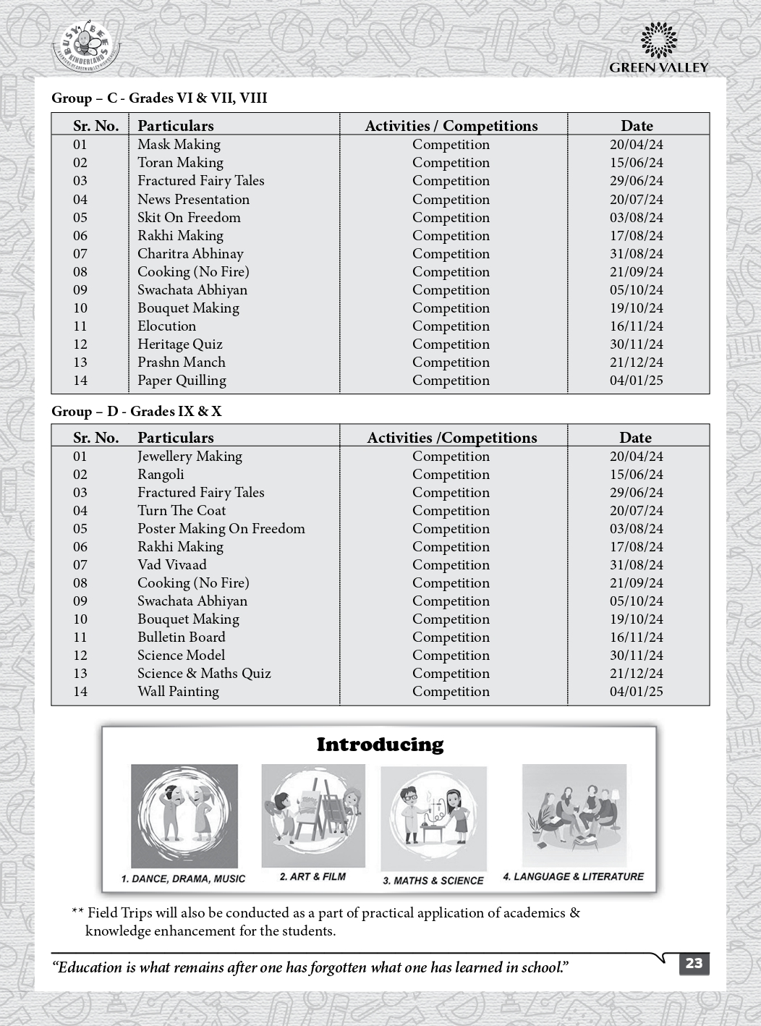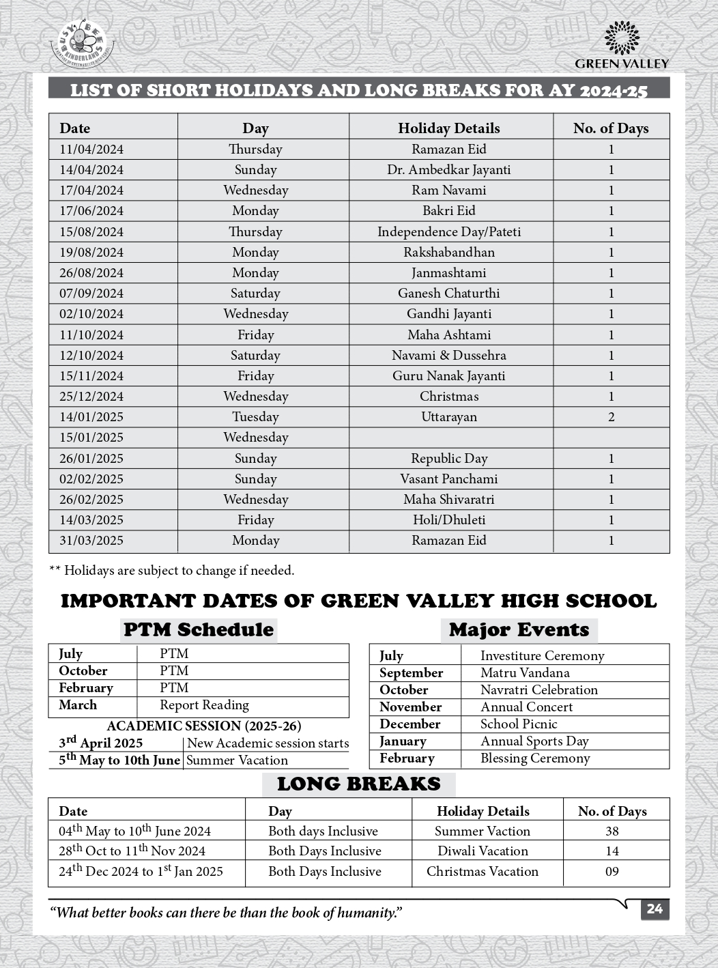

C. 3. LIST OF SCHOOL MANAGEMENT COMMITTEE (SMC)

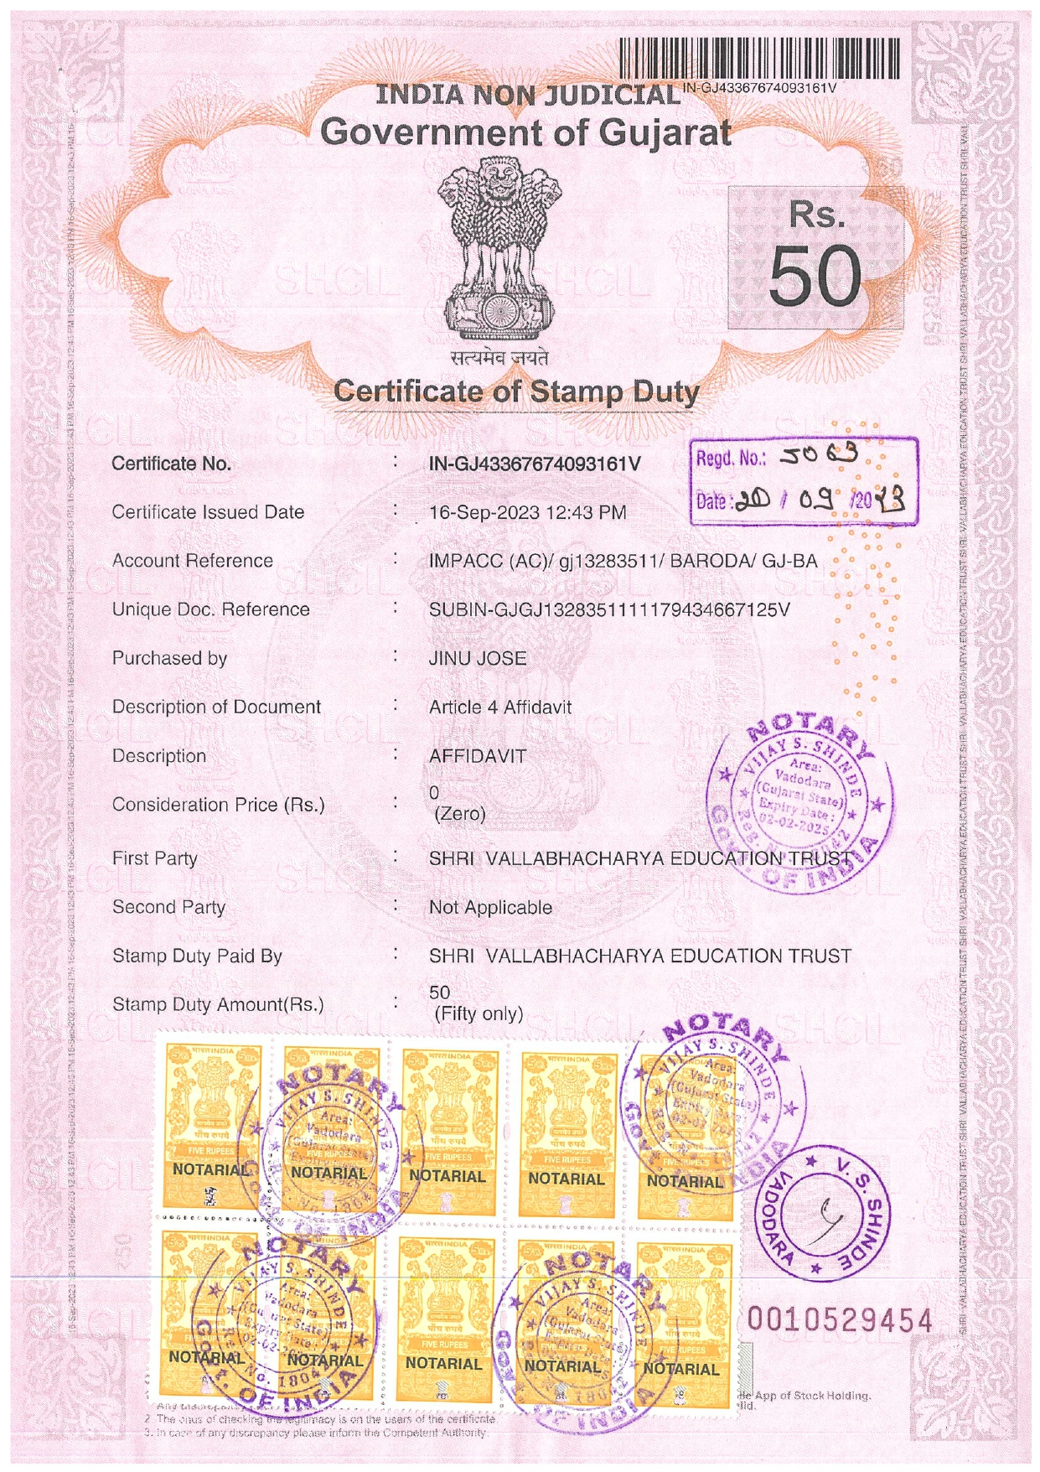

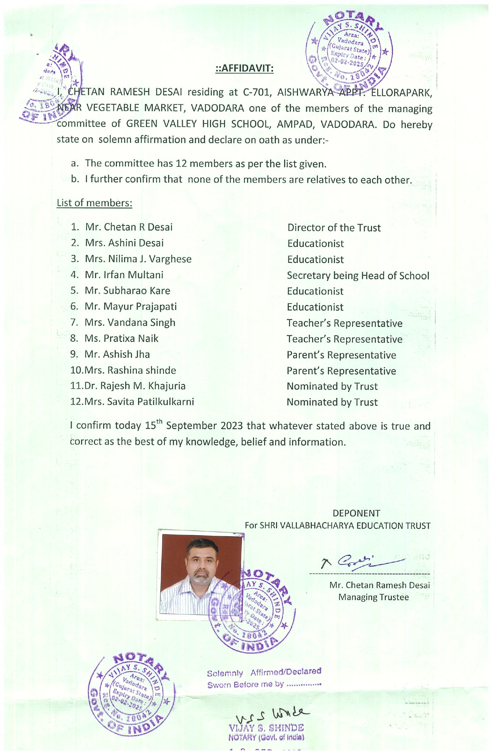

C. 4. LIST OF PARENTS TEACHERS ASSOCIATION (PTA) MEMBERS

C. 5. LAST THREE-YEAR RESULT OF THE BOARD EXAMINATION AS PER
APPLICABILITY

RESULT of CLASS: X

Sl. No. | YEAR | NO. OF REGISTERED STUDENTS | NO. OF PASSED STUDENTS | PASS PERCENTAGE | REMARKS
1. | 2020-21 | 34 | 34 | 100
2. | 2021-22 | 38 | 37 | 97.3
3. | 2022-23 | 37 | 37 | 100
4. | 2023-24 | 51 | 50 | 98.04

RESULT of CLASS XII:

Sl. No. | YEAR | NO. OF REGISTERED STUDENTS | NO. OF PASSED STUDENTS | PASS PERCENTAGE | REMARKS
1. | 2020-21 | 296 | 296 | 100
2. | 2021-22 | 320 | 316 | 98.8
3. | 2022-23 | 266 | 260 | 97.8
4. | 2023-24 | 446 | 398 | 89.24

D : STAFF (TEACHING) :

SL NO | INFORMATION | DETAILS
1 | PRINCIPAL | IRFAN MULTANI
2 | TOTAL NO. OF TEACHERS 49  PGT 27  TGT 14  PRT 8
3 | TEACHERS SECTION RATIO | 1.5:1
4 | DETAILS OF SPECIAL EDUCATOR | UJALA FADIA
5 | DETAILS OF COUNSELLOR AND WELLNESS TEACHER | UJALA FADIA

E : SCHOOL INFRASTRUCTURE:

SL NO | INFORMATION | DETAILS
1 | TOTAL CAMPUS AREA OF THE SCHOOL (IN SQ MTR) | 47971
2 | NO. AND SIZE OF THE CLASS ROOMS (IN SQ MTR) | 37 & 56
3 | NO. AND SIZE OF LABORATORIES INCLUDING COMPUTER LABS (IN SQ MTR) | 2 & 75
4 | INTERNET FACILITY | YES
5 | NO. OF GIRLS TOILETS | 24
6 | NO. OF BOYS TOILETS | 48
7 | LINK OF YOUTUBE VIDEO OF THE  INSPECTION OF SCHOOL COVERING THE INFRASTRUCTURE OF THE SCHOOL | Green Valley High School : CBSE Inspection 2020 - YouTube  Or  In youtube, in search option type  “green valley inspection” .

